1.Introduction to Modern JavaScript and DOM

1. Introduction to Modern JavaScript and DOM
a. Write a JavaScript program to link JavaScript file with the HTML page
b. Write a JavaScript program to select the elements in HTML page using selectors
c. Write a JavaScript program to implement the event listeners
d. Write a JavaScript program to handle the click events for the HTML button elements
e. Write a JavaScript program to With three types of functions
i. Function declaration
ii. Function definition
iii. Arrow functions
- Write a JavaScript program to link JavaScript file with the HTML page

Aim:
To Write a JavaScript program to link JavaScript file with the HTML page

Description:
To link a JavaScript file in HTML, you use the <script> tag with the src attribute, which specifies the path to your JavaScript file.

Basic Syntax
<script src="your-file.js"></script> Suppose we have the following files in the same folder:
- P1a.html
- scripting.js
Programs: P1a.html
<!DOCTYPE html>
<html lang="en">
<head>
<meta charset="UTF-8">
<title>Link JavaScript Example</title>
</head>
<body>
<h1>Hello from Dept of CAI</h1>
<center><h1>welcome to FSD-II Lab</h1></center>
<center><h1>Here we are Learning Full Stack Development using HTML,CSS,JAVASCRIPT </h1></center>

<!-- Link to external JavaScript file -->
<script src="script1.js"></script>
</body>
</html>

Script1.js
console.log("Hello from JavaScript!"); alert("JavaScript is successfully linked!");

Output:

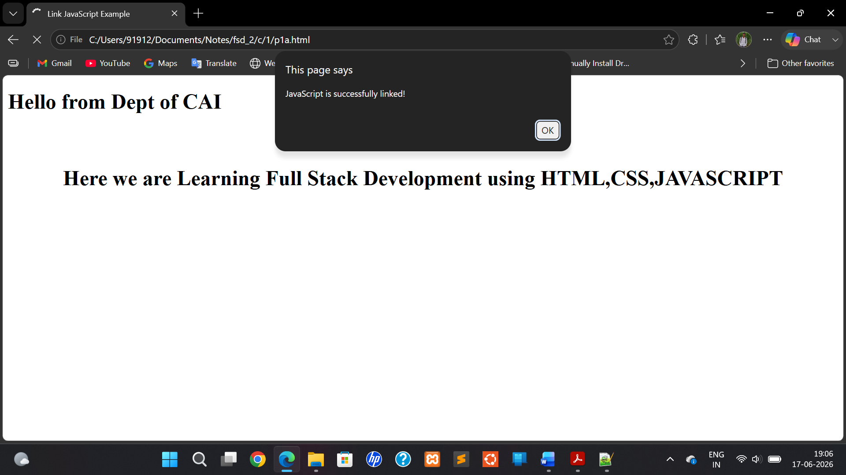

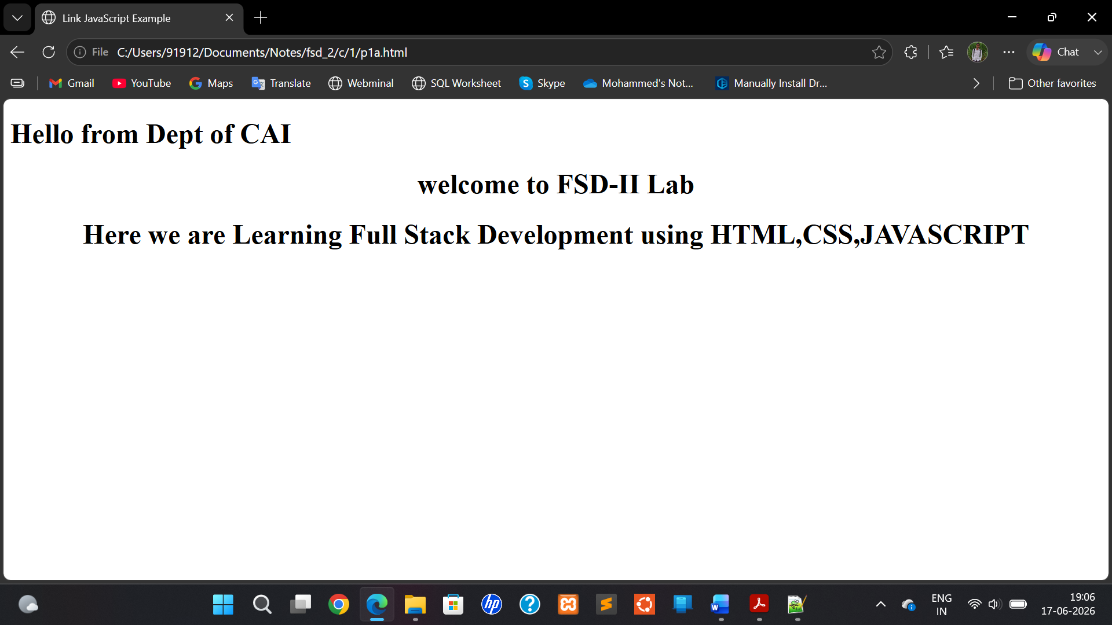

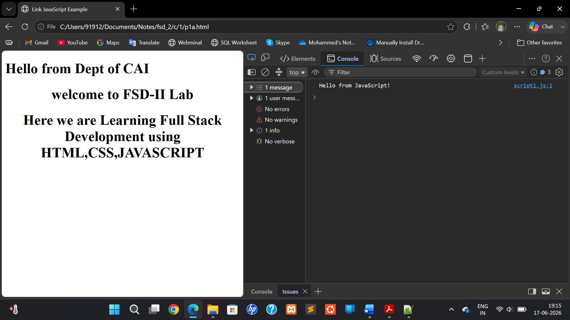
- Write a JavaScript program to select the elements in HTML page using selectors
Aim:
To Write a JavaScript program to select the elements in HTML page using selectors

Description:
CSS selectors
- Element Selector --- p { color: red; }
- Class Selector --- .btn { background-color: blue;}
- ID Selector ---- #header { font-size: 24px; }
- Attribute Selector input[type="submit"]
{
background-color: green;
}
- Descendant Selector ---- ul li { font-weight: bold; }
- Child Selector ul > li { text-decoration: underline; }
- Adjacent Sibling Selector --- h2 + p { margin-top: 0; }
- General Sibling Selector ---- h2 ~ p { font-style: italic; }

Program:
p2.html
<!DOCTYPE html>
<html>
<head>
<title>Selector with Color Change</title>
</head>
<body>

<h1 id="title">Hello SVPCET Students</h1>
<h1></h1>
<h1><p class="message">This Dept of CAI.</p><h1>
<h1><p>This is 3rd Year V Sem.</p></h1>
<button onclick="selectElements()">Click Me</button>
<script src="script2.js"></script>
</body>
</html>

script2.js
function selectElements()
{
let titlejs = document.getElementById("title");
titlejs.style.color = "blue";

let messagejs = document.getElementsByClassName("message")[0];
messagejs.style.color = "green";

let paragraphs = document.getElementsByTagName("p");
paragraphs[1].style.backgroundColor = "yellow";
}

OUTPUT:
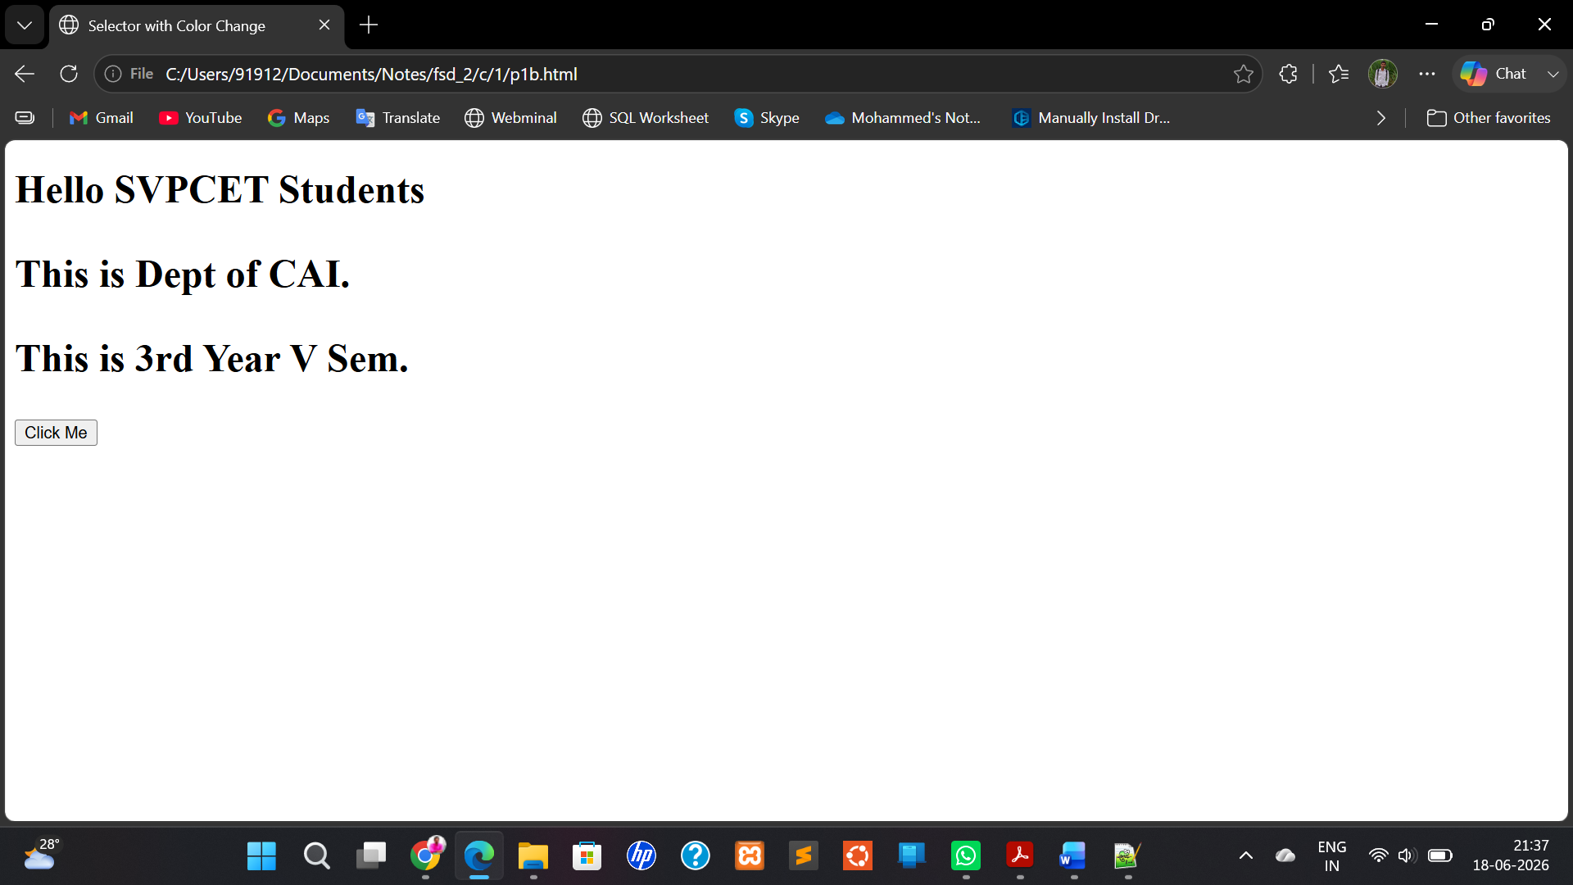

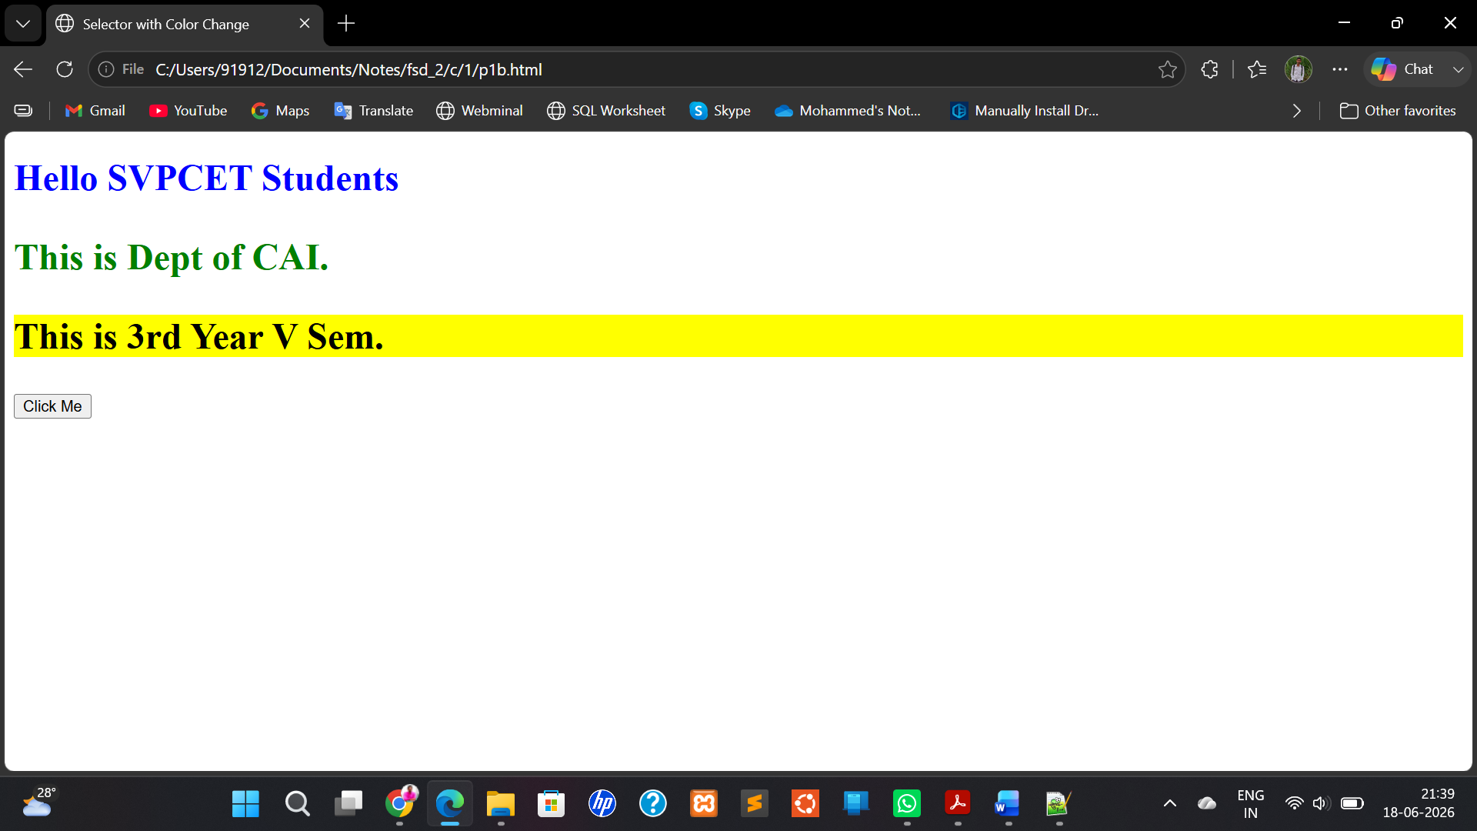

Write a JavaScript program to implement the event listeners

Aim:
To Write a JavaScript program to implement the event listeners

Description:
An event listener is a function in JavaScript that waits for an event (like click, mouseover, keydown) to happen on an HTML element — and then executes code.

Event | Description
click | When an element is clicked
mouseover | When mouse moves over an element
mouseout | When mouse leaves an element
keydown | When a key is pressed
submit | When a form is submitted
change | When form input changes
load | When page or image is fully loaded

PROGRAM:
P1c.html
<!DOCTYPE html>
<html>
<head>
<title>Event Listener Example</title>
</head>
<body>
<h2 id="text">Click the button to change this text</h2>
<button id="myButton">Click Me</button>

<script src="script3.js"></script>
</body>
</html>

script3.js
document.addEventListener("DOMContentLoaded", function () {

let button = document.getElementById("myButton");

button.addEventListener("click", function () {

let text = document.getElementById("text");

text.textContent = "The text has been changed!";
text.style.color = "green";

});

});

OUTPUT:

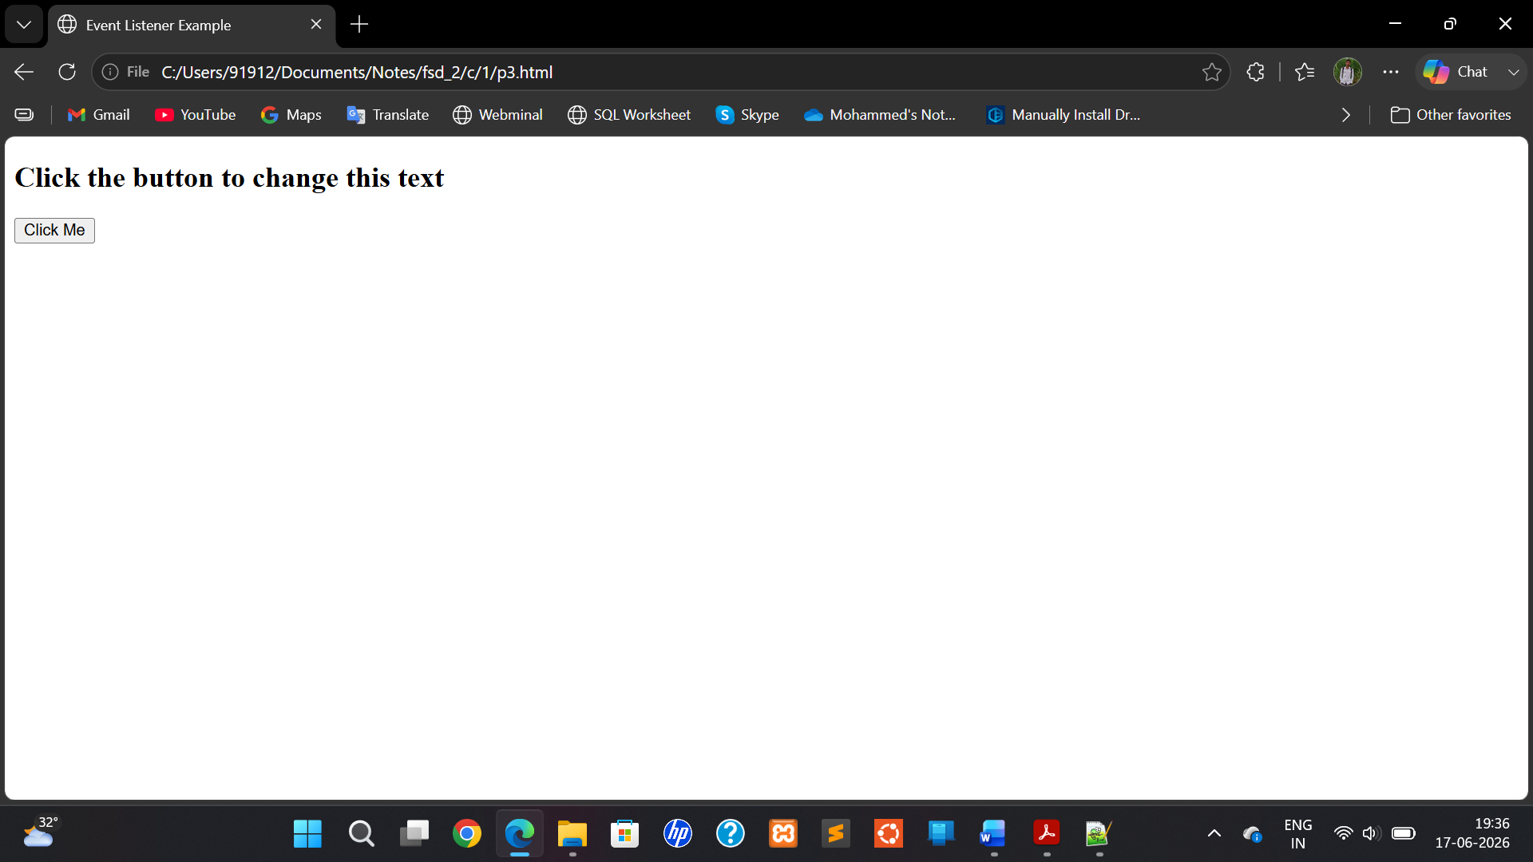

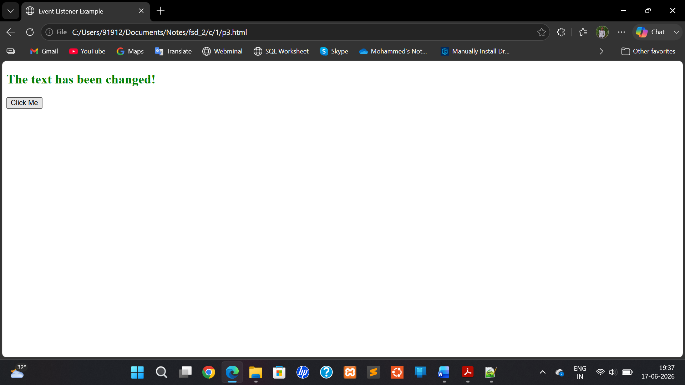

d. write a Java Script program to handle the click events for the HTML button elements
Aim:
To write a Java Script program to handle the click events for the HTML button elements

Description:
In HTML and JavaScript, "click" events are part of a broader category of mouse events. While the most common event is simply click, there are several other mouse-related events that can be applied to <button> elements (or other elements too).

Event | Trigger Description
click | Fires when the button is clicked (pressed and released with the left mouse button).
dblclick | Fires when the button is double-clicked (two quick successive clicks).
mousedown | Fires when the mouse button is pressed down on the button.
mouseup | Fires when the mouse button is released over the button.
mouseenter | Fires when the mouse pointer enters the button (no bubbling).
mouseleave | Fires when the mouse pointer leaves the button (no bubbling).
mouseover | Similar to mouseenter, but it bubbles.
mouseout | Similar to mouseleave, but it bubbles.
contextmenu | Fires when the right mouse button is clicked (usually opens the context menu).

Program:

P1d.html
<!DOCTYPE html>
<html>
<head>
<title>Button Click Events</title>
</head>
<body>
<h2>Click a Button:</h2>
<button id="btn1">Button 1</button>
<button id="btn2">Button 2</button>
<button id="btn3">Button 3</button>
<p id="output">You haven't clicked any button yet.</p>
<script src="script4.js"></script>
</body>
</html>

Script4.js

const btn1 = document.getElementById("btn1"); const btn2 = document.getElementById("btn2"); const btn3 = document.getElementById("btn3"); const output = document.getElementById("output"); btn1.addEventListener("click", function()
{

output.textContent = "You clicked Button 1!"; output.style.color = "blue";
});
btn2.addEventListener("click", function()
{
output.textContent = "You clicked Button 2!"; output.style.color = "green";
});
btn3.addEventListener("click", function()
{
output.textContent = "You clicked Button 3!"; output.style.color = "red";
});

Output:
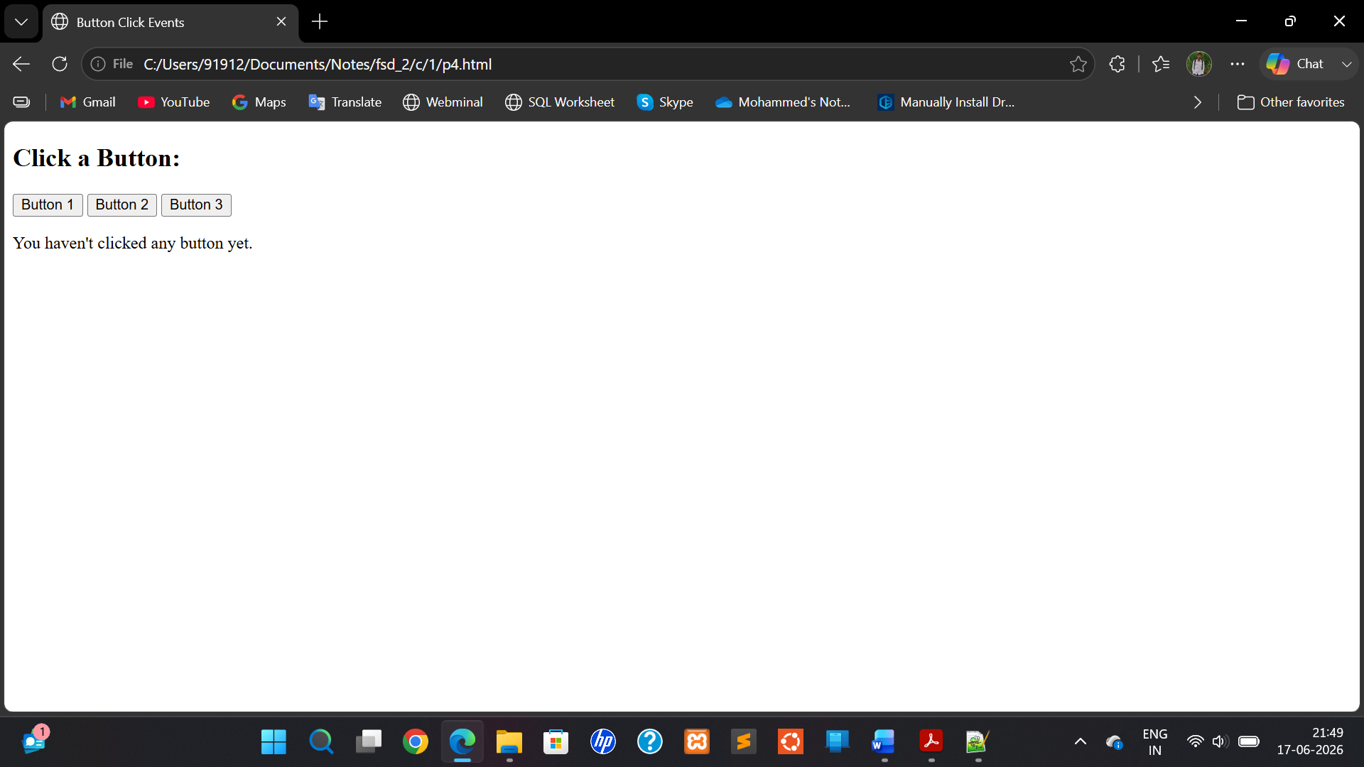
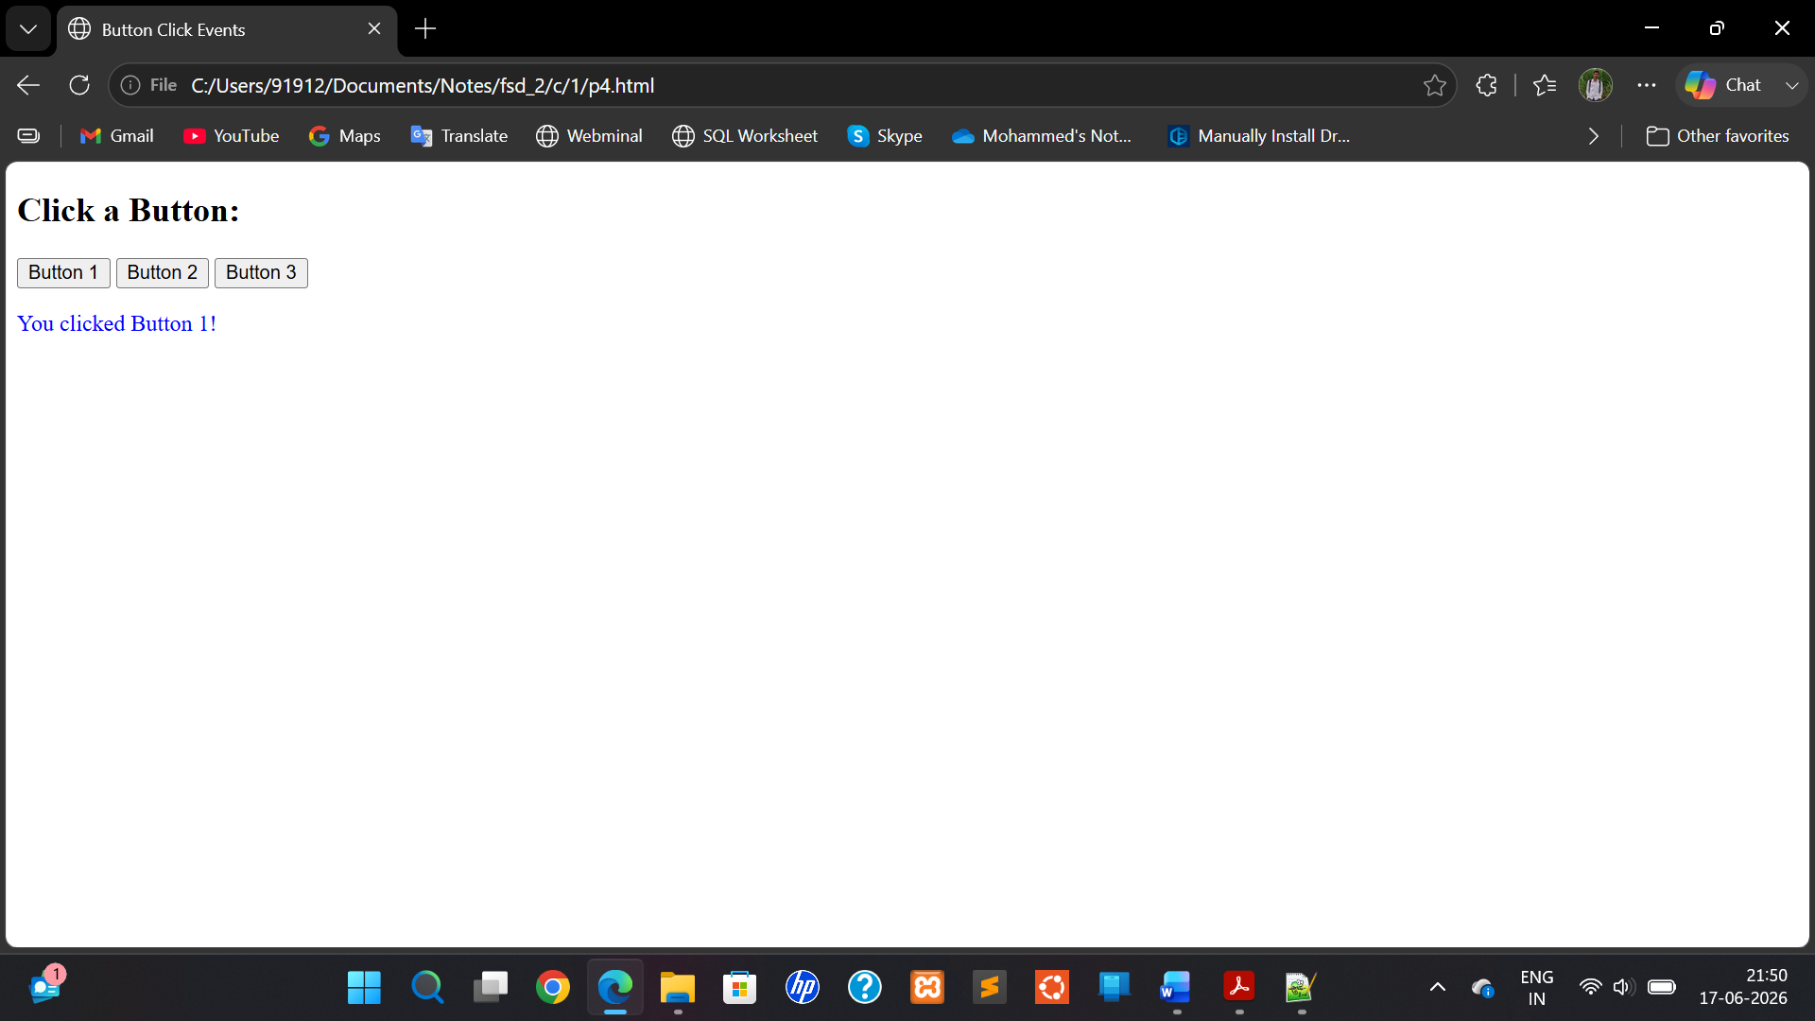

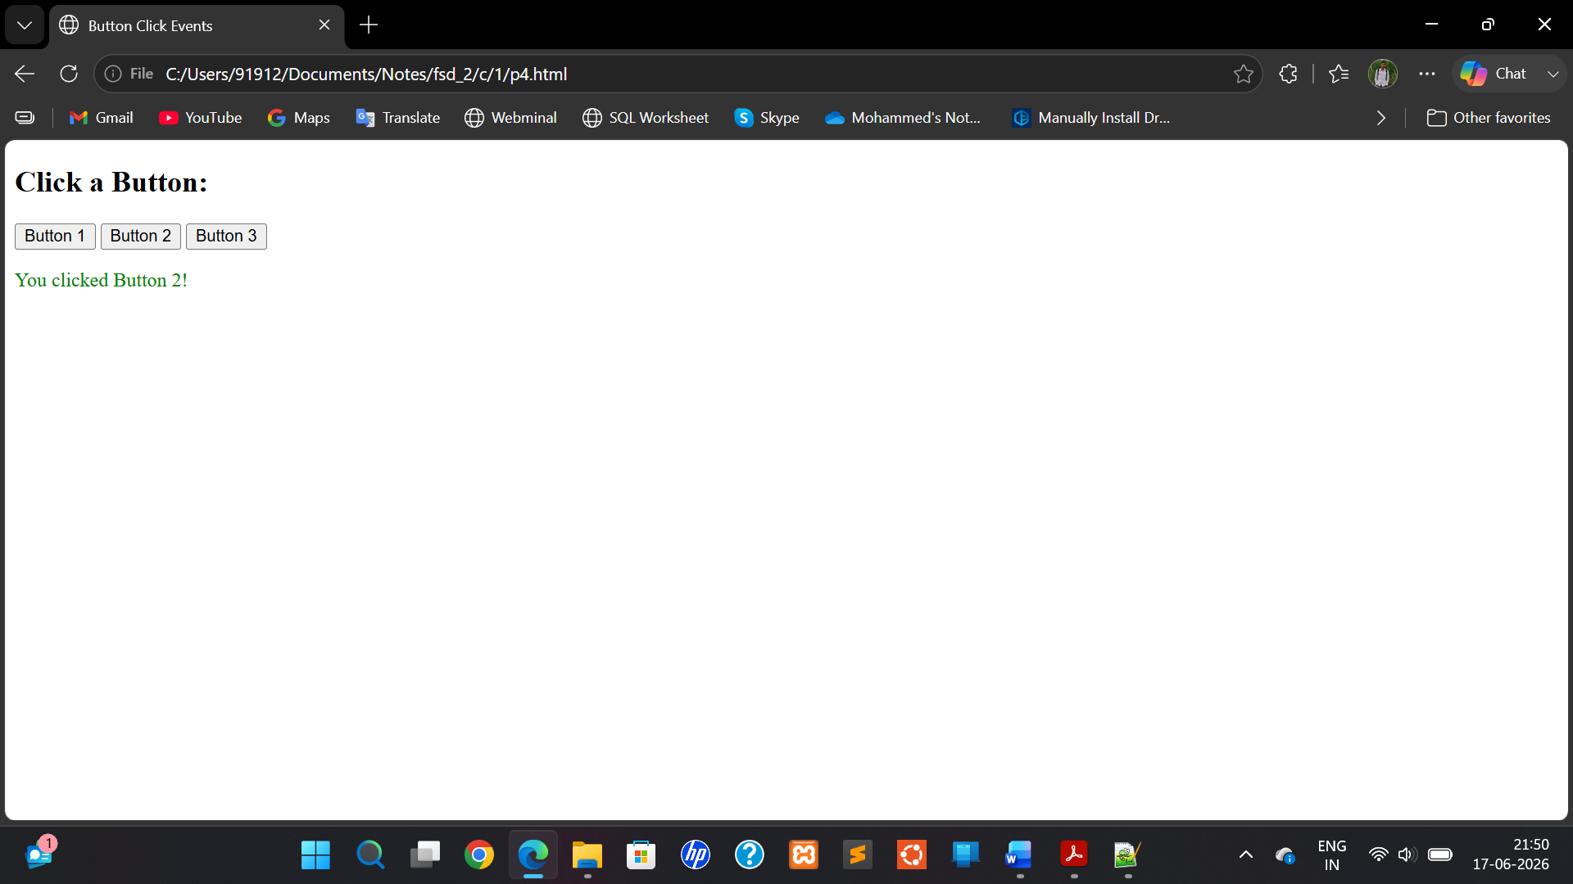

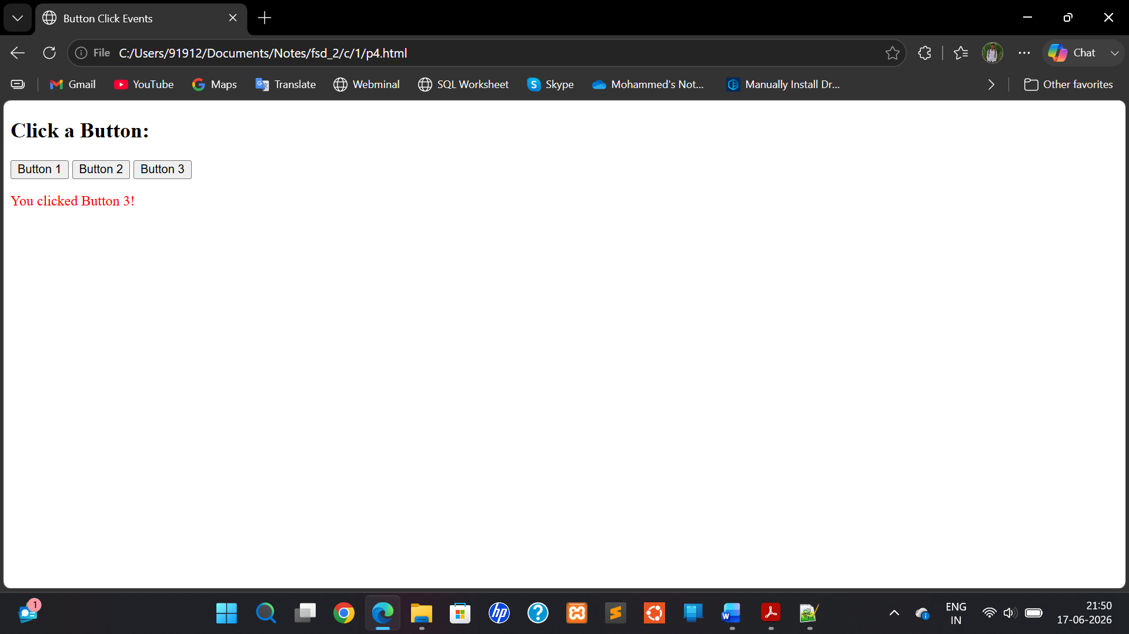

- Write a JavaScript program to With three types of functions
  - Function declaration
  - Function definition
  - Arrow functions Aim:
To Write a JavaScript program to With three types of functions
- Function declaration
- Function definition
- Arrow functions

Description:

Function Declaration
Definition: A function declaration is a standard way to define a named function using the function keyword at the top level of a script or within another function.
Syntax:
function functionName(parameters)
{
// code to execute
}

Function Definition (Expression)
Definition: A function expression defines a function and assigns it to a variable. It can be anonymous or named.
Syntax:
const functionName = function(parameters)
{
// code to execute
};

Arrow Function
Definition: An arrow function is a concise way to write function expressions using the => syntax. Introduced in ES6
Program:
<!DOCTYPE html>
<html>
<head>
<title>Three Types of Functions</title>
</head>
<body>
<h2>JavaScript Function Types</h2>
<button onclick="greet()">Call Function Declaration</button>
<button onclick="sayGoodbye()">Call Function Expression</button>
<button onclick="showThanks()">Call Arrow Function</button>
<p id="output"></p>
<script>
function greet()
{
document.getElementById("output").textContent = "Hello from Function Declaration!";
}
const sayGoodbye = function()
{
document.getElementById("output").textContent = "Goodbye from Function Expression!";
};
const showThanks = () =>
{
document.getElementById("output").textContent = "Thanks from Arrow Function!";
};
</script>
</body>
</html>

Program: (Java Script)

function greet()
{
console.log("Hello from a function declaration!");
}
const sayGoodbye = function()

{
console.log("Goodbye from a function expression!");
};
const sayThanks = () =>
{
console.log("Thanks from an arrow function!");
};
greet(); // Calls the declared function sayGoodbye(); // Calls the function expression sayThanks(); // Calls the arrow function

Output:
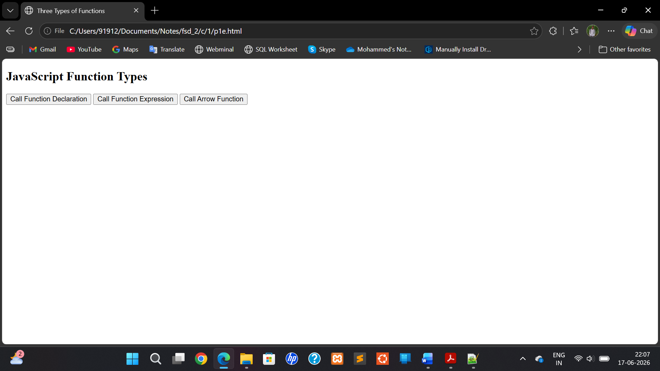

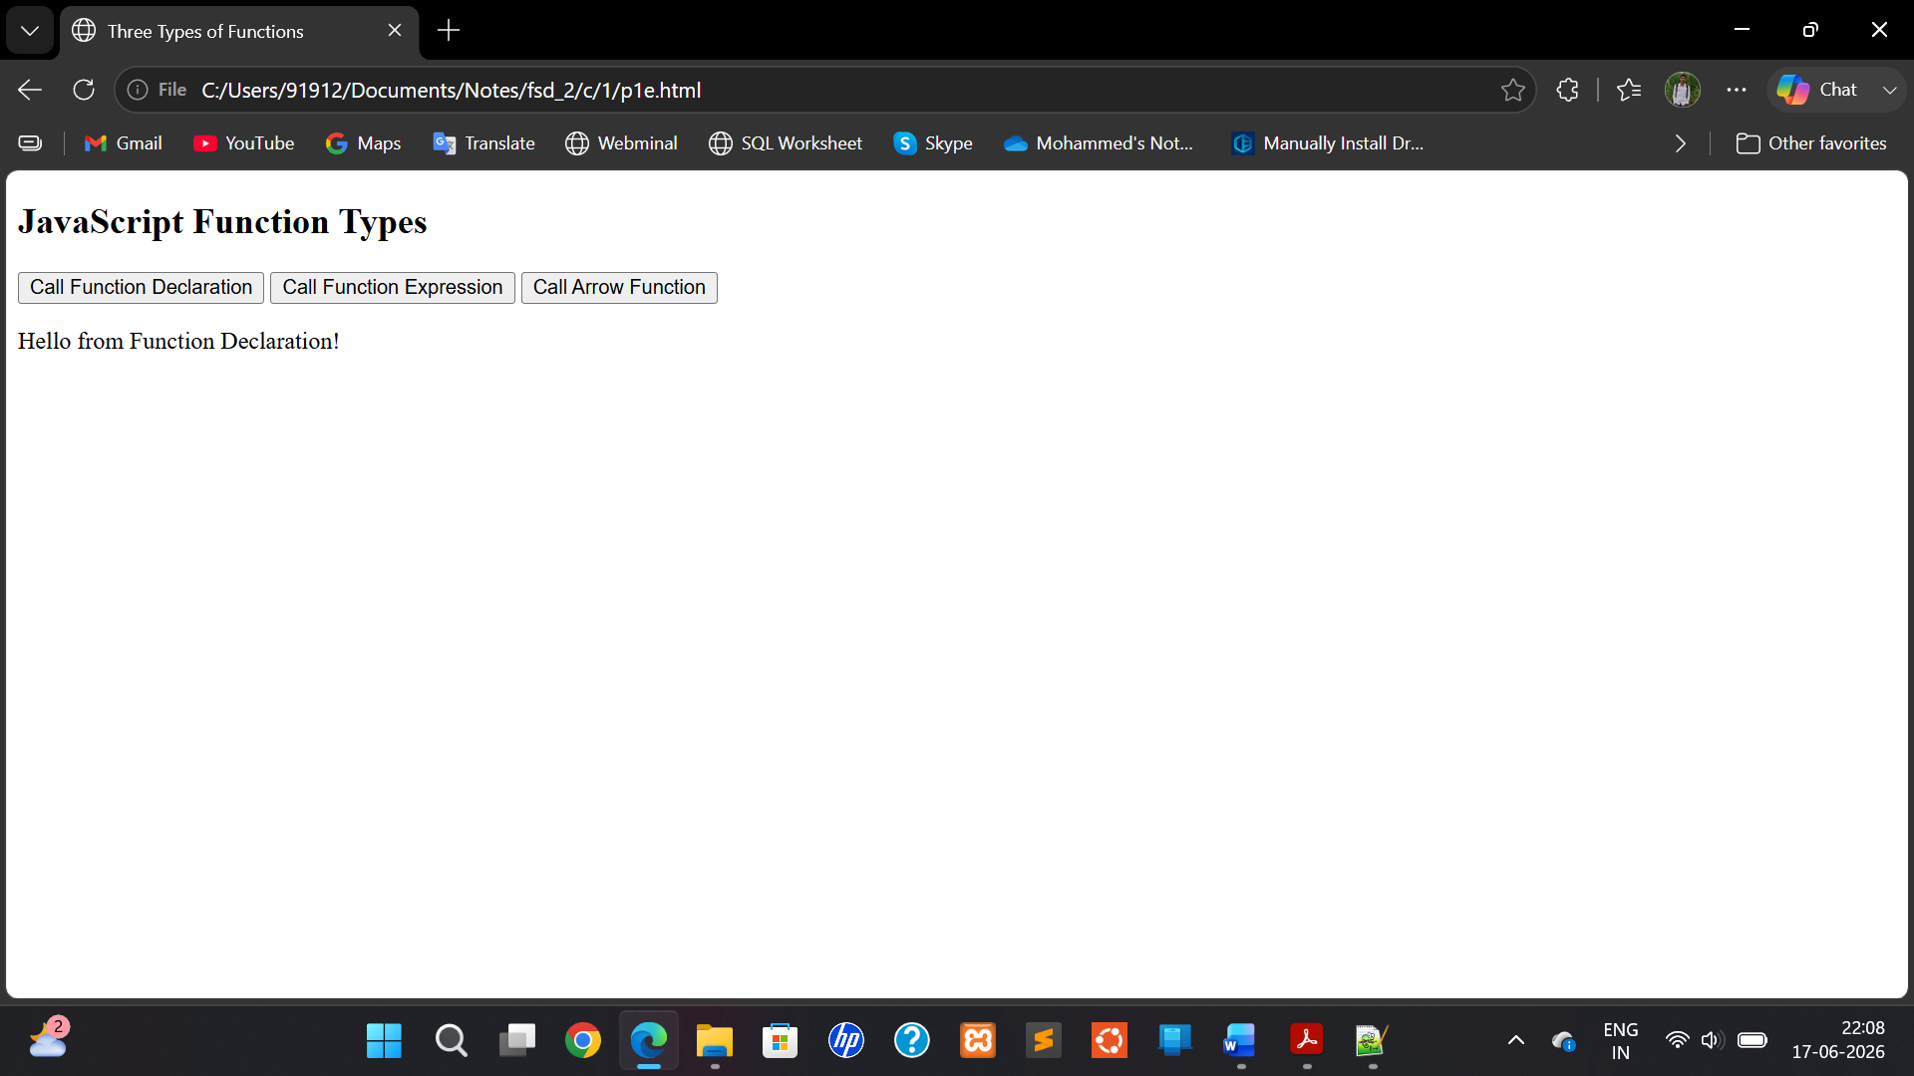

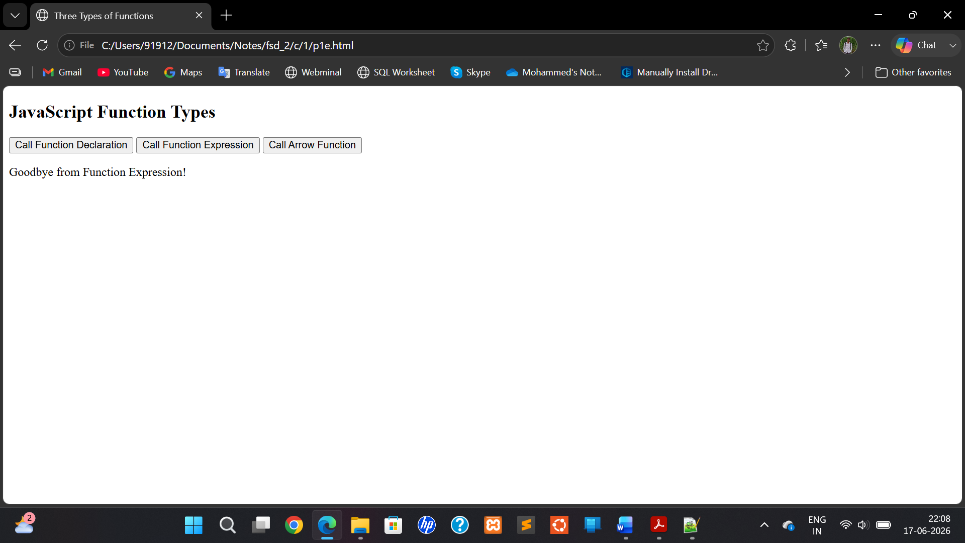

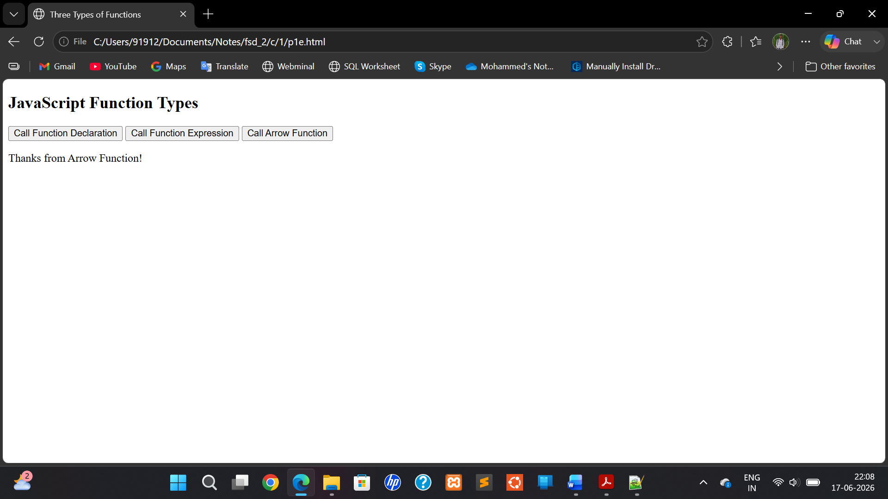

Github index.html program for deployment:
<!DOCTYPE html>
<html>
<head>
<title>JavaScript DOM Lab</title>
</head>
<body>
<h1>Modern JavaScript and DOM Programs</h1>

<ul>
<li><a href="program1.html">Program 1</a></li>
<li><a href="program2.html">Program 2</a></li>
<li><a href="program3.html">Program 3</a></li>
<li><a href="program4.html">Program 4</a></li>
<li><a href="program5.html">Program 5</a></li>
</ul>
</body>
</html>

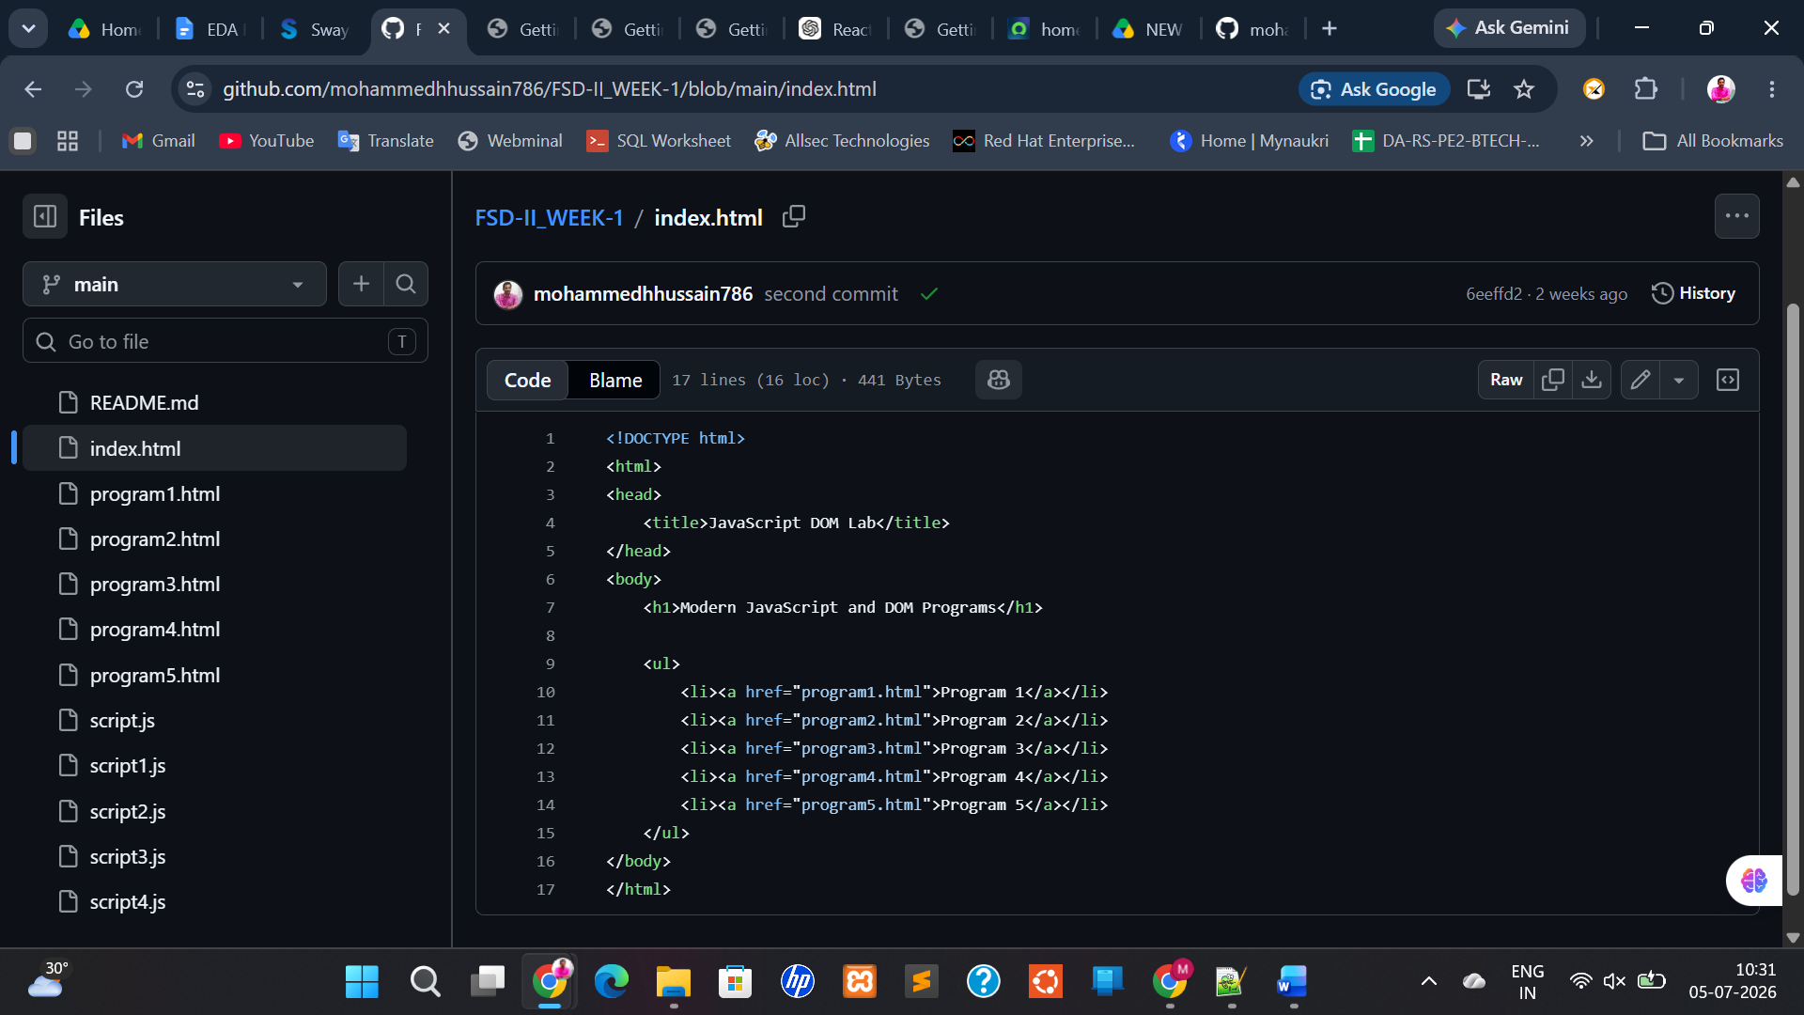

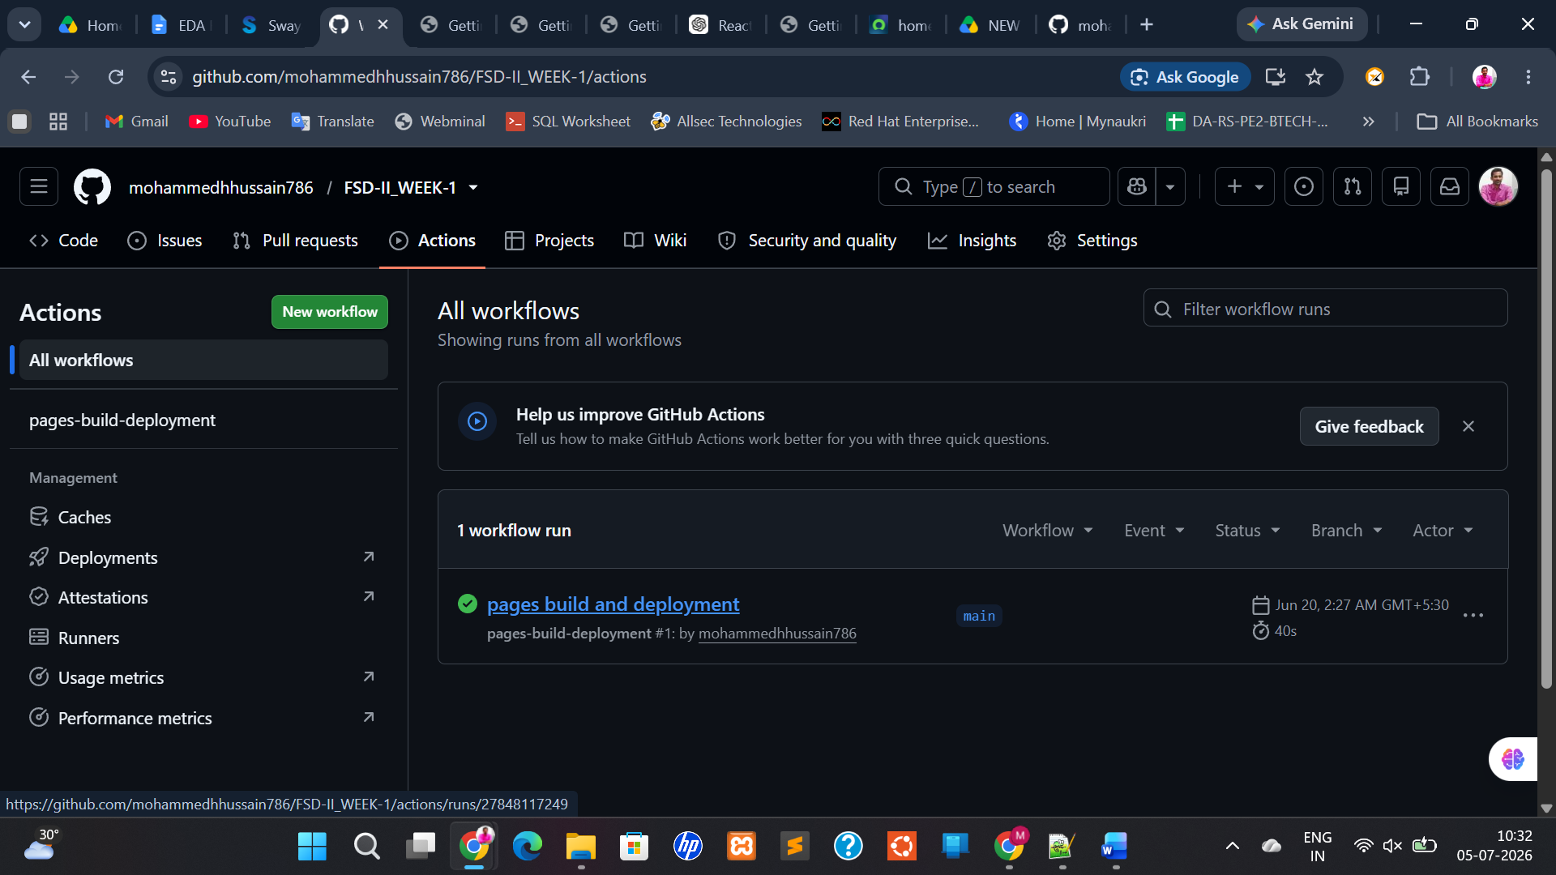

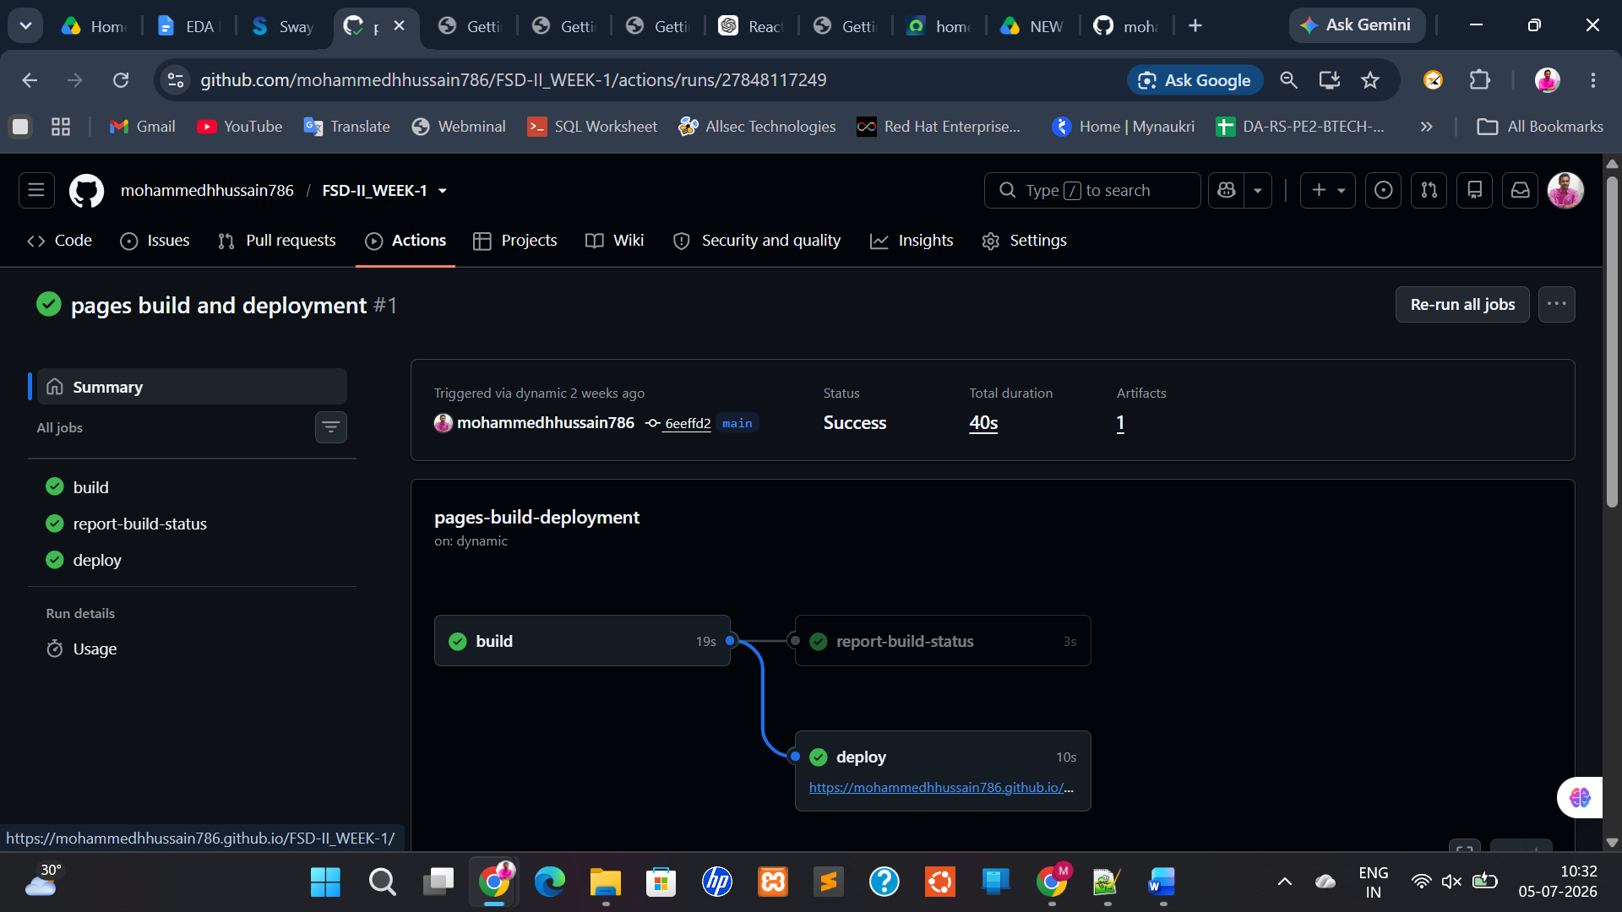

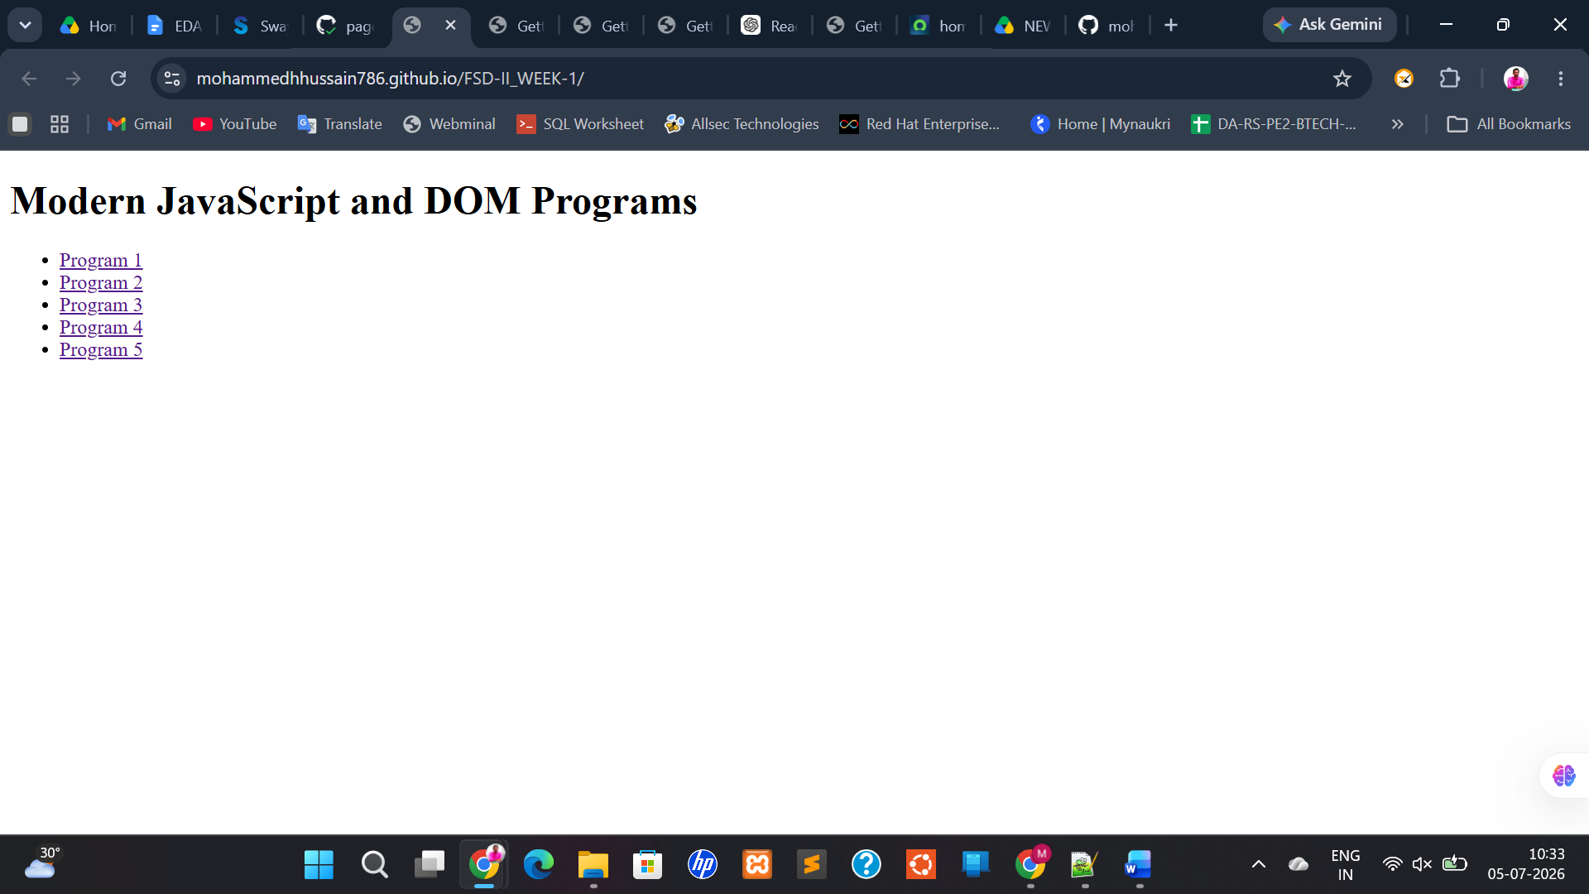

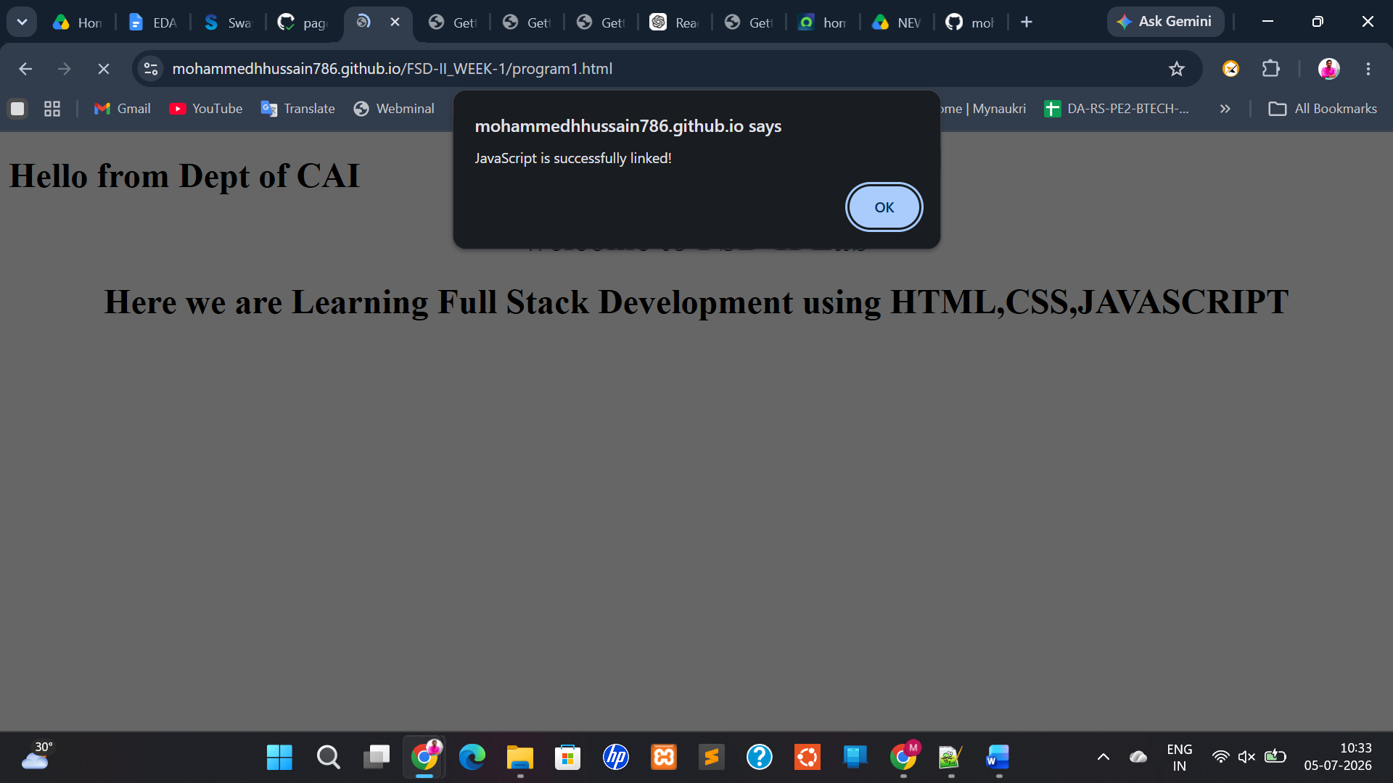

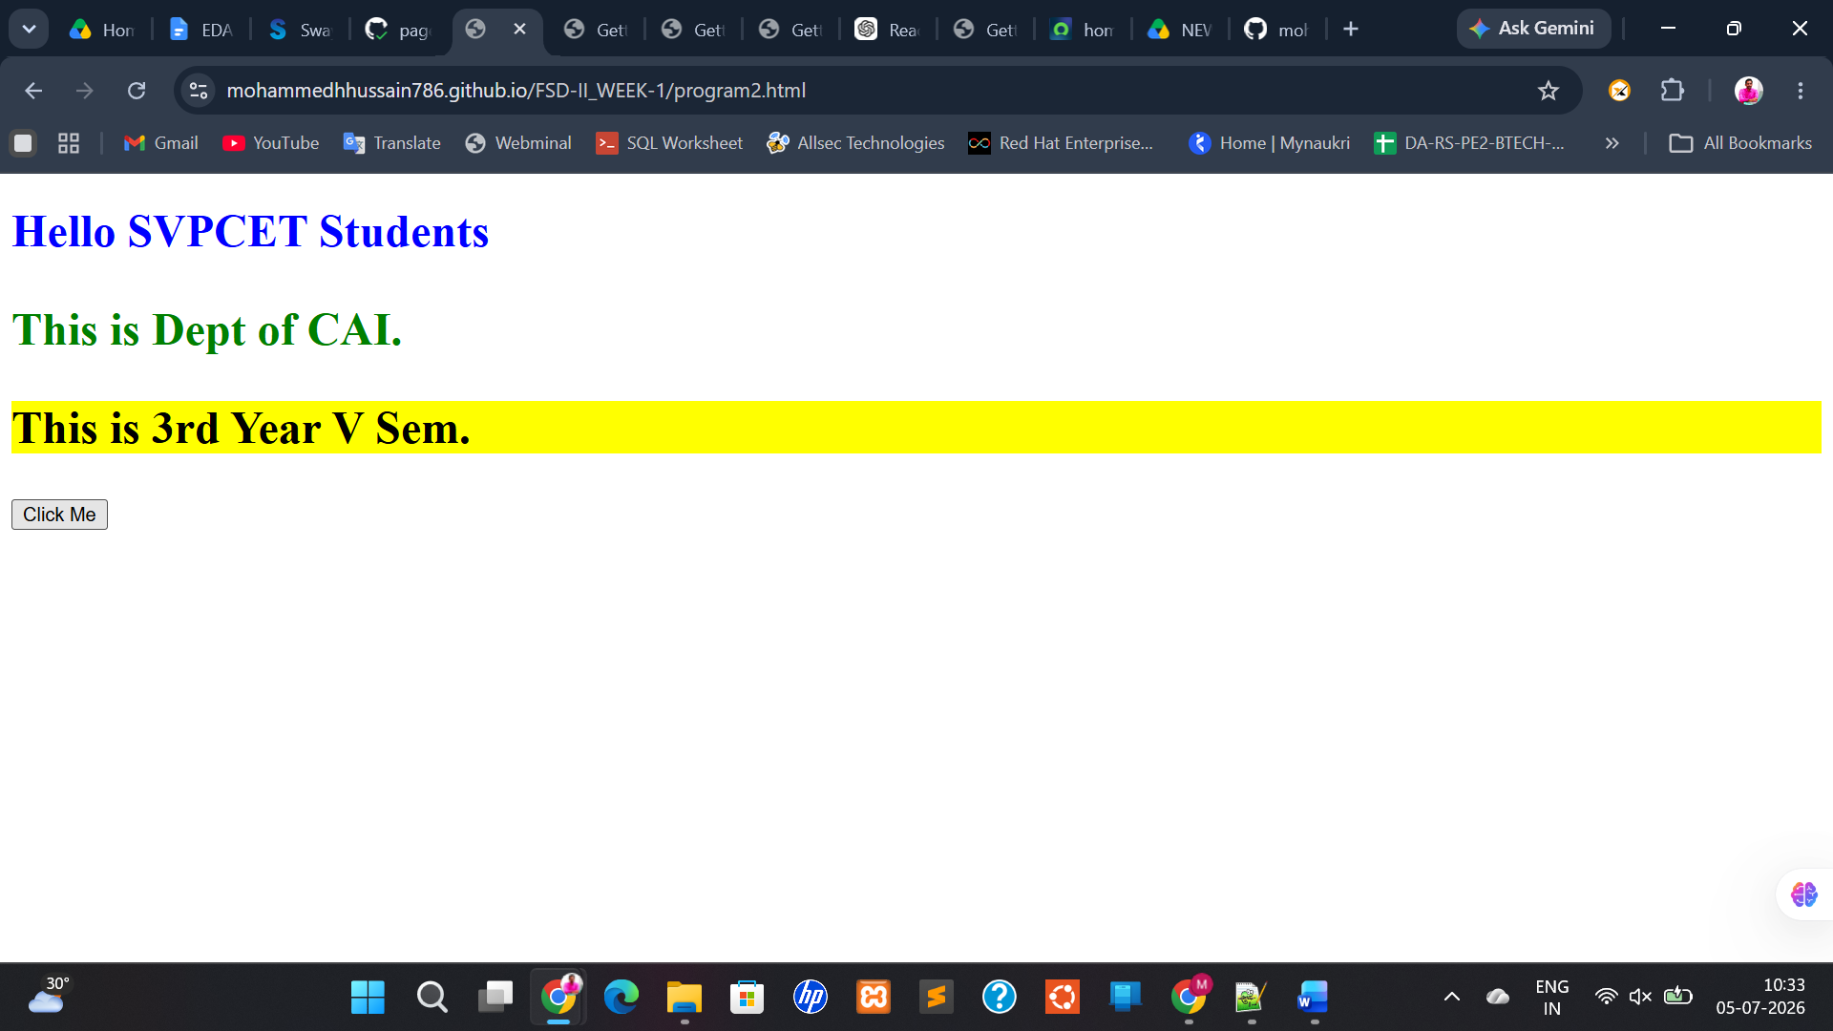

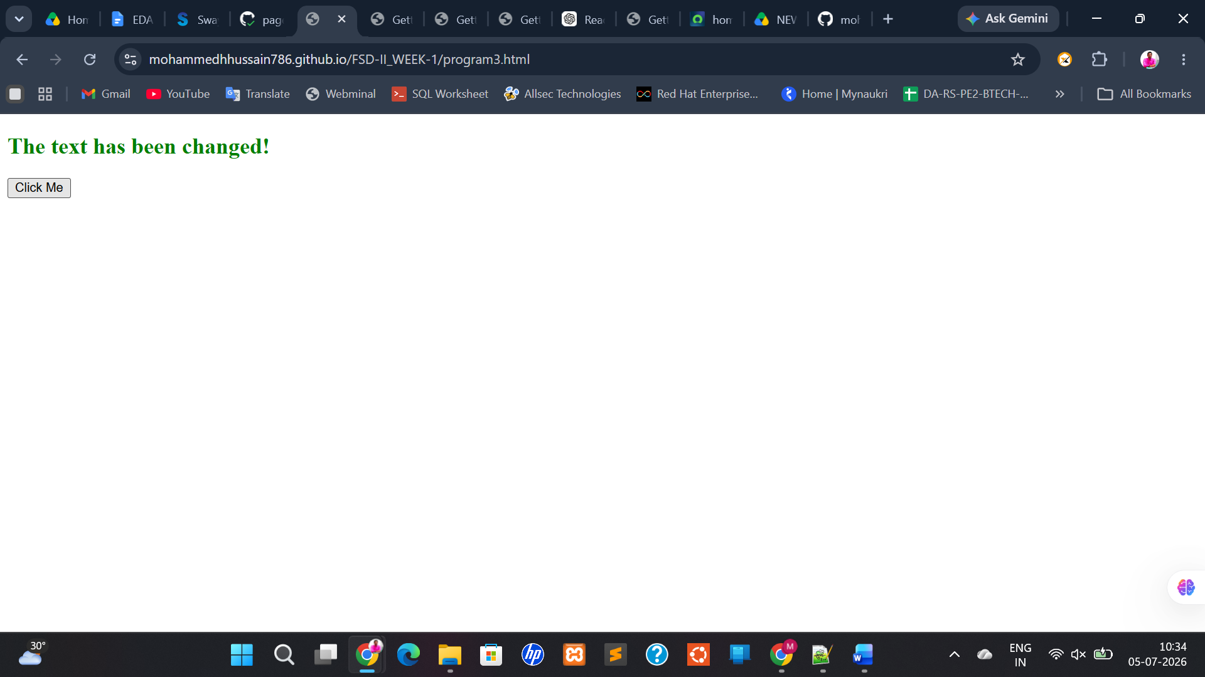

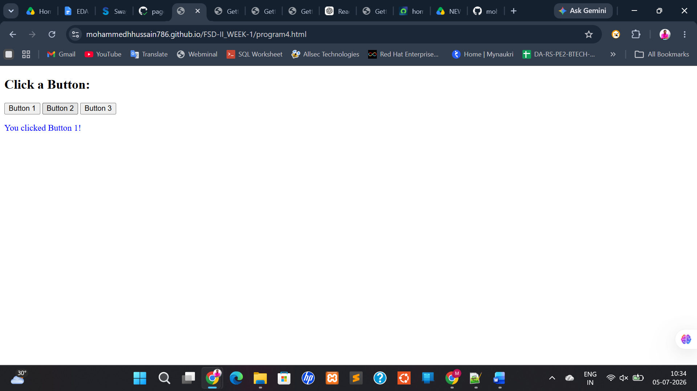

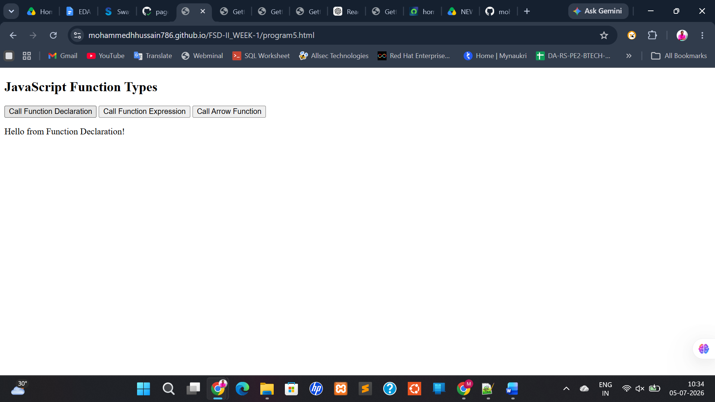

2. Basics of React. Js
React.js Basics
Step 1: Install Required Software
1. Install Node.js
React requires Node.js.
Download:
Node.js Official Website
Install the LTS Version.
After installation, open Command Prompt and verify:
node -v
Example Output:
v22.0.0
Check npm:
npm -v
Example:
10.5.0
Step 2: Install VS Code
Download:
Visual Studio Code
Install it.
Step 3: Create React Project
Open Command Prompt.
Move to Desktop:
cd Desktop
Create React App:
npx create-react-app react-basics
Wait until installation completes.
Move into project:
cd react-basics
Start project:
npm start
Browser opens:
http://localhost:3000
Project Structure
Inside VS Code:
react-basics
│
├── src
│ ├── App.js
│ ├── index.js
│
├── public
├── package.json
Most coding happens in:
src/App.js

a. Write a React program to implement a counter button using react class components
b. Write a React program to implement a counter button using react functional
components
c. Write a React program to handle the button click events in functional component
d. Write a React program to conditionally render a component in the browser
e. Write a React program to display text using String literals

  - Write a React program to implement a counter button using react class components

AIM:
To Write a React program to implement a counter button using react class components

Description:

When creating a React component, the component's name must start with an upper case letter. The component has to include the extends React.Component statement, this statement creates an inheritance to React.Component, and gives your component access to React.Component's functions.
The component also requires a render() method, this method returns HTML.

Syntax:
class Car extends React.Component
{
render()
{
return <h2>Hi, I am a Lakshman</h2>;
}
}
Program:
App.js
import React, { Component } from "react";

class App extends Component {

constructor() {
super();

this.state = {
count: 0
};
}

increment = () => {
this.setState({
count: this.state.count + 1
});
};

render() {
return (
<div>
<h1>Class Counter</h1>

<h2>{this.state.count}</h2>

<button onClick={this.increment}>
Increment
</button>
</div>
);
}
}

export default App;

Output:

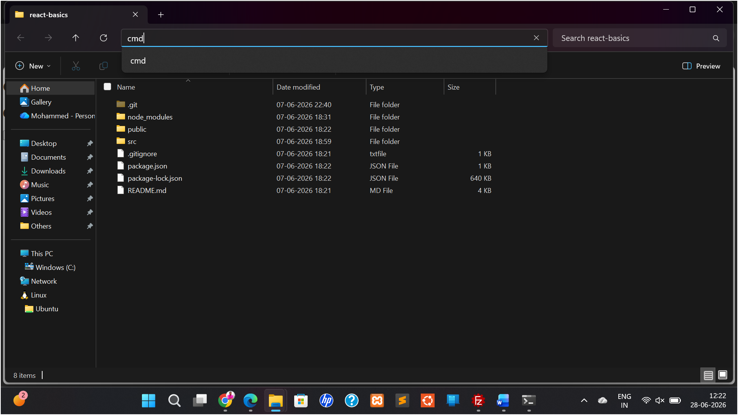

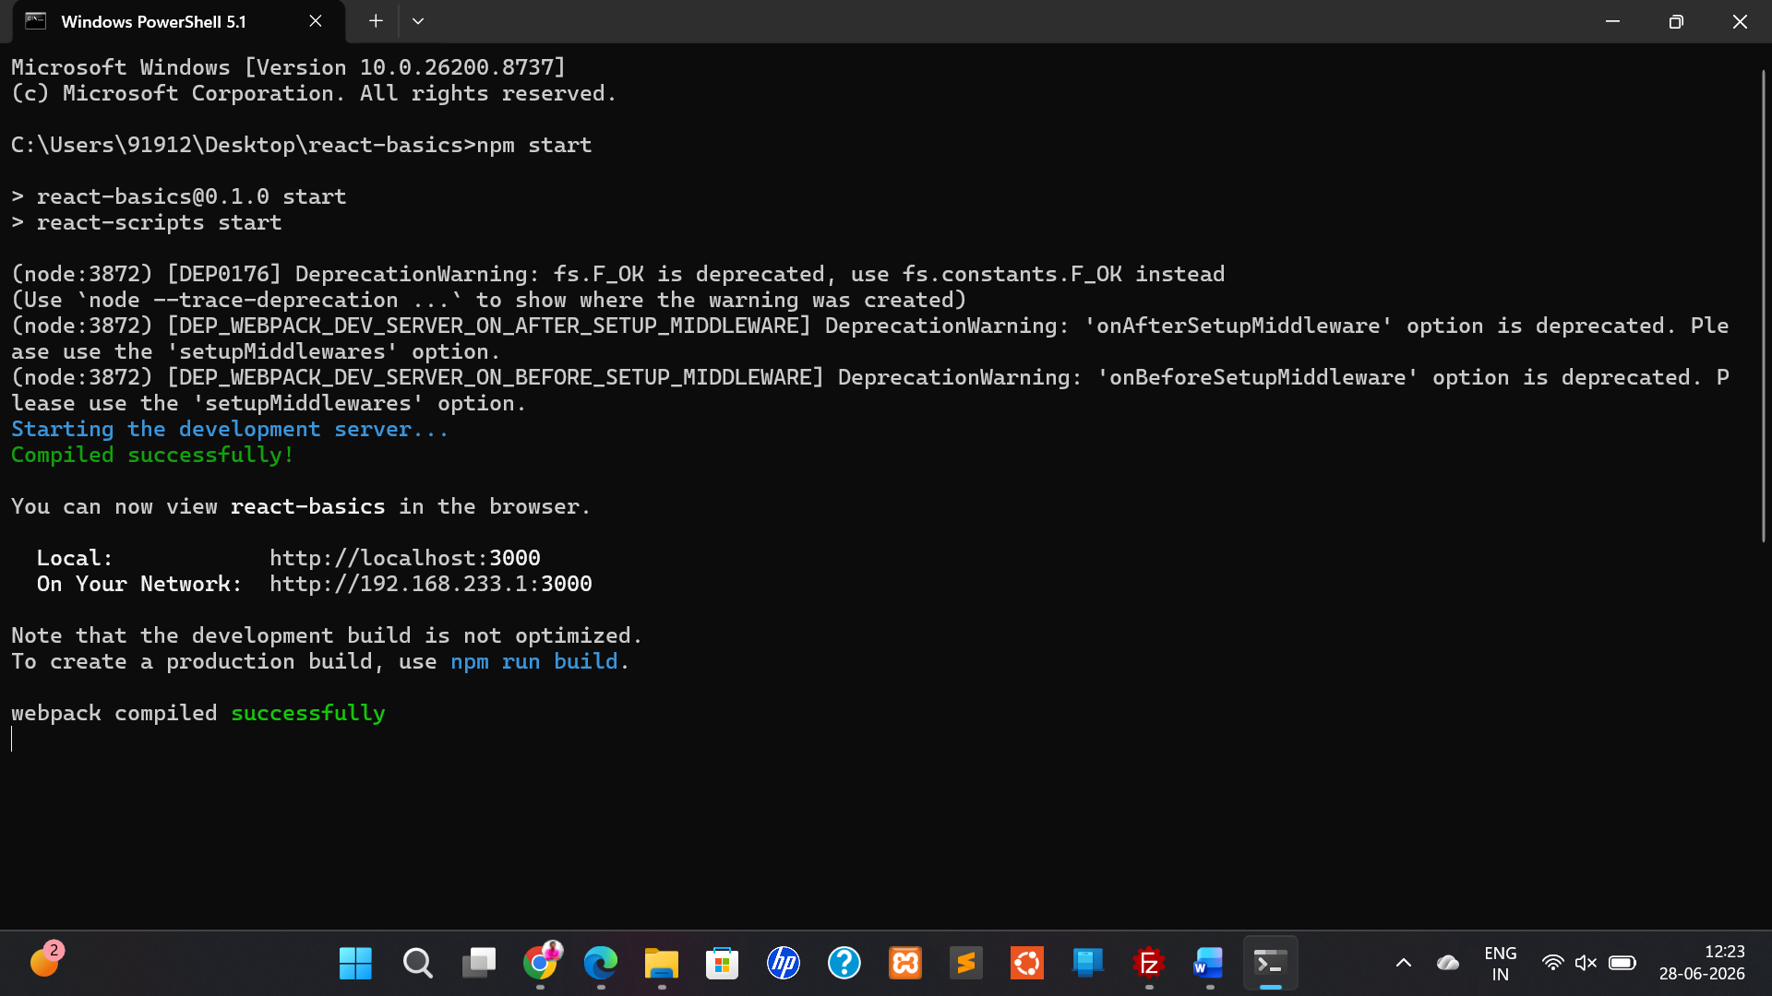

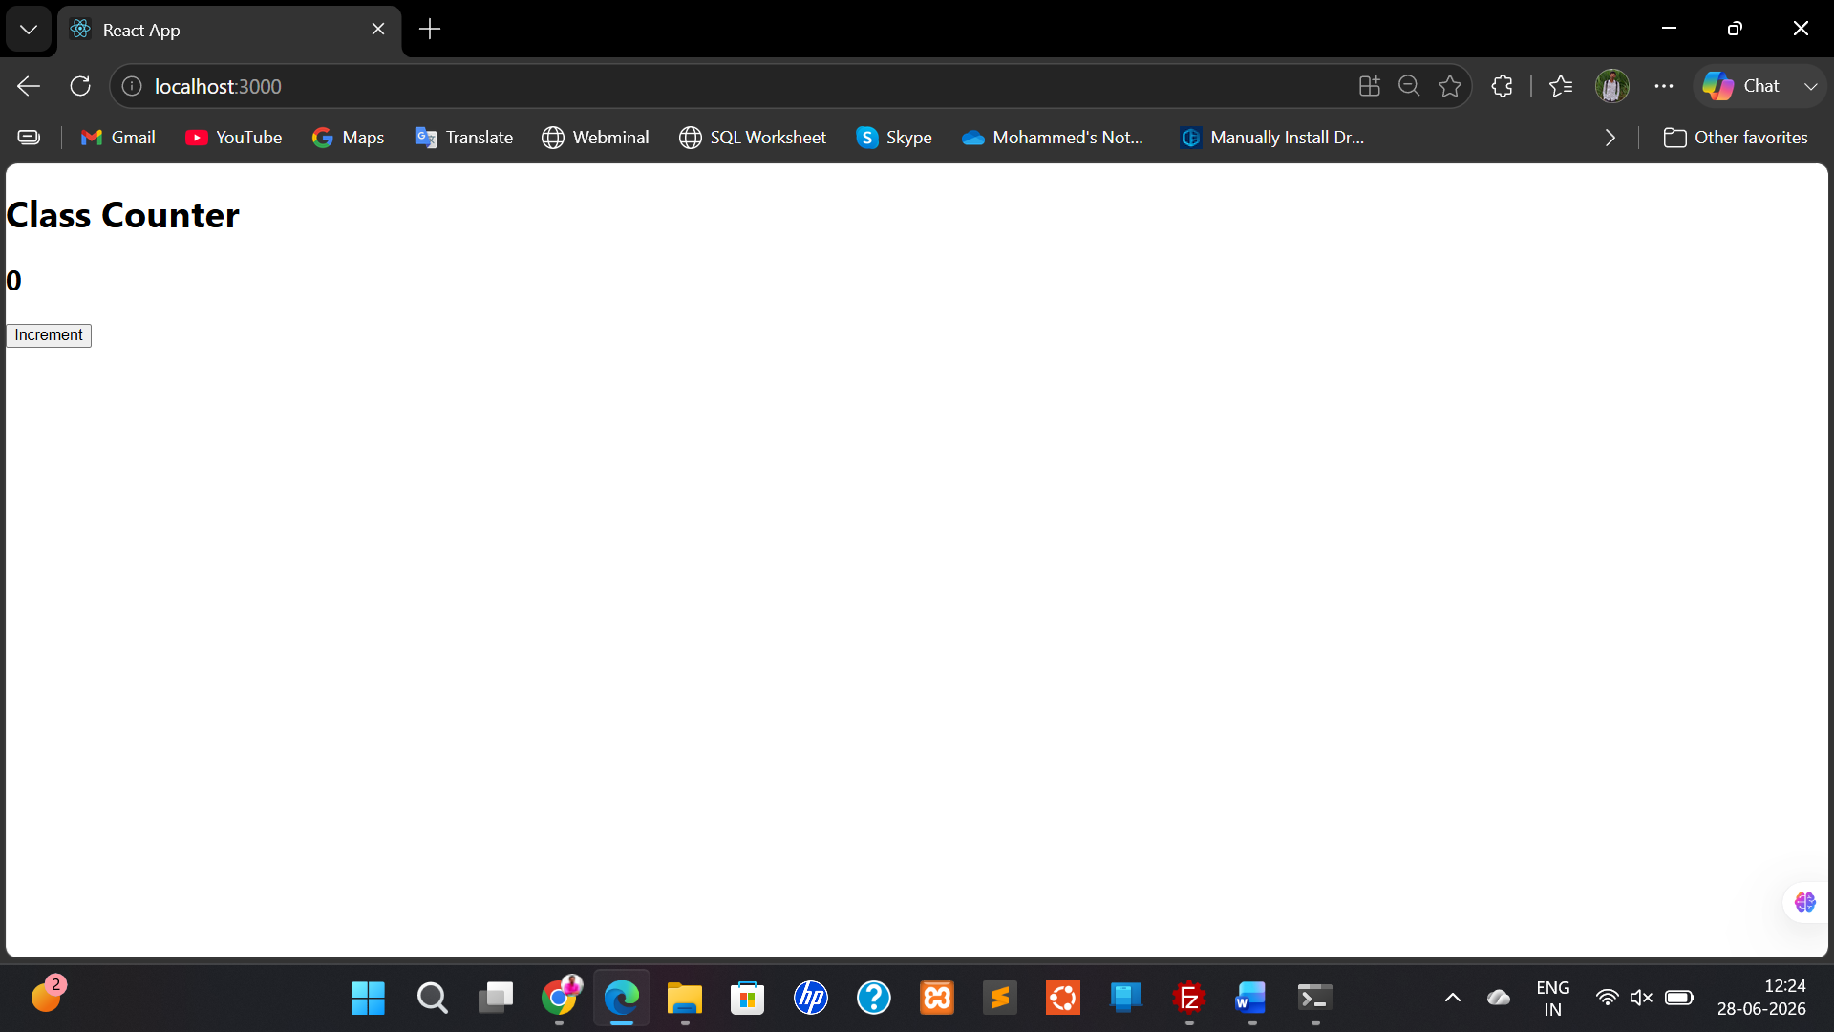

  - Write a React program to implement a counter button using react functional components

Aim:
To Write a React program to implement a counter button using react functional components

Description:
React functional components are JavaScript functions that accept an object of properties (known as props) as an argument and return a React element, which describes what should be rendered on the user interface.

Syntax:
Basic Function Component
function MyComponent(props)
{

return (
<div>
<h1>Hello, {props.name}!</h1>
</div>
);
}

Arrow Function Component
const MyComponent = (props) => { return (
<div>
<h1>Hello, {props.name}!</h1>
</div>
);
};

Program:
import React, { useState } from "react";

function App() {

const [count, setCount] = useState(0);

const increment = () => {
setCount(count + 1);
};

return (
<div>
<h1>Functional Counter</h1>

<h2>{count}</h2>

<button onClick={increment}>
Increment
</button>
</div>
);
}

export default App;

Output:

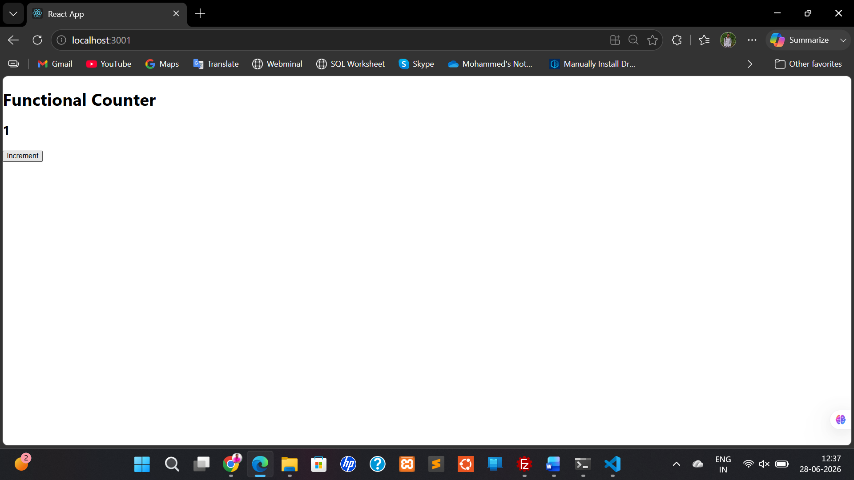

  - Write a React program to handle the button click events in functional component

Definition of Button Click Events in Functional Components
- Functional Component
A React component defined as a function, using hooks like useState to manage state.
- Button Element (<button>)
An HTML element used to trigger an action when clicked.

onClick Event Handler
A special React prop used to listen for and respond to a click event.
<button onClick={handleClick}>Click Me</button>

Event Handler Function
A function you define inside the component that executes when the button is clicked.

const handleClick = () => { console.log("Button clicked!");
};

State Management with useState
A React hook used to store and update component state (e.g., click count or message).
const [count, setCount] = useState(0);

Connecting Button to Logic
Combine the <button> with an onClick and update the state inside the handler:
<button onClick={() => setCount(count + 1)}>Click Me</button>

Rendering Updated Output
React re-renders the component when state changes, showing updated values:
<p>You clicked {count} times</p>

Program: APP.js
import React from "react";

function App() {

const handleClick = () => {
alert("Button Clicked");
};

return (
<div>
<h1>Button Event Example</h1>

<button onClick={handleClick}>
Click Me
</button>
</div>
);
}

export default App;

Output:
Steps:
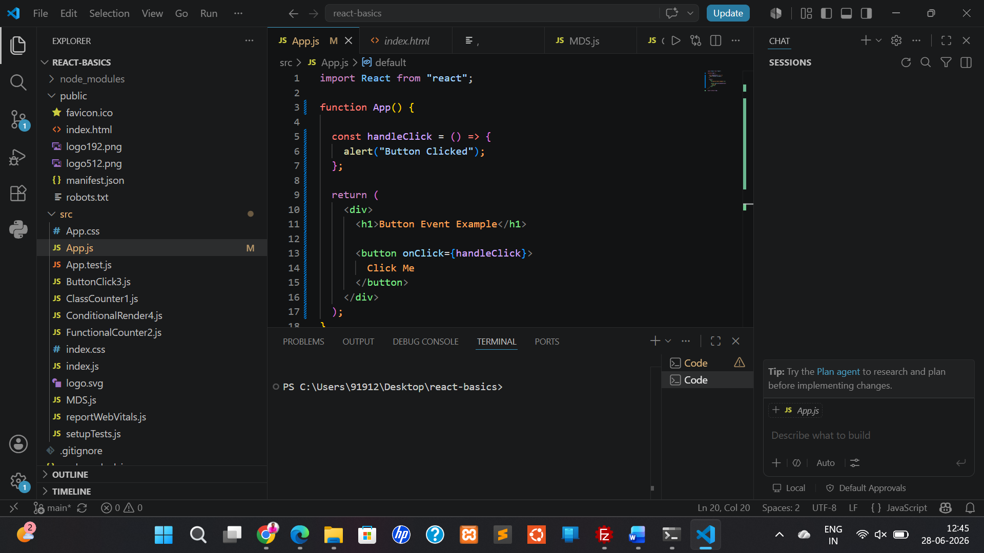

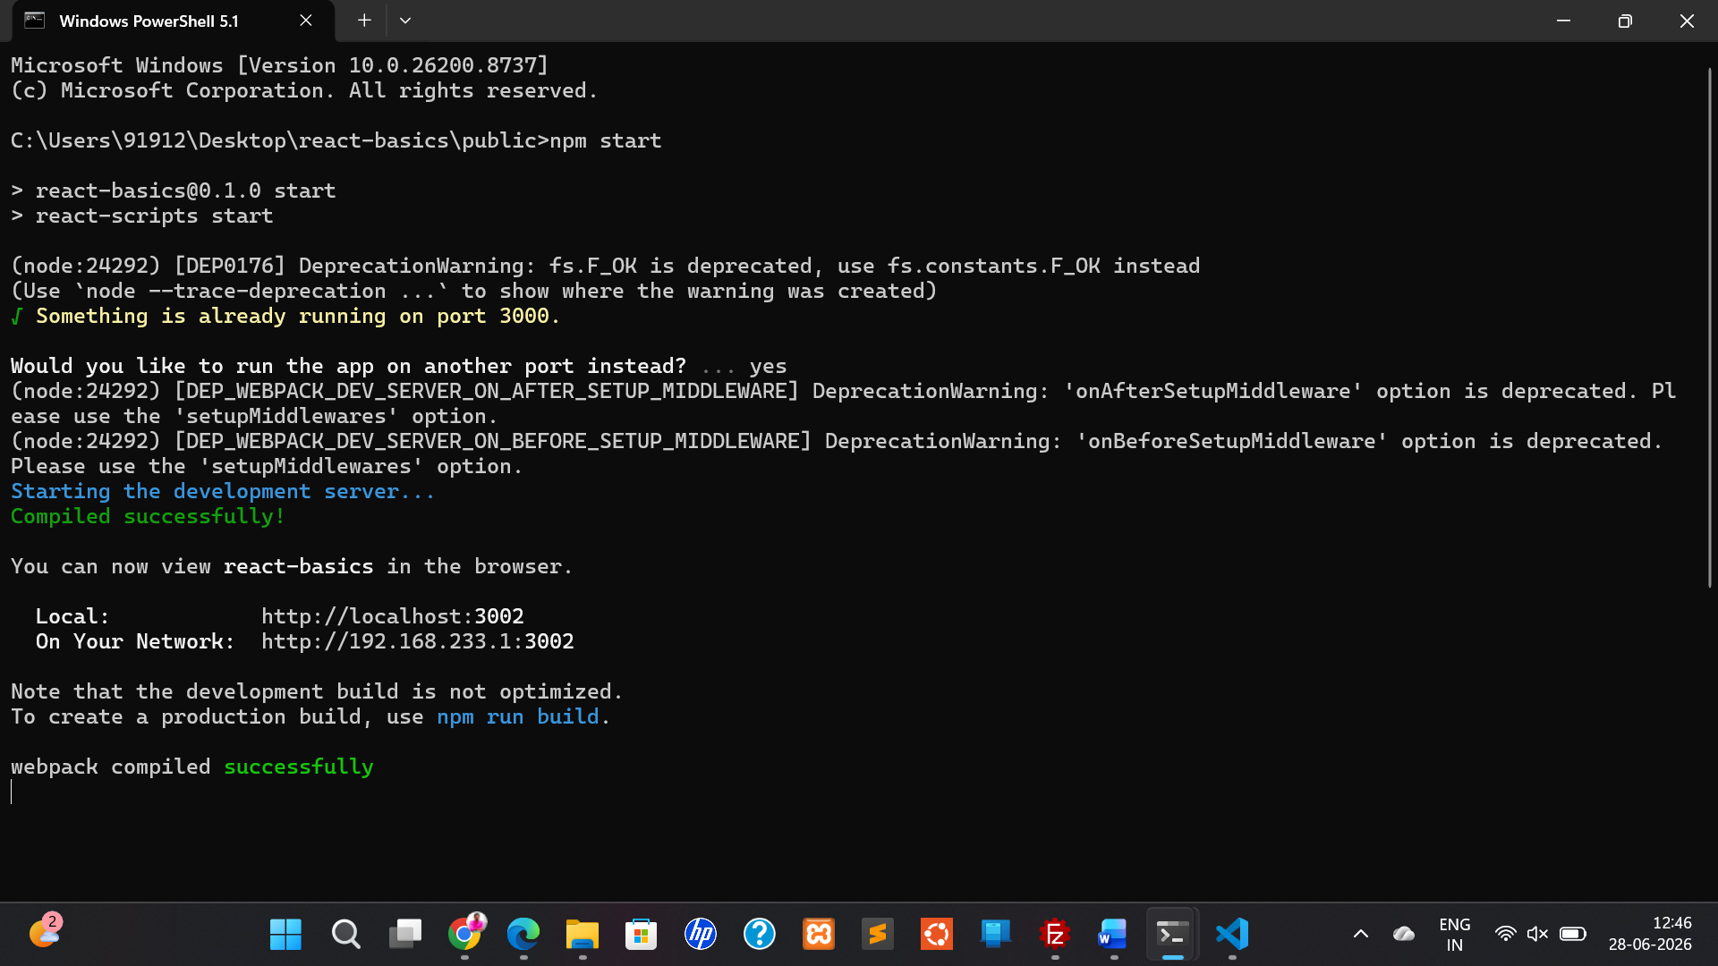

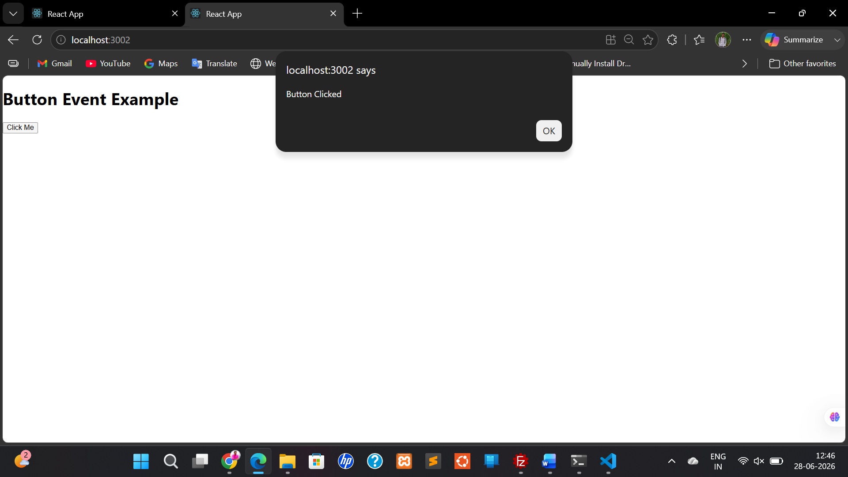

  - Write a React program to conditionally render a component in the browser
Aim: To Write a React program to conditionally render a component in the browser
Description:
Conditional rendering in React means displaying (or hiding) components based on a condition, such as user actions, state, or props. It allows your UI to dynamically change depending on application logic.

Program:
App.js
import React, { useState } from "react";

function App() {

const [loggedIn, setLoggedIn] = useState(false);

return (
<div>

<h1>Conditional Rendering</h1>

{
loggedIn
? <h2>Welcome User</h2>
: <h2>Please Login</h2>
}

<button
onClick={() => setLoggedIn(!loggedIn)}
>
Toggle
</button>

</div>
);
}

export default App;

Output:

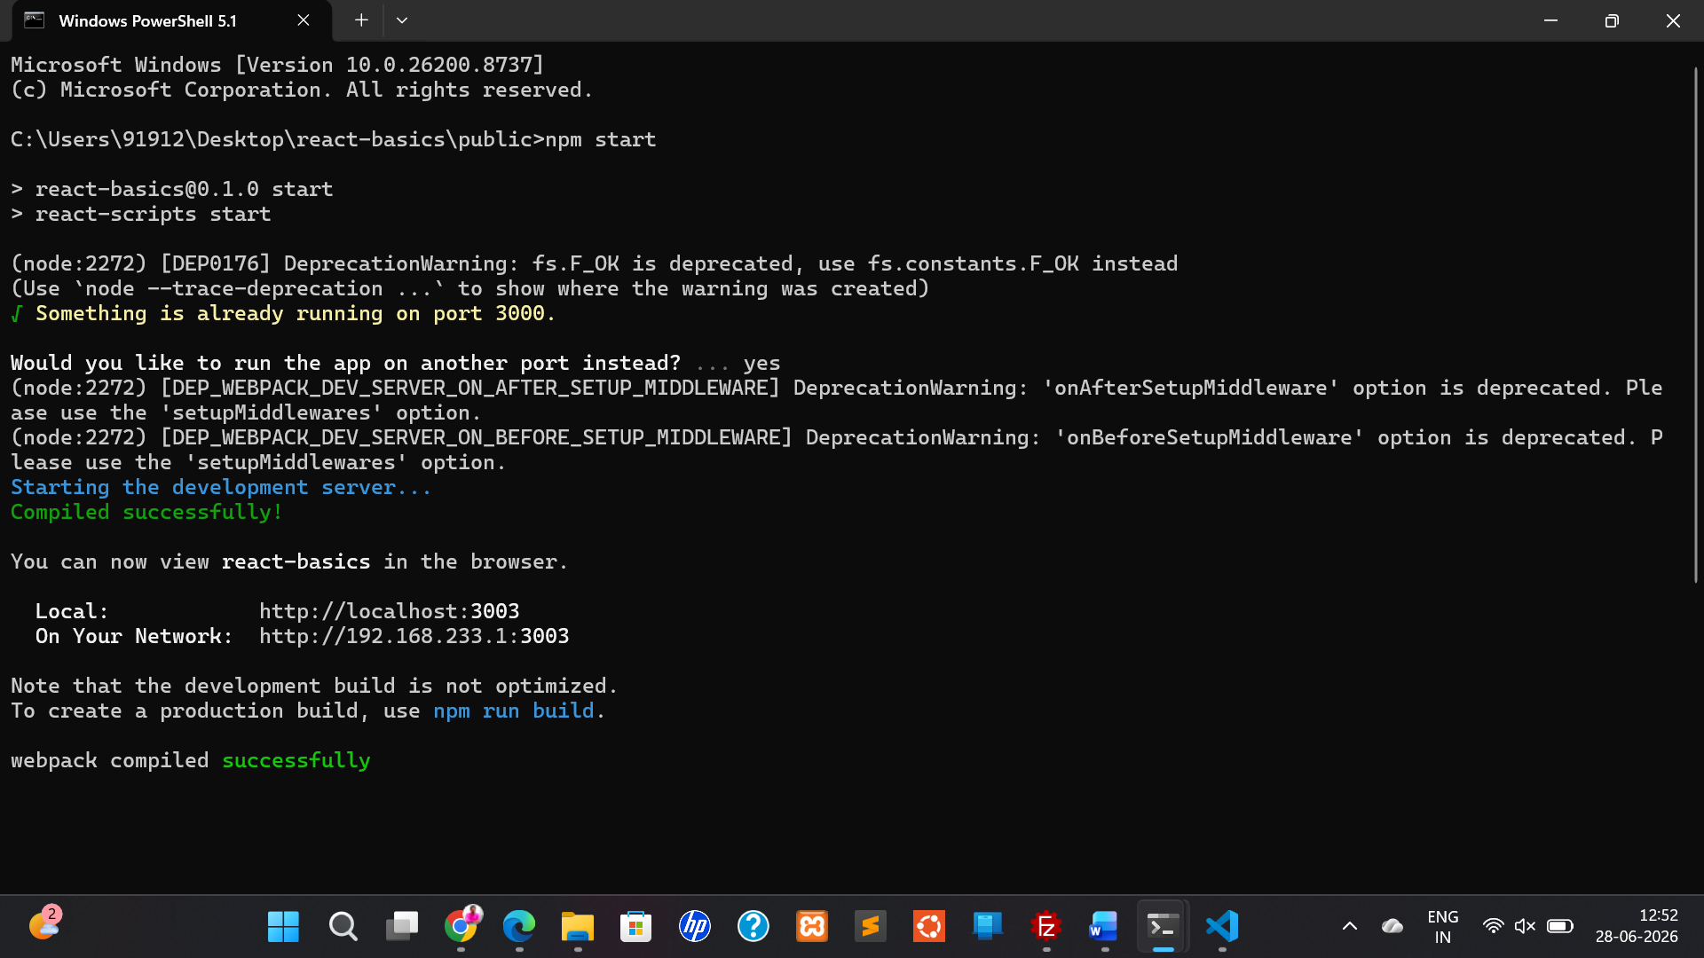
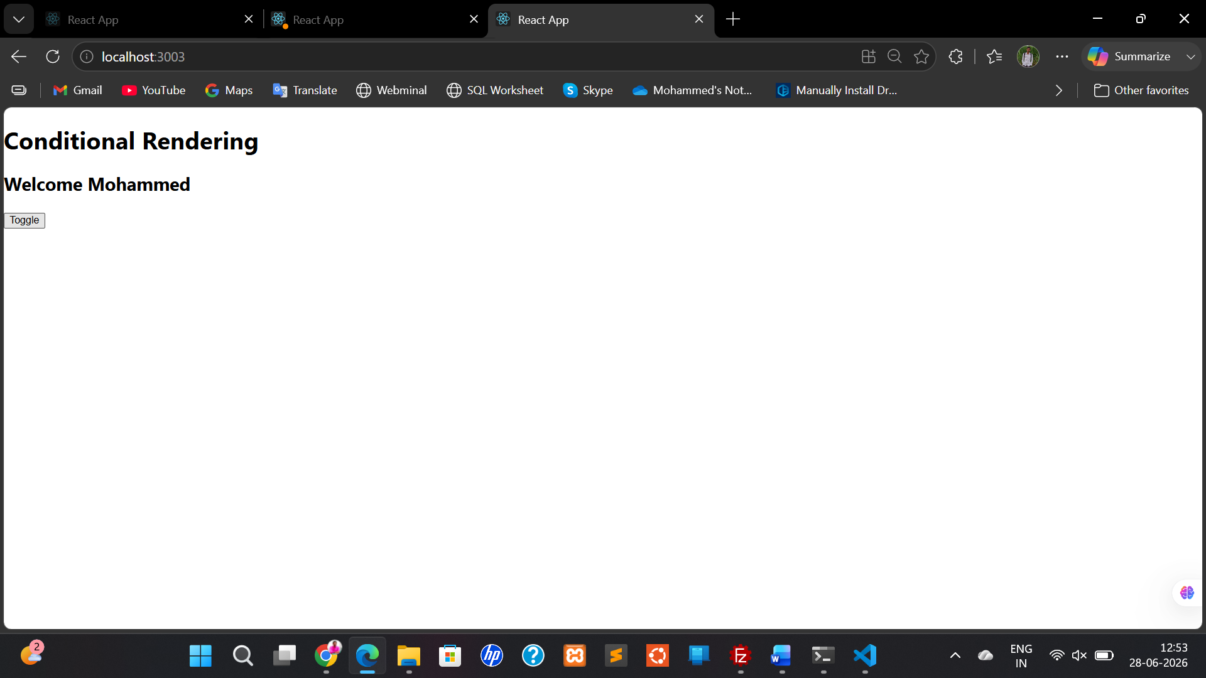

  - Write a React program to display text using String literals

Aim
To develop a React.js application that displays text using string literals within a functional component.

Description
String literals are fixed sequences of characters enclosed in single (' ') or double (" ") quotes. In React, string literals can be assigned to variables and displayed inside JSX using curly braces ({}). This approach allows developers to manage and render dynamic or static text efficiently. In this experiment, a functional component is created to display multiple text messages using string literal variables.

Source code:

import React from "react";

function App() {

const message = "Welcome to React JS";
const course = "React Basics";
const college = "SVPCET";

return (
<div style={{ textAlign: "center", marginTop: "50px" }}>
<h1>Display Text using String Literals</h1>

<h2>{message}</h2>
<h3>{course}</h3>
<h4>{college}</h4>
</div>
);
}

export default App;

output:

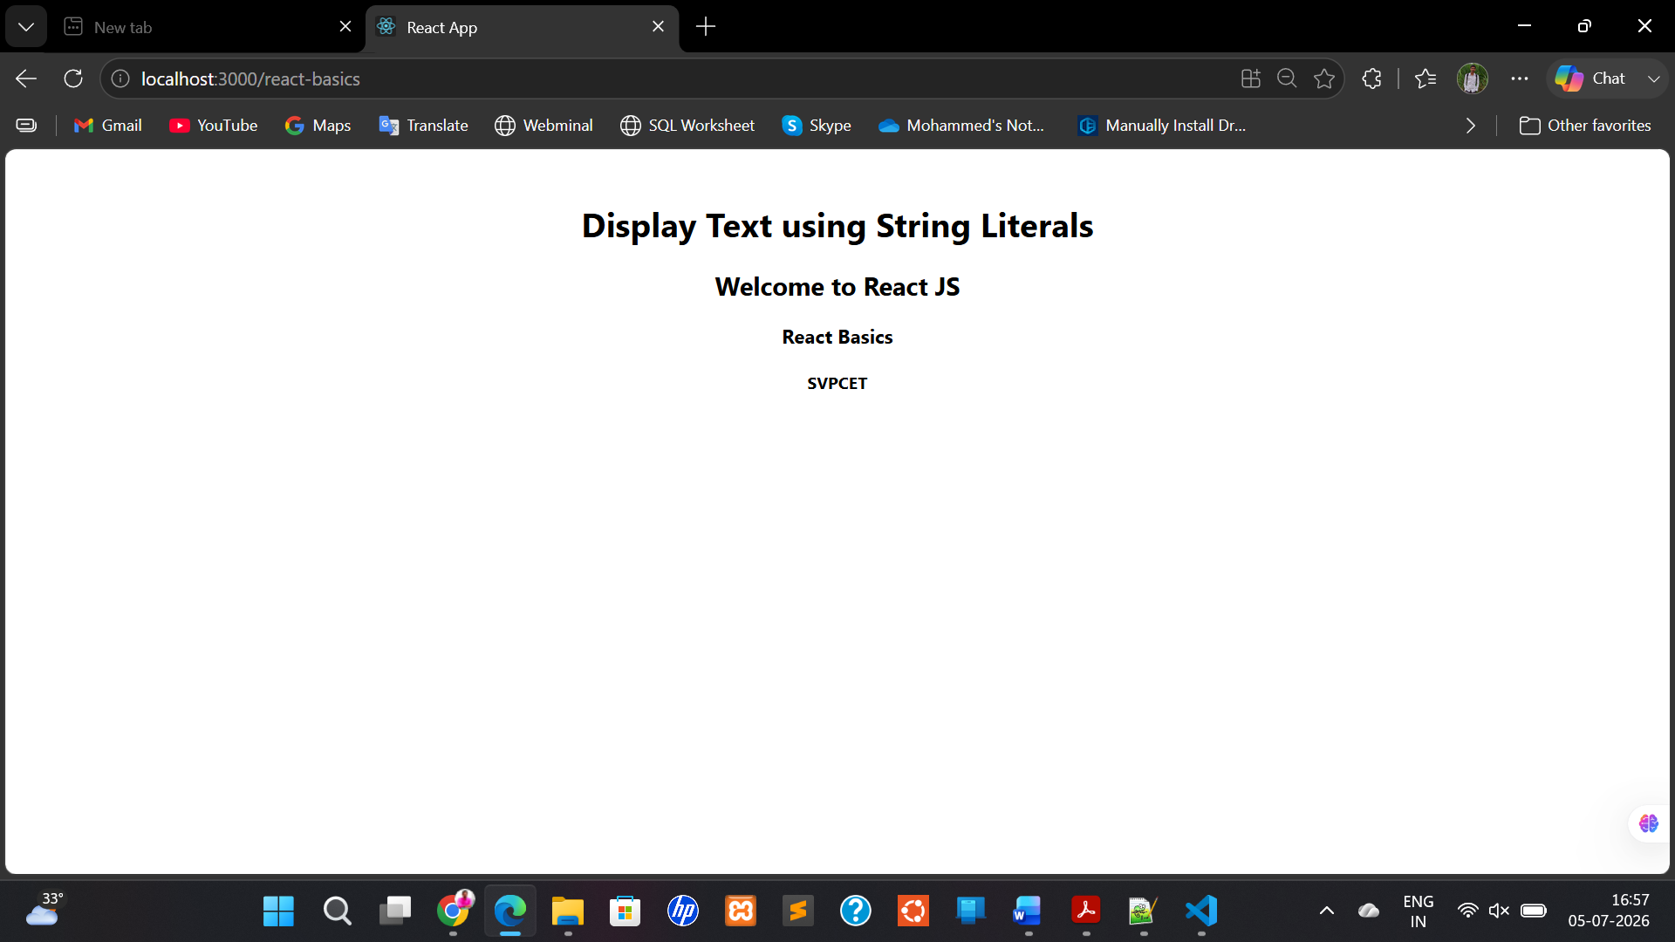

Deploying in the Github with single Repository:

Project Structure
Your finished project should look like this:
react-concepts/
│
├── public/
│
├── src/
│ ├── components/
│ │ ├── ProgramA.jsx
│ │ ├── ProgramB.jsx
│ │ ├── ProgramC.jsx
│ │ ├── ProgramD.jsx
│ │ └── ProgramE.jsx
│ │
│ ├── App.js
│ ├── App.css
│ └── index.js
│
├── package.json
├── .gitignore
└── README.md

Step 1: Create a React Project
Open Command Prompt or PowerShell.
Go to the folder where you want to save the project.
Example:
cd Documents
Create the project.
npx create-react-app react1
Go inside the project.
cd react-concepts
Start the project.
npm start
You should see
http://localhost:3000
Open it in the browser.

Step 2: Open in VS Code
Open the project.
code .

Step 3: Delete Unnecessary Files
Inside src
Delete
App.css
App.test.js
logo.svg
reportWebVitals.js
setupTests.js
Keep
index.js
App.js

Step 4: Create Components Folder
Inside src
Create a new folder.
components
Now your structure becomes
src
│
├── components
├── App.js
└── index.js

Step 5: Create Five Component Files
Inside components
Create
ProgramA.jsx
ProgramB.jsx
ProgramC.jsx
ProgramD.jsx
ProgramE.jsx

Step 6: Create CSS File
Inside src
Create
App.css

Step 7: Your Folder Structure

Your finished project should look like this:
react-concepts/
│
├── public/
│
├── src/
│ ├── components/
│ │ ├── ProgramA.jsx
│ │ ├── ProgramB.jsx
│ │ ├── ProgramC.jsx
│ │ ├── ProgramD.jsx
│ │ └── ProgramE.jsx
│ │
│ ├── App.js
│ ├── App.css
│ └── index.js
│
├── package.json
├── .gitignore
└── README.md

Step 8: Run the Project
npm start
Browser opens automatically.

Step 9: Create Git Repository
Inside terminal
git init

Step 10: Add Files
git add .

Step 11: Commit
git commit -m "Initial React Concepts Project"

Step 12: Create GitHub Repository
Go to
https://github.com
Create a repository named
react-concepts
Do not initialize it with README because your project already has one.

Step 13: Connect Local Project
Replace yourusername with your GitHub username.
git remote add origin https://github.com/yourusername/react-concepts.git

Step 14: Push Code
git branch -M main

git push -u origin main
Your project is now available on GitHub.

Step 15: Install GitHub Pages
Inside the project
npm install gh-pages --save-dev

Step 16: Edit package.json
Add a homepage field.
If your username is mohammedhhussain786, it will look like:

"homepage": "https://mohammedhhussain786.github.io/react-concepts",

Also add these scripts:
"predeploy": "npm run build",
"deploy": "gh-pages -d build"
Your scripts section should include:
"scripts": {
"start": "react-scripts start",
"build": "react-scripts build",
"test": "react-scripts test",
"eject": "react-scripts eject",
"predeploy": "npm run build",
"deploy": "gh-pages -d build"
}

Step 17: Deploy
npm run deploy
After a minute, your site will be available at:
https://yourusername.github.io/react-concepts/

Step 18: View on Your Phone
Open the GitHub Pages URL in your mobile browser.
No installation is needed.

Step 19: Final Development Workflow
Whenever you make changes:
npm start
Test locally.
Then save and push:
git add .
git commit -m "Updated Program A"
git push
Finally redeploy:
npm run deploy

PA.jsx

import React, { Component } from "react";

class PA extends Component {

constructor() {
super();

this.state = {
count: 0
};
}

increment = () => {
this.setState({
count: this.state.count + 1
});
};

render() {
return (
<div>
<h1>Class Counter</h1>

<h2>{this.state.count}</h2>

<button onClick={this.increment}>
Increment
</button>
</div>
);
}
}

export default PA;

PB.jsx

import React, { useState } from "react";

function PB() {

const [count, setCount] = useState(0);

const increment = () => {
setCount(count + 1);
};

return (
<div>
<h1>Functional Counter</h1>

<h2>{count}</h2>

<button onClick={increment}>
Increment
</button>
</div>
);
}

export default PB;

PC.jsx

import React from "react";

function PC() {

const handleClick = () => {
alert("Button Clicked");
};

return (
<div>
<h1>Button Event Example</h1>

<button onClick={handleClick}>
Click Me
</button>
</div>
);
}

export default PC;

PD.jsx

import React, { useState } from "react";

function PD() {

const [loggedIn, setLoggedIn] = useState(false);

return (
<div>

<h1>Conditional Rendering</h1>

{
loggedIn
? <h2>Welcome User</h2>
: <h2>Please Login</h2>
}

<button
onClick={() => setLoggedIn(!loggedIn)}
>
Toggle
</button>

</div>
);
}

export default PD;

PE.jsx

import React from "react";

function PE() {

const message = "Welcome to React JS";
const course = "React Basics";
const college = "SVPCET";

return (
<div style={{ textAlign: "center", marginTop: "50px" }}>
<h1>Display Text using String Literals</h1>

<h2>{message}</h2>
<h3>{course}</h3>
<h4>{college}</h4>
</div>
);
}

export default PE;

index.js

import React from 'react';
import ReactDOM from 'react-dom/client';
import './index.css';
import App from './App';
import reportWebVitals from './reportWebVitals';

const root = ReactDOM.createRoot(document.getElementById('root'));
root.render(
<React.StrictMode>
<App />
</React.StrictMode>
);

// If you want to start measuring performance in your app, pass a function
// to log results (for example: reportWebVitals(console.log))
// or send to an analytics endpoint. Learn more: https://bit.ly/CRA-vitals
reportWebVitals();

App.js

import React, { useState } from "react";
import "./App.css";

import PA from "./components/pa";
import PB from "./components/pb";
import PC from "./components/pc";
import PD from "./components/pd";
import PE from "./components/pe";

function App() {
const [program, setProgram] = useState("A");

return (
<div className="container">
<h1>React Lab Programs</h1>

<div className="button-container">
<button onClick={() => setProgram("A")}>Program A</button>
<button onClick={() => setProgram("B")}>Program B</button>
<button onClick={() => setProgram("C")}>Program C</button>
<button onClick={() => setProgram("D")}>Program D</button>
<button onClick={() => setProgram("E")}>Program E</button>
</div>

<hr />

<div className="output">
{program === "A" && <PA />}
{program === "B" && <PB />}
{program === "C" && <PC />}
{program === "D" && <PD />}
{program === "E" && <PE />}
</div>
</div>
);
}

export default App;

package.json

{
"name": "react1",
"version": "0.1.0",
"private": true,
"homepage": "https://mohammedhhussain786.github.io/react1",
"dependencies": {
"@testing-library/dom": "^10.4.1",
"@testing-library/jest-dom": "^6.9.1",
"@testing-library/react": "^16.3.2",
"@testing-library/user-event": "^13.5.0",
"react": "^19.2.7",
"react-dom": "^19.2.7",
"react-scripts": "5.0.1",
"web-vitals": "^2.1.4"
},
"scripts": {
"start": "react-scripts start",
"build": "react-scripts build",
"test": "react-scripts test",
"eject": "react-scripts eject",
"predeploy": "npm run build",
"deploy": "gh-pages -d build"
},
"eslintConfig": {
"extends": [
"react-app",
"react-app/jest"
]
},
"browserslist": {
"production": [
">0.2%",
"not dead",
"not op_mini all"
],
"development": [
"last 1 chrome version",
"last 1 firefox version",
"last 1 safari version"
]
},
"devDependencies": {
"gh-pages": "^6.3.0"
}
}

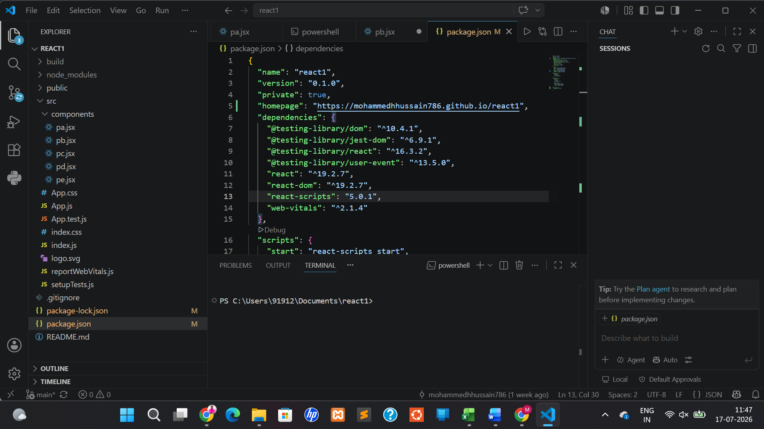

https://github.com/mohammedhhussain786/react1/tree/main/src

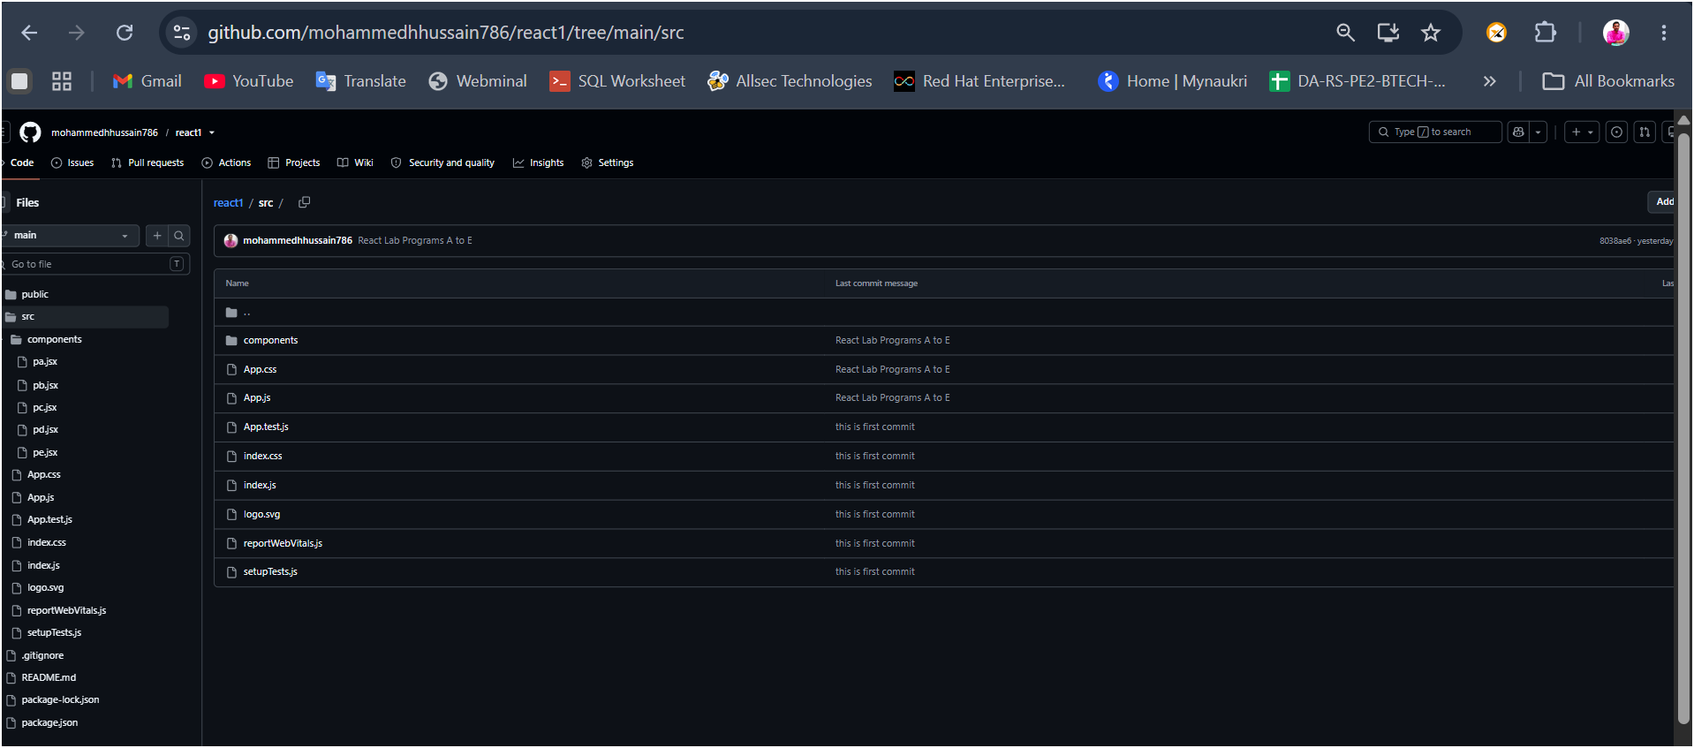

https://mohammedhhussain786.github.io/react1/

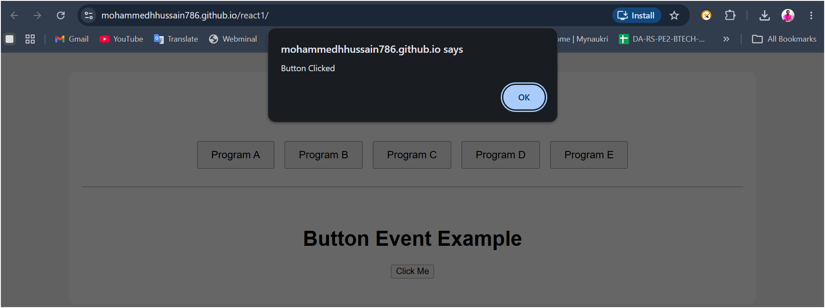

3.Important concepts of React. js
Important concepts of React. js
a. Write a React program to implement a counter button using React use State hook
b. Write a React program to fetch the data from an API using React use Effect hook
c. Write a React program with two react components sharing data using Props.
d. Write a React program to implement the forms in react
e. Write a React program to implement the iterative rendering using map() function

  - Write a React program to implement a counter button using React use State hook

Aim: To Write a React program to implement a counter button using React use State hook

Description:
- The useState hook is a built-in React function that lets function components have state, just like class components do.
- In React, state is data that changes over time — like a counter, form input, or toggle.

Basic Syntax of useState

const [stateVariable, setStateFunction] = useState(initialValue);

  - stateVariable: The current value of the state.
  - setStateFunction: A function used to update that state.
  - useState(initialValue): Initializes the state with the given value.

Program:

import React, { useState } from "react";

function App() {
const [count, setCount] = useState(0);

return (
<div style={{ textAlign: "center", marginTop: "50px" }}>
<h1>Counter Application</h1>

<h2>{count}</h2>

<button onClick={() => setCount(count + 1)}>
Increment
</button>
</div>
);
}

export default App;

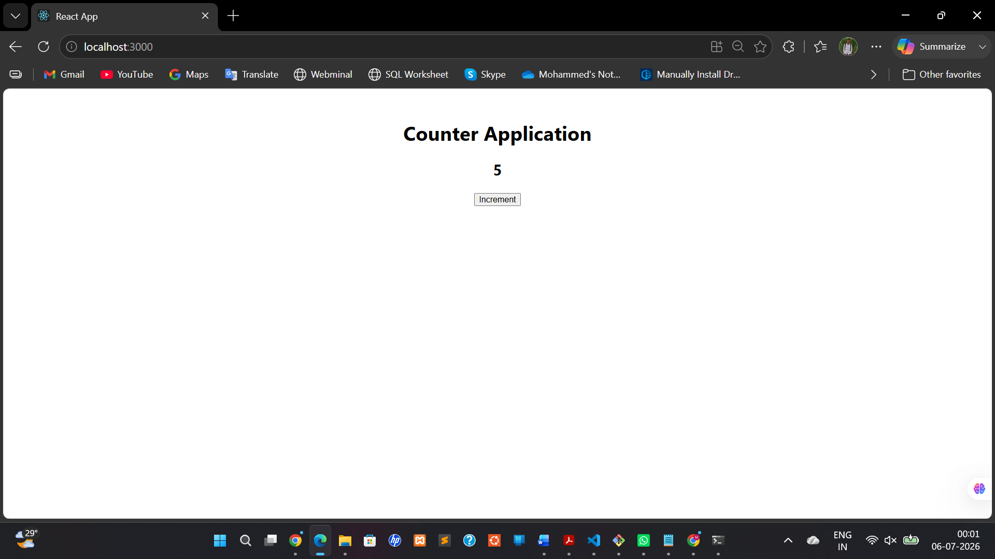

Write a React program to fetch the data from an API using React use Effect hook

Aim: To Write a React program to fetch the data from an API using React use Effect hook

Description:

The useEffect hook in React is used to perform side effects in functional components — such as fetching data, setting up subscriptions, timers, or manually manipulating the DOM.
Basic Syntax
useEffect(() => {
// Side effect code (e.g., fetch, event listeners, etc.) return () => {
// Cleanup code (optional)
};

}, [dependencies]);
Program:
App.js
import React, { useEffect, useState } from "react";

function App() {
const [students, setStudents] = useState([]);

useEffect(() => {
setTimeout(() => {
setStudents([
"Rahul",
"Priya",
"Amit",
"Sneha",
"Kiran"
]);
}, 1000);
}, []);

return (
<div style={{ padding: "20px" }}>
<h1>Student List</h1>

<ul>
{students.map((student, index) => (
<li key={index}>{student}</li>
))}
</ul>
</div>
);
}

export default App;

Output:
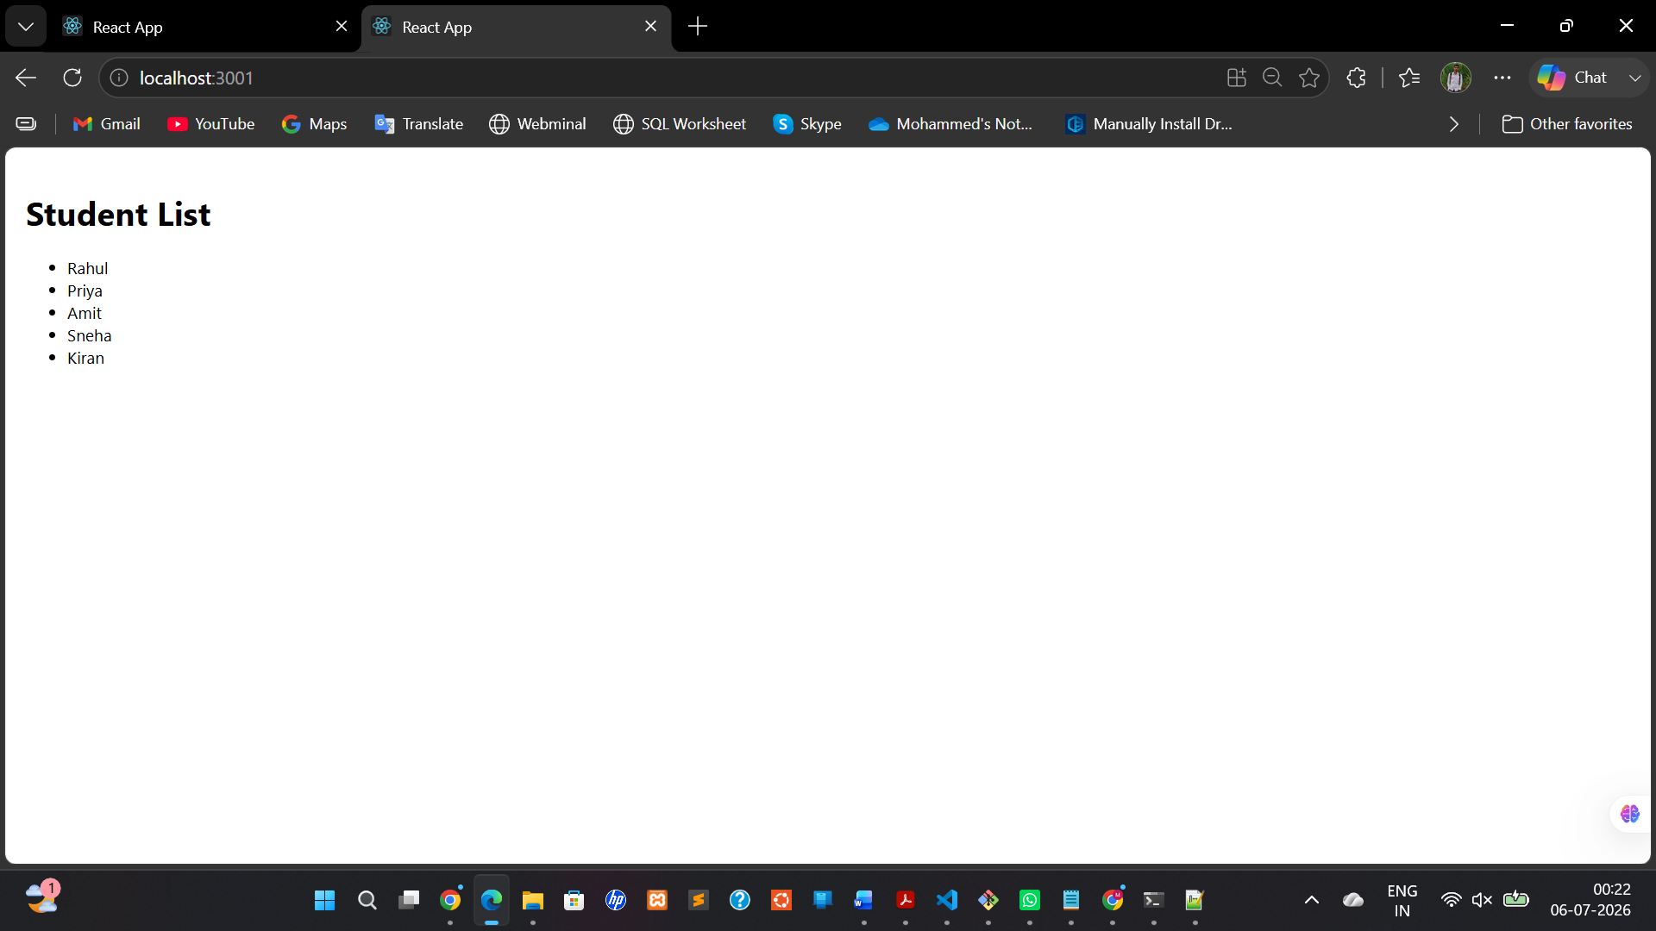

App.js
import React, { useState, useEffect } from "react";

function App() {
const [user, setUser] = useState(null);

useEffect(() => {
fetch("https://api.github.com/users/octocat")
.then((res) => res.json())
.then((data) => setUser(data))
.catch((err) => console.log(err));
}, []);

if (!user) {
return <p>Loading...</p>;
}

return (
<div>
<h1>{user.login}</h1>
<img src={user.avatar_url} alt="avatar" width="100" />
<p>{user.name}</p>
<a href={user.html_url} target="_blank" rel="noreferrer">
GitHub Profile
</a>
</div>
);
}

export default App;

index.js
import React from "react";
import ReactDOM from "react-dom/client";
import App from "./App";

const root = ReactDOM.createRoot(document.getElementById("root"));

root.render(
<React.StrictMode>
<App />
</React.StrictMode>
);
Output:
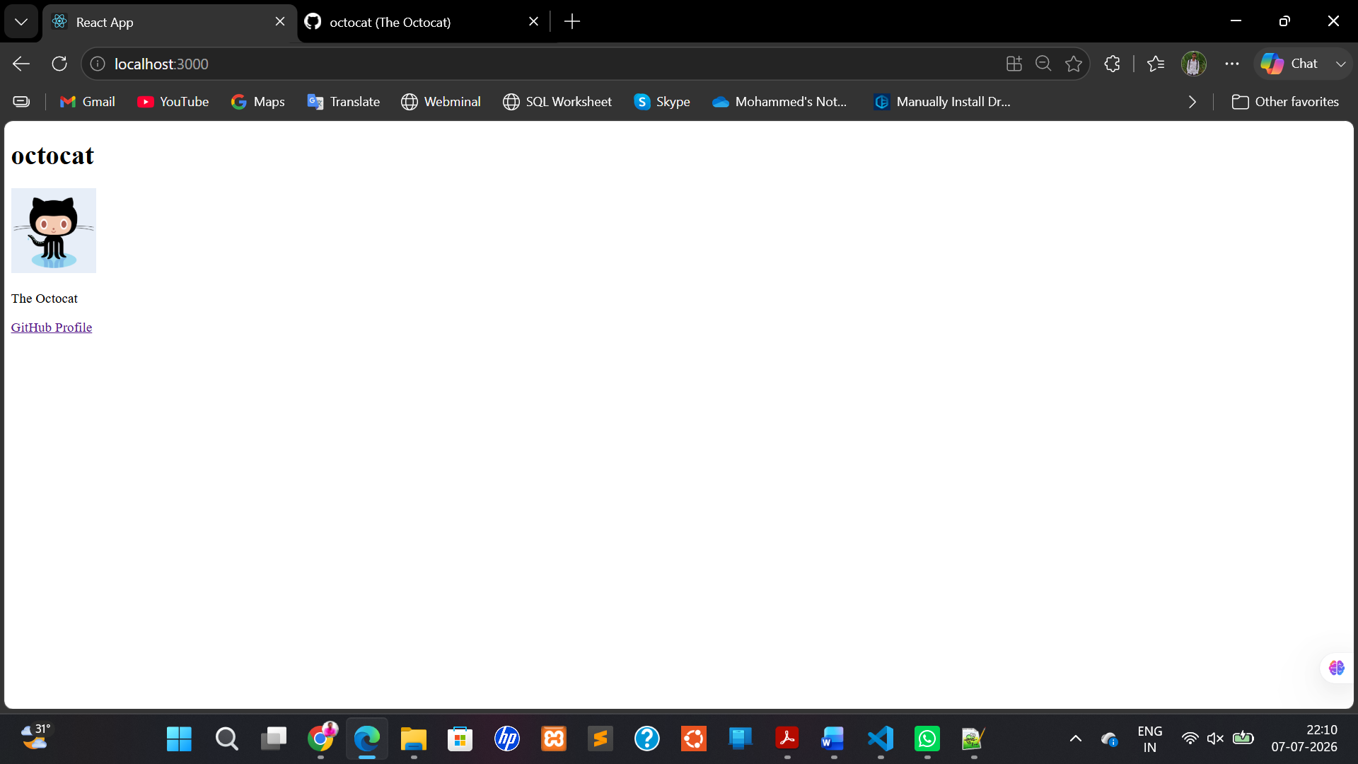

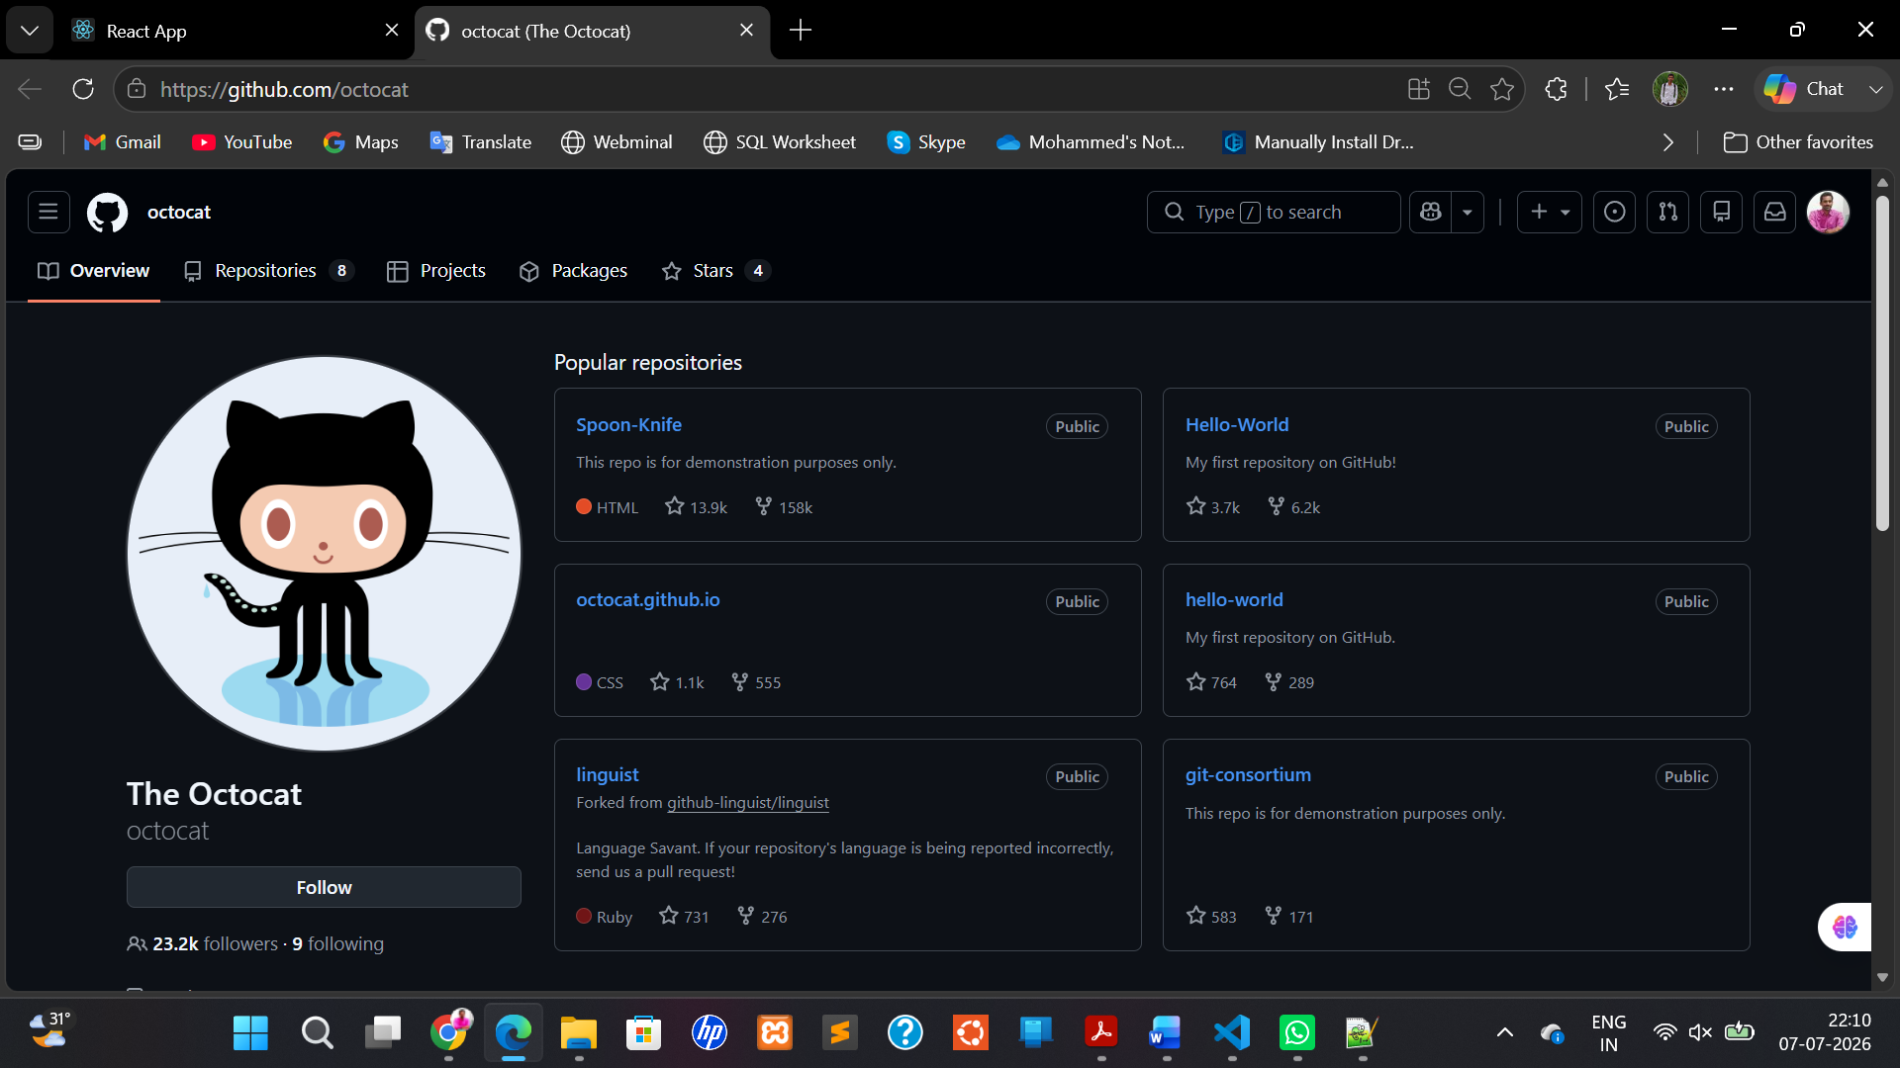

c. Write a React program with two react components sharing data using Props.

Aim: To Write a React program with two react components sharing data using Props.

Description:
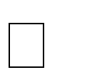
Props (short for “properties”) are a way to pass data from a parent component to a child component.
Props are read-only inside the child component, meaning the child cannot modify them.
This is how React components communicate and share data in a unidirectional flow.

Two Components Sharing Data Using Props
    - Parent Component
Holds some data or state and passes it down as props to one or more child components.
    - Child Component
Receives the data via props and uses it to render UI or perform logic.

Parent component
A parent component is a React component that contains or renders one or more child components inside it.
It’s called “parent” because it owns or controls the child components.
The parent can pass data or instructions to the child components using props.

Program:
App.js
import Child from "./Child";

function App() {

return (

<div>

<h1>React Props Example</h1>

<Child name="Mohammed" />

</div>

);

}

export default App;

Child.js
function Child(props) {

return (
<h2>Welcome {props.name}</h2>
);

}

export default Child;
Output:
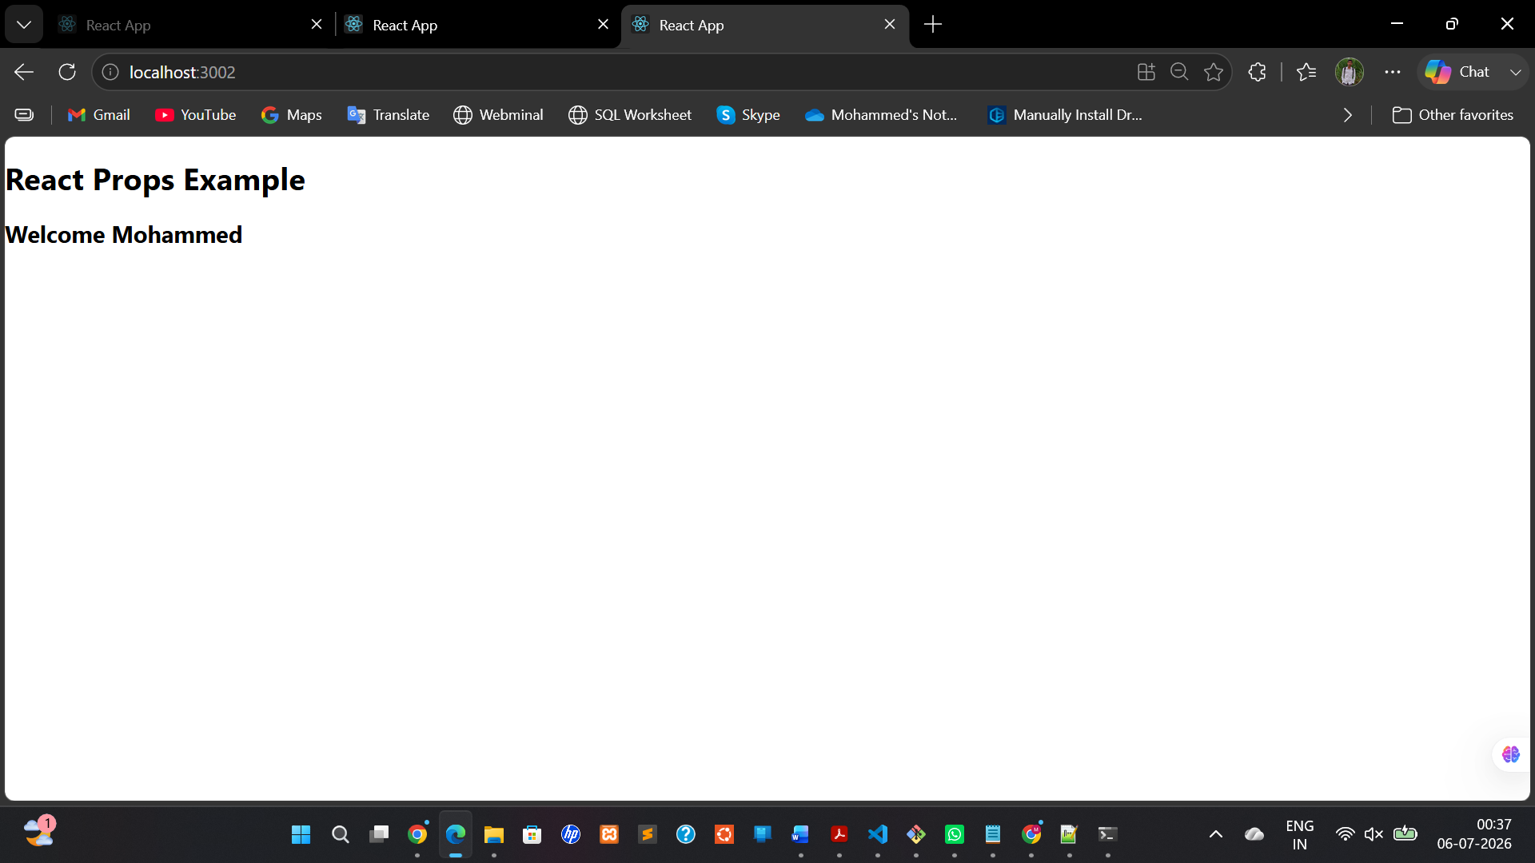
(d) React Forms
Description
React Forms use state to manage user input.
The input value is controlled using the useState Hook.
Source Code:
import React, { useState } from "react";

function App() {

const [name, setName] = useState("");

return (

<div>

<h1>React Form</h1>

<input

type="text"
placeholder="Enter Name"

value={name}

onChange={(e) => setName(e.target.value)}

/>

<h2>Hello {name}</h2>

</div>

);

}

export default App;

output:
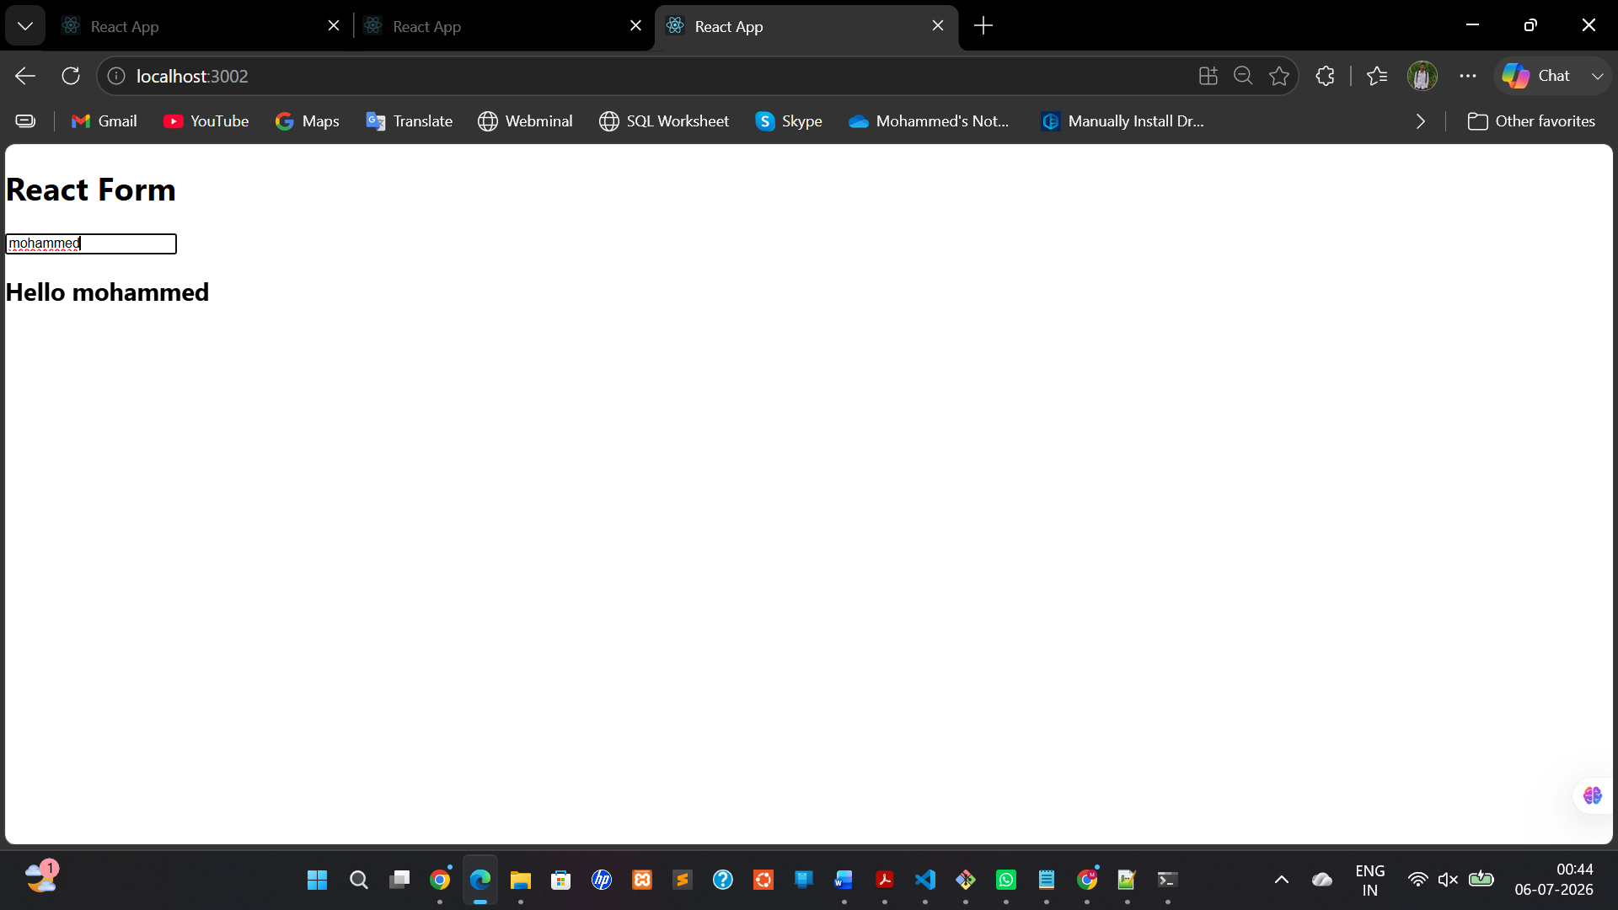

(e) Iterative Rendering using map()
Description
React uses the JavaScript map() function to display multiple elements dynamically.
Source code:
function App() {

const fruits = [

"Apple",
"Banana",
"Orange",
"Mango"

];

return (

<div>

<h1>Fruit List</h1>

<ul>

{fruits.map((fruit, index) => (

<li key={index}>
{fruit}
</li>

))}

</ul>

</div>

);

}

export default App;

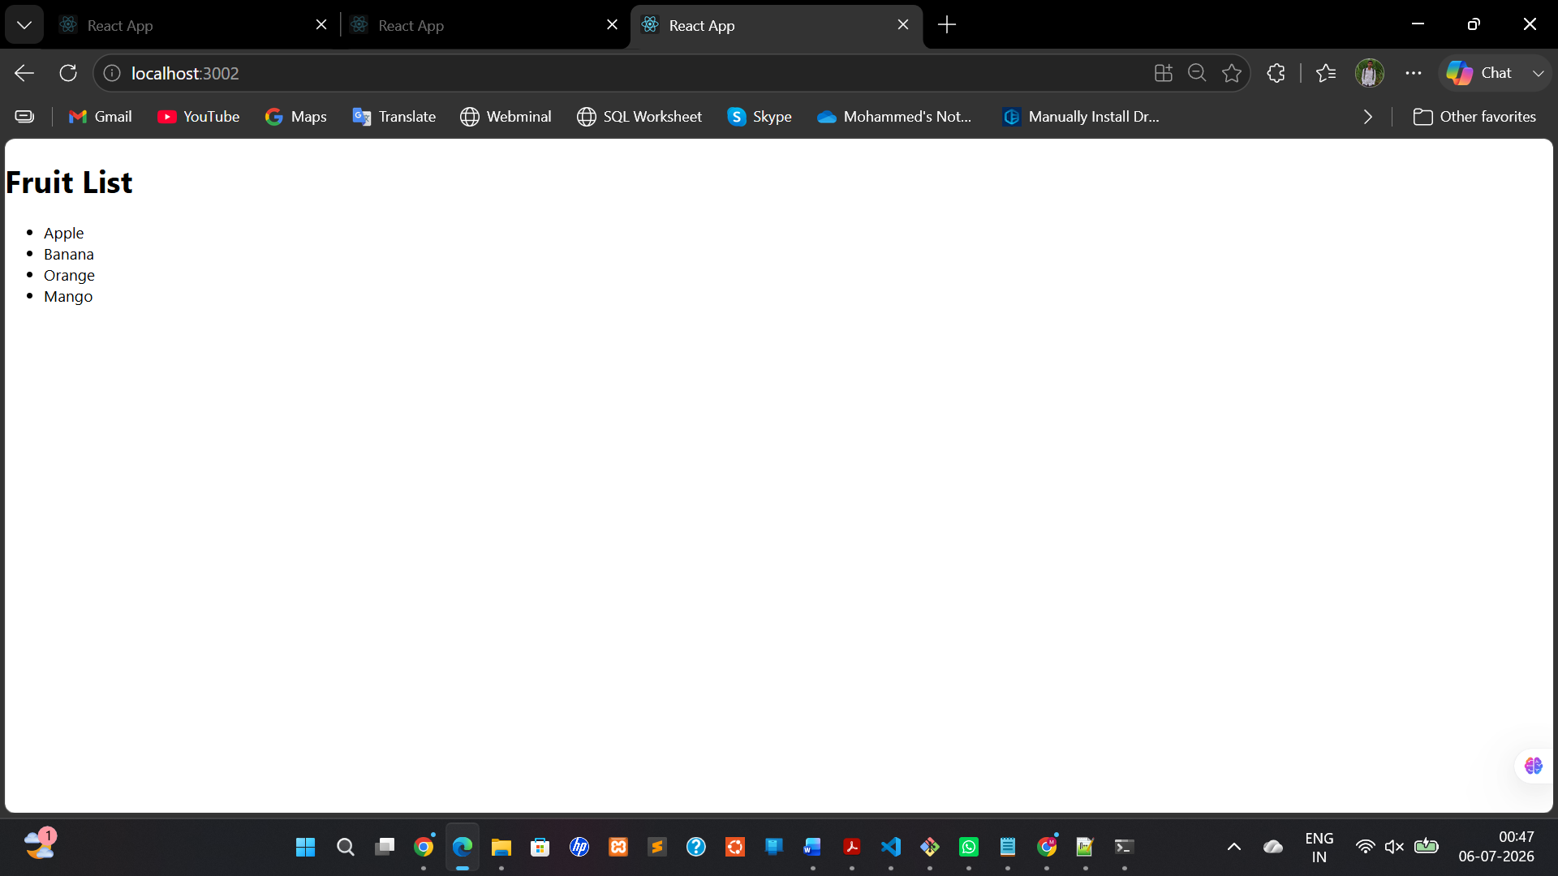

Deploying in Github using single repository:
Your project structure
react2
│
├── src
│ ├── components
│ │ ├── pa.jsx ← 3A
│ │ ├── pb.jsx ← 3B
│ │ ├── pc.jsx ← 3C
│ │ ├── pd.jsx ← 3D
│ │ └── pe.jsx ← 3E
│ │ |_____child.jsx
│ ├── App.js ← Navigation
│ ├── App.css
│ └── index.js

Pa.jsx

import React, { useState } from "react";

function PA() {
const [count, setCount] = useState(0);

return (
<div style={{ textAlign: "center", marginTop: "50px" }}>
<h1>Counter Application</h1>

<h2>{count}</h2>

<button onClick={() => setCount(count + 1)}>
Increment
</button>
</div>
);
}

export default PA;

pb.jsx

import React, { useState, useEffect } from "react";

function PB() {
const [user, setUser] = useState(null);

useEffect(() => {
fetch("https://api.github.com/users/octocat")
.then((res) => res.json())
.then((data) => setUser(data))
.catch((err) => console.log(err));
}, []);

if (!user) {
return <p>Loading...</p>;
}

return (
<div style={{ textAlign: "center", marginTop: "30px" }}>
<h1>{user.login}</h1>

<img
src={user.avatar_url}
alt="avatar"
width="120"
/>

<p>{user.name}</p>

<a
href={user.html_url}
target="_blank"
rel="noreferrer"
>
GitHub Profile
</a>
</div>
);
}

export default PB;

pc.jsx

import Child from "./child";

function PC() {
return (
<div style={{ textAlign: "center", marginTop: "30px" }}>
<h1>React Props Example</h1>

<Child name="Mohammed" />
</div>
);
}

export default PC;

pd.jsx

import React, { useState } from "react";

function PD() {
const [name, setName] = useState("");

return (
<div style={{ textAlign: "center", marginTop: "30px" }}>
<h1>React Form</h1>

<input
type="text"
placeholder="Enter Name"
value={name}
onChange={(e) => setName(e.target.value)}
/>

<h2>Hello {name}</h2>
</div>
);
}

export default PD;

pe.jsx

function PE() {
const fruits = [
"Apple",
"Banana",
"Orange",
"Mango"
];

return (
<div style={{ textAlign: "center", marginTop: "30px" }}>
<h1>Fruit List</h1>

<ul style={{ listStyleType: "none", padding: 0 }}>
{fruits.map((fruit, index) => (
<li key={index}>{fruit}</li>
))}
</ul>
</div>
);
}

export default PE;

child.jsx
function Child(props) {
return (
<h2>Welcome {props.name}</h2>
);
}

export default Child;

App.js

import React, { useState } from "react";
import "./App.css";

import PA from "./components/pa";
import PB from "./components/pb";
import PC from "./components/pc";
import PD from "./components/pd";
import PE from "./components/pe";

function App() {
const [program, setProgram] = useState("A");

return (
<div className="container">
<h1>Experiment 3 - Important Concepts of React.js</h1>

<div className="button-container">
<button onClick={() => setProgram("A")}>Program A</button>
<button onClick={() => setProgram("B")}>Program B</button>
<button onClick={() => setProgram("C")}>Program C</button>
<button onClick={() => setProgram("D")}>Program D</button>
<button onClick={() => setProgram("E")}>Program E</button>
</div>

<hr />

<div className="output">
{program === "A" && <PA />}
{program === "B" && <PB />}
{program === "C" && <PC />}
{program === "D" && <PD />}
{program === "E" && <PE />}
</div>
</div>
);
}

export default App;

App.css

body {
margin: 0;
padding: 0;
font-family: Arial, sans-serif;
background: #f2f2f2;
}

.container {
width: 90%;
max-width: 900px;
margin: 30px auto;
background: white;
padding: 20px;
border-radius: 10px;
box-shadow: 0px 2px 10px rgba(0, 0, 0, 0.2);
}

h1 {
text-align: center;
color: #333;
}

.button-container {
display: flex;
justify-content: center;
flex-wrap: wrap;
gap: 10px;
margin: 20px 0;
}

.button-container button {
padding: 10px 20px;
font-size: 16px;
cursor: pointer;
border: none;
border-radius: 5px;
background-color: #1976d2;
color: white;
}

.button-container button:hover {
background-color: #125aa0;
}

.output {
margin-top: 20px;
padding: 20px;
}

Index.js

import React from "react";
import ReactDOM from "react-dom/client";
import "./index.css";
import App from "./App";

const root = ReactDOM.createRoot(document.getElementById("root"));

root.render(
<React.StrictMode>
<App />
</React.StrictMode>
);

Package.json

{
"name": "react2",
"version": "0.1.0",
"private": true,
"homepage": "https://mohammedhhussain786.github.io/react2",
"dependencies": {
"@testing-library/dom": "^10.4.1",
"@testing-library/jest-dom": "^6.9.1",
"@testing-library/react": "^16.3.2",
"@testing-library/user-event": "^13.5.0",
"react": "^19.2.7",
"react-dom": "^19.2.7",
"react-scripts": "5.0.1",
"web-vitals": "^2.1.4"
},
"scripts": {
"start": "react-scripts start",
"build": "react-scripts build",
"test": "react-scripts test",
"eject": "react-scripts eject",
"predeploy": "npm run build",
"deploy": "gh-pages -d build"
},
"eslintConfig": {
"extends": [
"react-app",
"react-app/jest"
]
},
"browserslist": {
"production": [
">0.2%",
"not dead",
"not op_mini all"
],
"development": [
"last 1 chrome version",
"last 1 firefox version",
"last 1 safari version"
]
},
"devDependencies": {
"gh-pages": "^6.3.0"
}
}

Your src folder should now be:
src
│
├── components
│ ├── pa.jsx
│ ├── pb.jsx
│ ├── pc.jsx
│ ├── pd.jsx
│ ├── pe.jsx
│ └── child.jsx
│
├── App.js
├── App.css
├── index.css
└── index.js

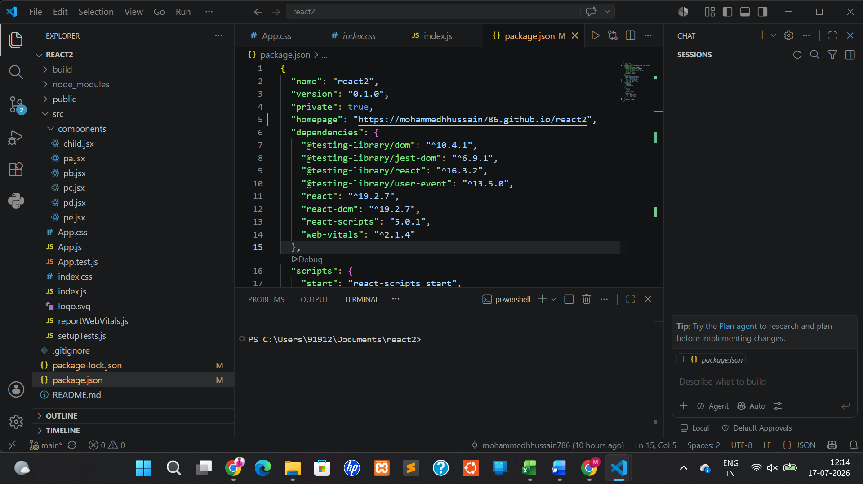

https://github.com/mohammedhhussain786/react2/tree/main/src

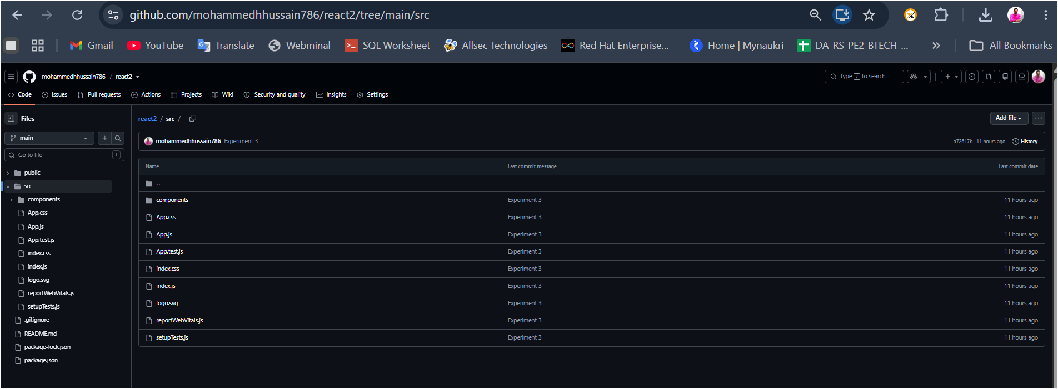

https://mohammedhhussain786.github.io/react2/
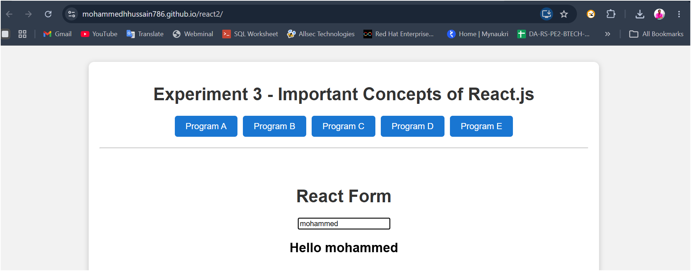

4. Introduction to Git and GitHub
a. Setup
Install Git on local machine.
Configure Git (user name, email).
Create GitHub account and generate a personal access token.

Introduction to Git and GitHub – Setup
Aim
To install Git, configure Git with user details, create a GitHub account, and generate a Personal Access Token (PAT).

Software Requirements
- Windows 10/11
- Internet Connection
- Git
- GitHub Account

Step 1: Install Git
- Open your browser.
- Go to https://git-scm.com/
- Download the latest version of Git for Windows.
- Run the installer.
- Keep the default settings and click Next until installation is complete.
- Click Finish.

Step 2: Verify Git Installation
Open Command Prompt or Git Bash and type:
git --version
Output
git version 2.xx.x.windows.x

Step 3: Configure Git
Set your username.
git config --global user.name "Your Name"
Example
git config --global user.name "Mohammed Hussain"
Set your email.
git config --global user.email "youremail@example.com"
Example
git config --global user.email "mohammed@example.com"

Step 4: Verify Configuration
Check the configured username.
git config --global user.name
Check the configured email.
git config --global user.email
View all Git configuration.
git config --list

Step 5: Create a GitHub Account
- Open https://github.com
- Click Sign Up.
- Enter:
  - Email Address
  - Password
  - Username
- Verify your account.
- Complete the registration process.
- Log in to GitHub.

Step 6: Generate a Personal Access Token (PAT)
- Log in to GitHub.
- Click your Profile Picture.
- Select Settings.
- Go to Developer Settings.
- Select Personal access tokens.
- Click Tokens (classic) or Fine-grained tokens.
- Click Generate new token.
- Enter:
  - Token name
  - Expiration date
  - Required permissions (for example, repo for repository access)
- Click Generate Token.
- Copy the generated token and store it securely. It is displayed only once.

Commands Used
git --version

git config --global user.name "Your Name"

git config --global user.email "youremail@example.com"

git config --list

git config --global user.name

git config --global user.email

Result
Git was successfully installed and configured. A GitHub account was created, and a Personal Access Token (PAT) was generated for secure authentication with GitHub.

b. Basic Git Workflow
Create a local repository using git init
Create and add files git add.
Commit files git commit -m "Initial commit"
Connect to GitHub remote git remote add origin <repo_url
Push to GitHub git push-u origin main

Aim
To create a local Git repository, add files, commit changes, connect to a GitHub remote repository, and push the project to GitHub.

Software Requirements
- Git Installed
- GitHub Account
- Internet Connection
- Command Prompt / Git Bash

Step 1: Create a Project Folder
Open Command Prompt or Git Bash and create a new folder.
mkdir MyProject
Move into the project folder.
cd MyProject

Step 2: Initialize a Git Repository
Initialize the folder as a Git repository.
git init
Output
Initialized empty Git repository in .../MyProject/.git/

Step 3: Create a File
Create a file named README.md.
echo "# MyProject" > README.md
You can also create any other file such as index.html or app.js.

Step 4: Check Repository Status
git status
Output
On branch main

No commits yet

Untracked files:
README.md

Step 5: Add Files to the Staging Area
Add a single file.
git add README.md
Or add all files.
git add .

Step 6: Commit the Changes
Create the first commit.
git commit -m "Initial commit"
Output
[main (root-commit)] Initial commit
1 file changed, 1 insertion(+)

Step 7: Create a Repository on GitHub
- Log in to GitHub.
- Click New Repository.
- Enter a repository name (e.g., MyProject).
- Click Create Repository.
- Copy the repository URL.
Example:
https://github.com/username/MyProject.git

Step 8: Connect the Local Repository to GitHub
git remote add origin https://github.com/username/MyProject.git
Verify the remote repository.
git remote -v
Output
origin https://github.com/username/MyProject.git (fetch)
origin https://github.com/username/MyProject.git (push)

Step 9: Push the Project to GitHub
If your branch is main, use:
git push -u origin main
If your branch is master, use:
git push -u origin master
Output
Enumerating objects: 3, done.
Counting objects: 100% (3/3), done.
Writing objects: 100% (3/3), done.
To https://github.com/username/MyProject.git
* [new branch] main -> main
Branch 'main' set up to track 'origin/main'.

Step 10: Verify on GitHub
- Open your GitHub repository.
- Refresh the page.
- Confirm that the uploaded files (e.g., README.md) are visible.

Commands Used
mkdir MyProject

cd MyProject

git init

echo "# MyProject" > README.md

git status

git add README.md

git add .

git commit -m "Initial commit"

git remote add origin https://github.com/username/MyProject.git

git remote -v

git push -u origin main

Result
A local Git repository was successfully created using git init. Files were added to the staging area with git add, committed using git commit, connected to a GitHub repository using git remote add origin, and successfully pushed to GitHub using git push -u origin main.

c. Branching and Collaboration
Create a branch git checkout -b featurel
Merge branch to main git merge featurel
Resolve merge conflicts (guided)

Aim
To create a new branch, work on it, merge it into the main branch, and resolve merge conflicts.

Software Requirements
- Git Installed
- GitHub Account
- Local Git Repository

Step 1: Check the Current Branch
Open Command Prompt or Git Bash and navigate to your project folder.
git branch
Output
* main

Step 2: Create a New Branch
Create a new branch named feature1 and switch to it.
git checkout -b feature1
Output
Switched to a new branch 'feature1'
Verify the current branch.
git branch
Output
* feature1
main

Step 3: Modify a File
Edit README.md (or any project file).
Example:
# MyProject

This feature was added in the feature1 branch.

Step 4: Commit the Changes
Stage the modified file.
git add .
Commit the changes.
git commit -m "Added feature1 changes"
Output
[feature1] Added feature1 changes

Step 5: Switch Back to Main Branch
git checkout main

Step 6: Merge the Feature Branch
Merge feature1 into main.
git merge feature1
Output (Successful Merge)
Updating xxxxxxx..yyyyyyy
Fast-forward
README.md | 1 +

Step 7: Push the Updated Main Branch
git push origin main

Resolving Merge Conflicts (Guided)
A merge conflict occurs when the same part of a file is modified differently in two branches.
Step 1: Create a Conflict
Modify the same line in main and commit it.
git add .
git commit -m "Updated README in main"
Switch to feature1.
git checkout feature1
Modify the same line differently and commit.
git add .
git commit -m "Updated README in feature1"
Switch back to main.
git checkout main
Attempt to merge.
git merge feature1
Output
Auto-merging README.md
CONFLICT (content): Merge conflict in README.md
Automatic merge failed; fix conflicts and then commit the result.

Step 2: Open the Conflicted File
Git marks the conflict like this:
<<<<<<< HEAD
Welcome to MyProject
=======
Welcome to Feature1 Project
>>>>>>> feature1

Step 3: Resolve the Conflict
Edit the file and keep the desired content.
Example:
Welcome to MyProject - Feature1 Added Successfully
Remove the conflict markers:
- <<<<<<< HEAD
- =======
- >>>>>>> feature1
Save the file.

Step 4: Mark the Conflict as Resolved
git add README.md

Step 5: Complete the Merge
git commit -m "Resolved merge conflict"

Step 6: Push the Changes
git push origin main

Commands Used
git branch

git checkout -b feature1

git add .

git commit -m "Added feature1 changes"

git checkout main

git merge feature1

git push origin main

git add README.md

git commit -m "Resolved merge conflict"

Result
A new branch feature1 was successfully created using git checkout -b. Changes were committed on the branch and merged into the main branch using git merge. A merge conflict was simulated, manually resolved by editing the conflicted file, committed, and the updated project was successfully pushed to GitHub.

5. Upload React Project to GitHub
Create a new React app using npx create-react-app myapp
Initialize a git repo and push to GitHub
Use .gitignore to exclude node_modules

Create multiple branches: feature/navbar, feature/form
Practice merge and pull requests (can use GitHub GUI)

Aim
To create a React application, initialize a Git repository, upload it to GitHub, use .gitignore to exclude node_modules, create multiple branches, and practice merging and pull requests.

Software Requirements
- Node.js and npm
- Git
- GitHub Account
- Visual Studio Code

Step 1: Create a New React Application
Open Command Prompt or VS Code Terminal.
Create a React application.
npx create-react-app myapp
Move to the project directory.
cd myapp
Start the application.
npm start
Output
Compiled successfully!

Local: http://localhost:3000

Step 2: Initialize Git Repository
Initialize Git.
git init
Check the repository status.
git status

Step 3: Verify the .gitignore File
The create-react-app project automatically creates a .gitignore file.
Open .gitignore and verify that it contains:
node_modules/
build/
.env.local
.env.development.local
.env.test.local
.env.production.local
The node_modules folder will not be uploaded to GitHub.

Step 4: Add and Commit the Project
Stage all files.
git add .
Commit the project.
git commit -m "Initial React project"

Step 5: Create a GitHub Repository
- Log in to GitHub.
- Click New Repository.
- Enter the repository name myapp.
- Click Create Repository.
- Copy the repository URL.
Example:
https://github.com/username/myapp.git

Step 6: Connect the Local Repository to GitHub
Add the remote repository.
git remote add origin https://github.com/username/myapp.git
Rename the default branch to main (if required).
git branch -M main
Push the project to GitHub.
git push -u origin main

Step 7: Create Feature Branches
Create the feature/navbar branch.
git checkout -b feature/navbar
Make changes to the navigation component.
Stage and commit.
git add .
git commit -m "Added navigation bar"

Create the feature/form branch.
git checkout main
git checkout -b feature/form
Make changes to the form component.
Stage and commit.
git add .
git commit -m "Added form component"

Step 8: Push Branches to GitHub
Push the feature/navbar branch.
git push -u origin feature/navbar
Push the feature/form branch.
git push -u origin feature/form

Step 9: Create a Pull Request (GitHub GUI)
- Open your GitHub repository.
- Select the feature/navbar branch.
- Click Compare & pull request.
- Add a title and description.
- Click Create Pull Request.
- Review the changes.
- Click Merge Pull Request.
- Click Confirm Merge.
Repeat the same steps for the feature/form branch.

Step 10: Pull the Latest Changes
After merging, update the local repository.
git checkout main
git pull origin main

Commands Used
npx create-react-app myapp

cd myapp

npm start

git init

git status

git add .

git commit -m "Initial React project"

git remote add origin https://github.com/username/myapp.git

git branch -M main

git push -u origin main

git checkout -b feature/navbar

git add .

git commit -m "Added navigation bar"

git push -u origin feature/navbar

git checkout main

git checkout -b feature/form

git add .

git commit -m "Added form component"

git push -u origin feature/form

git checkout main

git pull origin main

Result
A React application was successfully created using npx create-react-app. The project was initialized as a Git repository and uploaded to GitHub. The .gitignore file excluded the node_modules directory from version control. Two feature branches, feature/navbar and feature/form, were created, changes were committed and pushed to GitHub, and the branches were merged into the main branch using GitHub Pull Requests.

6. Introduction to Node.js and Express. js

a. Write a program to implement the 'hello world' message in the route through the browser using Express
b. Write a program to develop a small website with multiple routes using Express. js
c. Write a program to print the 'hello world' in the browser console using Express. js
d. Write a program to implement the CRUD operations using Express. js
e. Write a program to establish the connection between API and Database using Express - My SQL driver.

Prerequisites:
Step 1: Install Node.js
Download and install Node.js from its official website.
After installation, check the versions.
node -v
npm -v
Example Output
v24.x.x
10.x.x

Step 2: Create Project Folder
mkdir express-lab
cd express-lab

Step 3: Initialize Node Project
npm init -y
This creates
package.json

Step 4: Install Express
npm install express

(a) Hello World using Express Route
Folder Structure
program1
│
├── node_modules
├── package.json
└── app.js

app.js
const express = require("express");

const app = express();

app.get("/", (req, res) => {
res.send("Hello World");
});

app.listen(3000, () => {
console.log("Server is running on port 3000");
});

Run
node app.js
Output
Server is running on port 3000
Open browser
http://localhost:3000
Output
Hello World
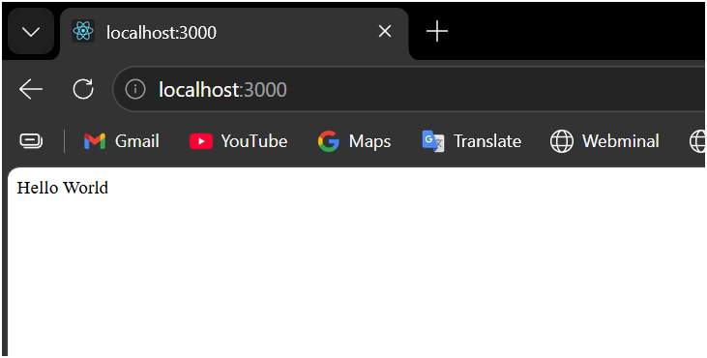

(b) Small Website with Multiple Routes
Folder Structure
program2
│
├── package.json
└── app.js

app.js

const express = require("express");

const app = express();

app.get("/", (req, res) => {
res.send("<h1>Welcome to Home Page</h1>");
});

app.get("/about", (req, res) => {
res.send("<h1>About Us</h1>");
});

app.get("/contact", (req, res) => {
res.send("<h1>Contact Us</h1>");
});

app.get("/services", (req, res) => {
res.send("<h1>Our Services</h1>");
});

app.listen(3000, () => {
console.log("Server Started");
});

Run
node app.js
Visit
http://localhost:3000/
Home Page
http://localhost:3000/about
About Page
http://localhost:3000/contact
Contact Page
http://localhost:3000/services
Services Page
Output:
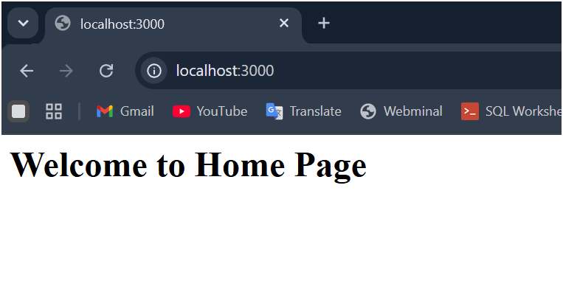

(c) Print Hello World in Browser Console
This means printing in the Node.js console (terminal) when the browser accesses the route.

app.js
const express = require("express");

const app = express();

app.get("/", (req, res) => {

console.log("Hello World");

res.send("Check terminal for Hello World.");
});

app.listen(3000, () => {
console.log("Server Running");
});

Run:
node app.js
Open
http://localhost:3000
Browser
Check terminal for Hello World.
Terminal
Hello World
Output:
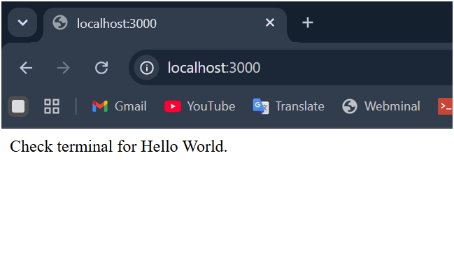

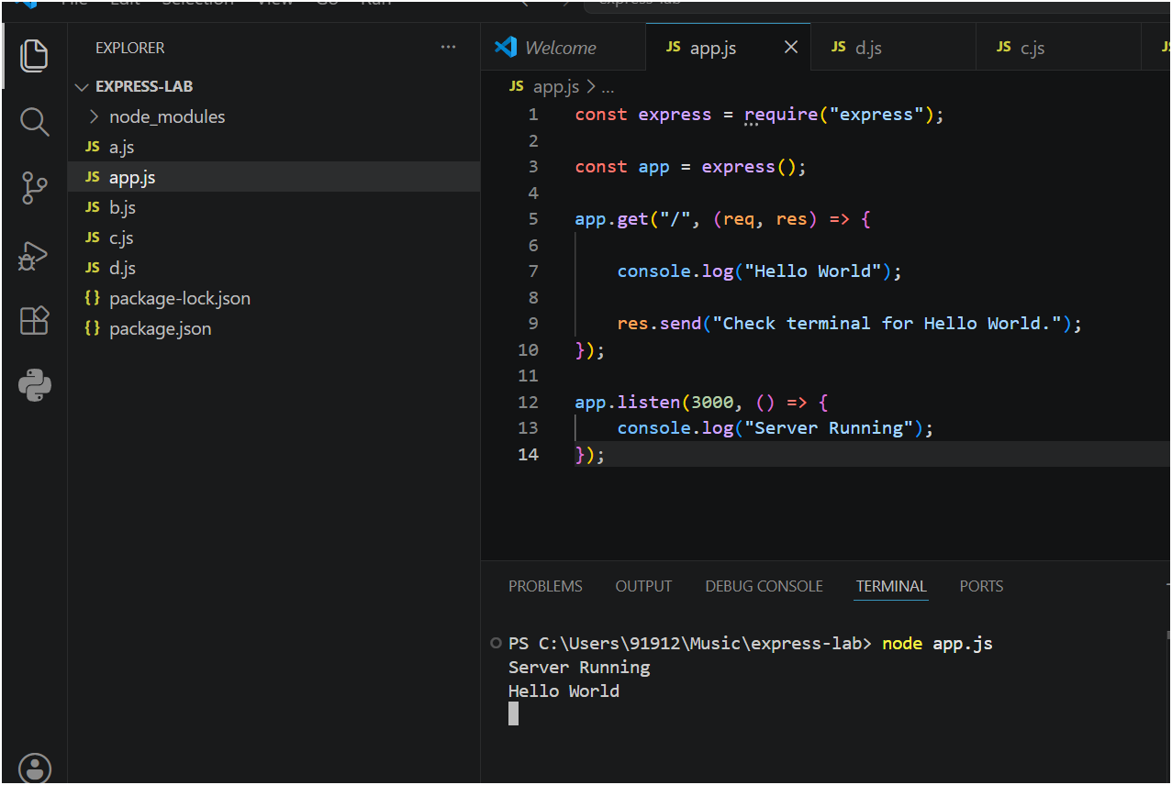

d. Write a program to implement the CRUD operations using Express. Js
This completes the four CRUD operations:
- C – Create → POST
- R – Read → GET
- U – Update → PUT
- D – Delete → DELETE

app.js

const express = require("express");

const app = express();

app.use(express.json());

let students = [
{ id: 1, name: "Ram" },
{ id: 2, name: "Priya" }
];

// GET All Students
app.get("/students", (req, res) => {
res.json(students);
});

// GET Student by ID
app.get("/students/:id", (req, res) => {

const id = parseInt(req.params.id);

const student = students.find(s => s.id === id);

if (!student) {
return res.status(404).json({
message: "Student not found"
});
}

res.json(student);

});

// POST Student
app.post("/students", (req, res) => {

const { id, name } = req.body;

students.push({ id, name });

res.json({
message: "Student Added Successfully"
});

});

// PUT Student
app.put("/students/:id", (req, res) => {

const id = parseInt(req.params.id);

const student = students.find(s => s.id === id);

if (!student) {
return res.status(404).json({
message: "Student not found"
});
}

student.name = req.body.name || student.name;

res.json({
message: "Student Updated Successfully",
student: student
});

});

// DELETE Student
app.delete("/students/:id", (req, res) => {

const id = parseInt(req.params.id);

const index = students.findIndex(s => s.id === id);

if (index === -1) {
return res.status(404).json({
message: "Student not found"
});
}

students.splice(index, 1);

res.json({
message: "Student Deleted Successfully"
});

});

// Start Server
app.listen(3000, () => {
console.log("Server Running");
});

Test CRUD Operations
You can use:
- Postman
- Thunder Client (VS Code Extension)
- Browser (GET requests only)

Install and Open Thunder Client in the vs code
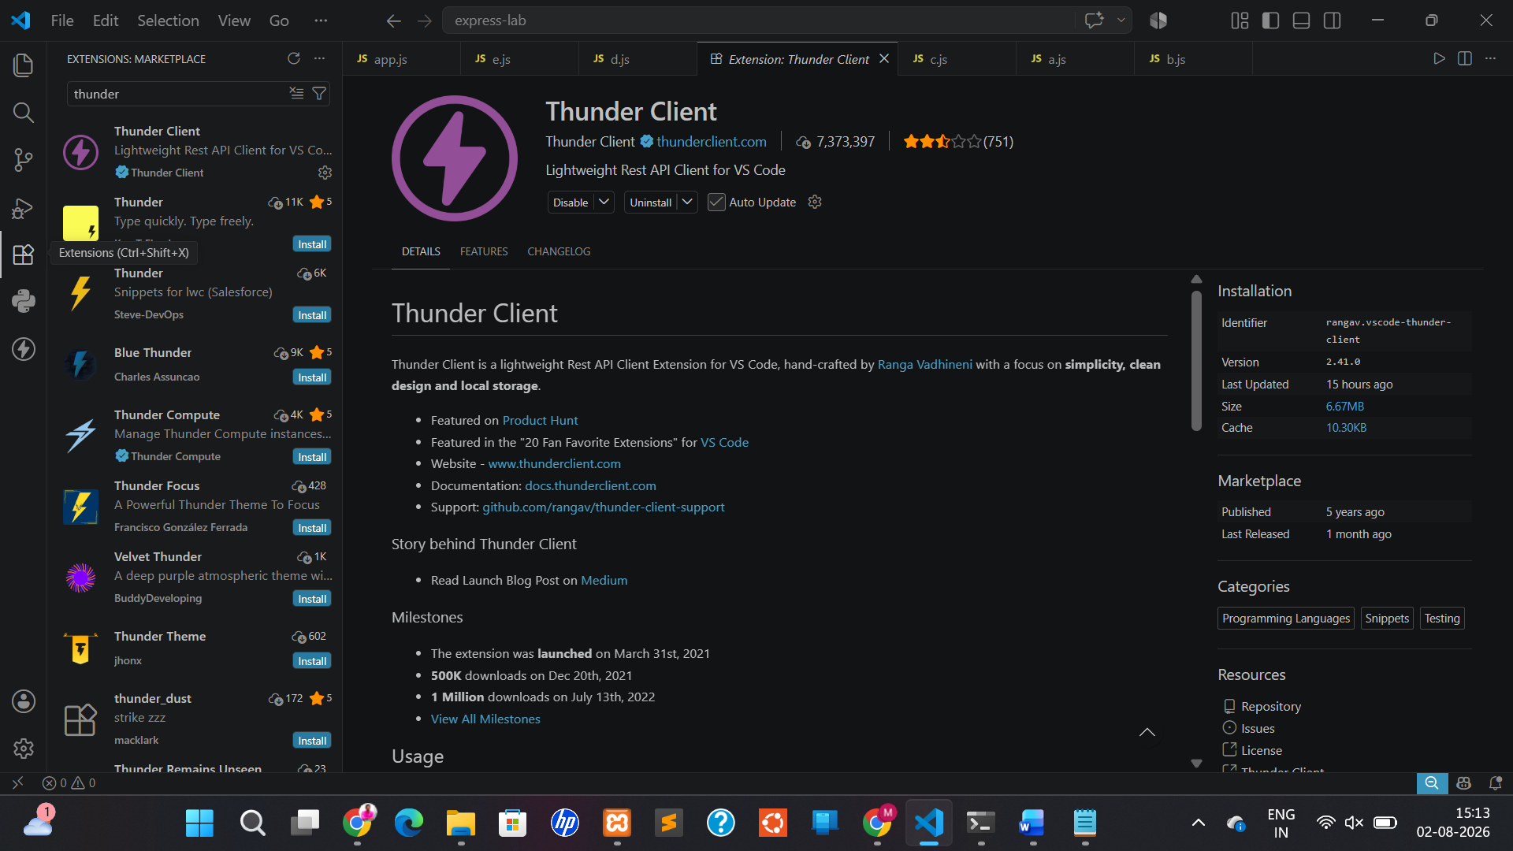

- Click the Thunder Client icon.
- Click New Request.
You'll see:
Method ▼ URL _____________________________ Send
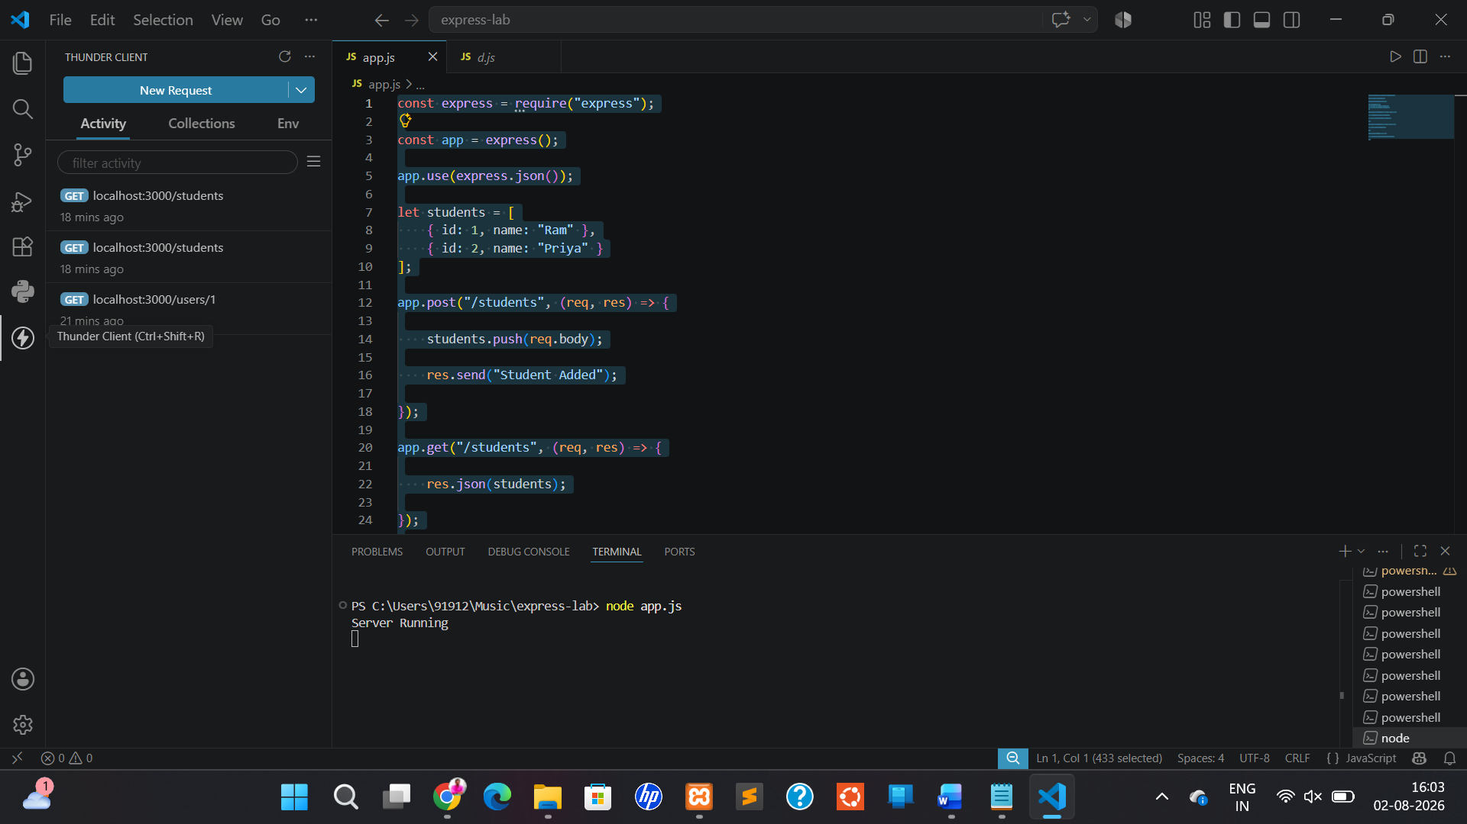

1. READ (GET All Users) - http://localhost:3000/students

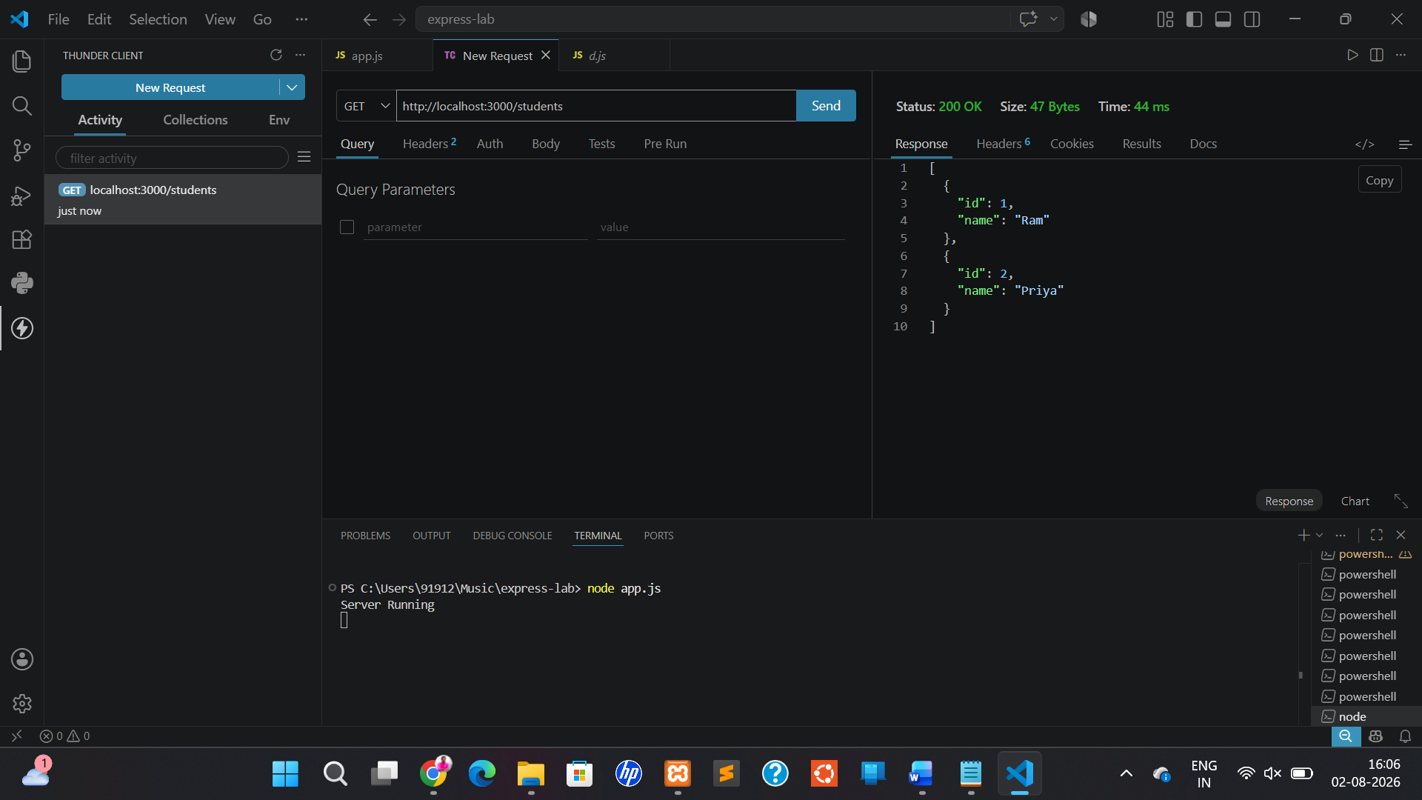

2. POST (Add Student)
Click New Request.
Method
POST
URL
http://localhost:3000/students
Click
Body
↓
Choose
JSON

Paste
{
"id":3,
"name":"Rahul"
}

Click

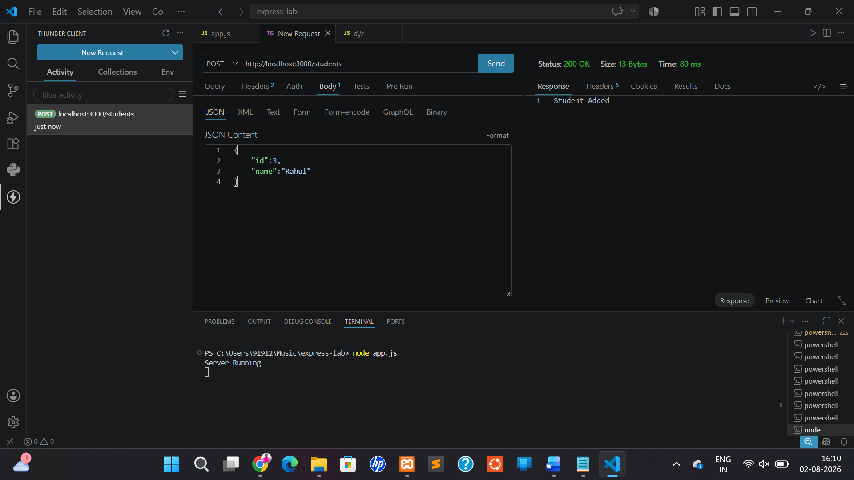

Verify the Student is Added
Create another request.
Method
GET
URL
http://localhost:3000/students
Click
Send
Now the output becomes
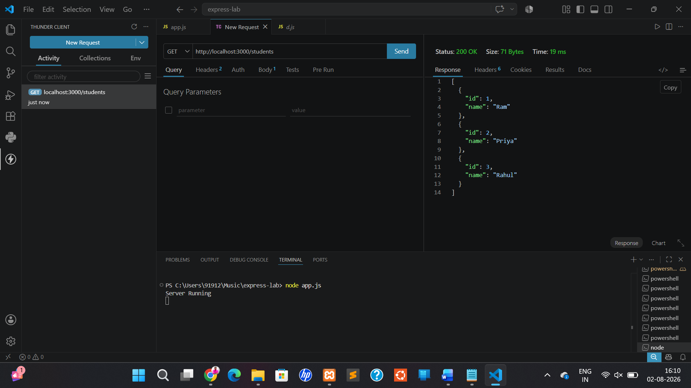

3.Update Student
Method: PUT
URL
http://localhost:3000/students/3
Body → JSON
{
"name": "MDS"
}
Response

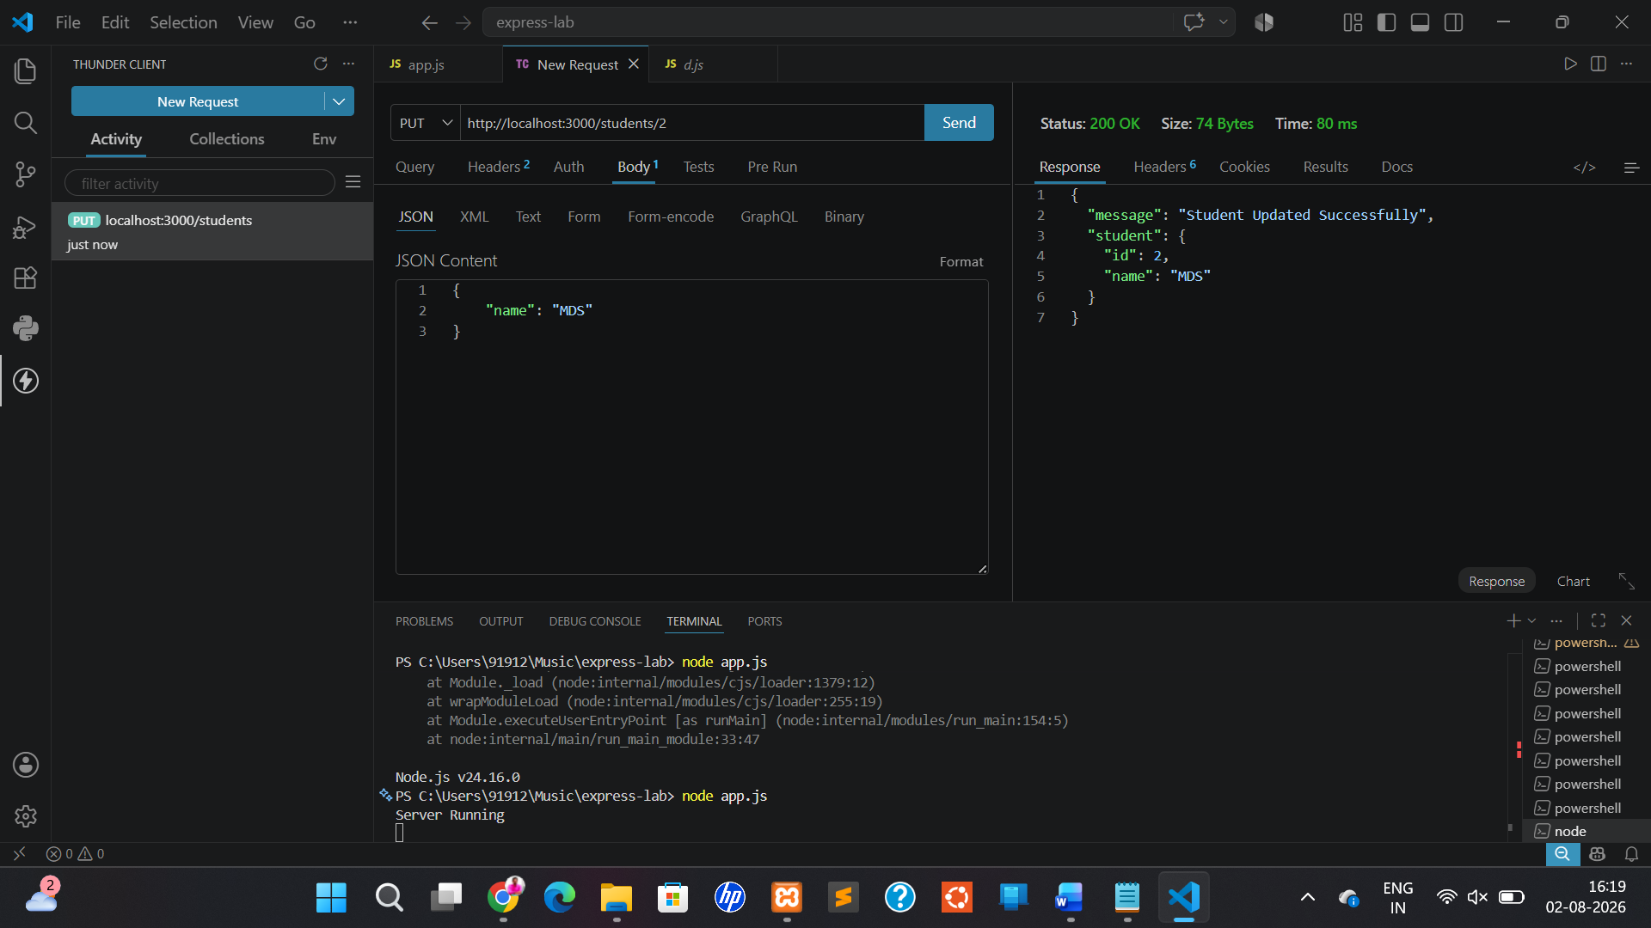

4.Delete Student
Method: DELETE
URL
http://localhost:3000/students/2
Body: None
Response
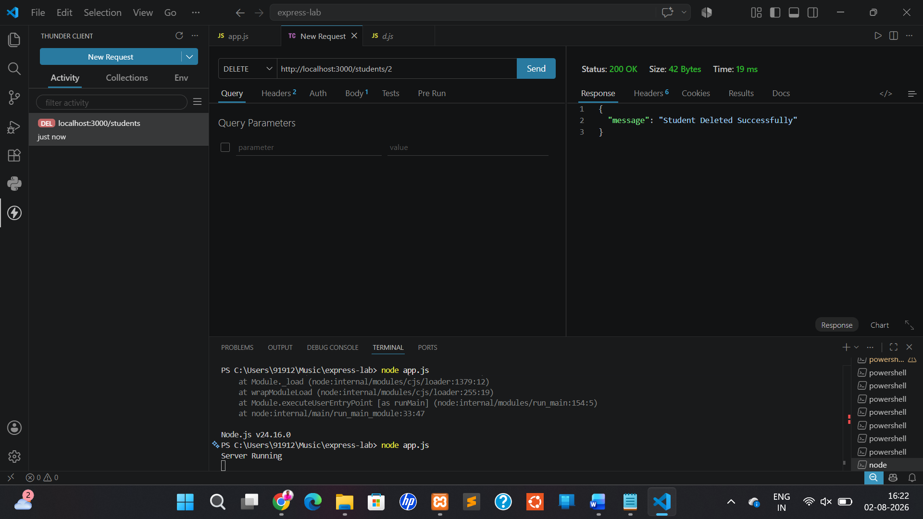
Method | URL | Purpose
POST | http://localhost:3000/students | Add Student
GET | http://localhost:3000/students | View Students
PUT | http://localhost:3000/students/2 | Update Student
DELETE | http://localhost:3000/students/2 | Delete Student

e. Write a program to establish the connection between API and Database using Express - My SQL driver.
Express API + MySQL Connection
Here, the data is stored in a MySQL database instead of an array.

Step 1: Start MySQL
If using XAMPP:
- Open XAMPP Control Panel.
- Start Apache (optional).
- Start MySQL.
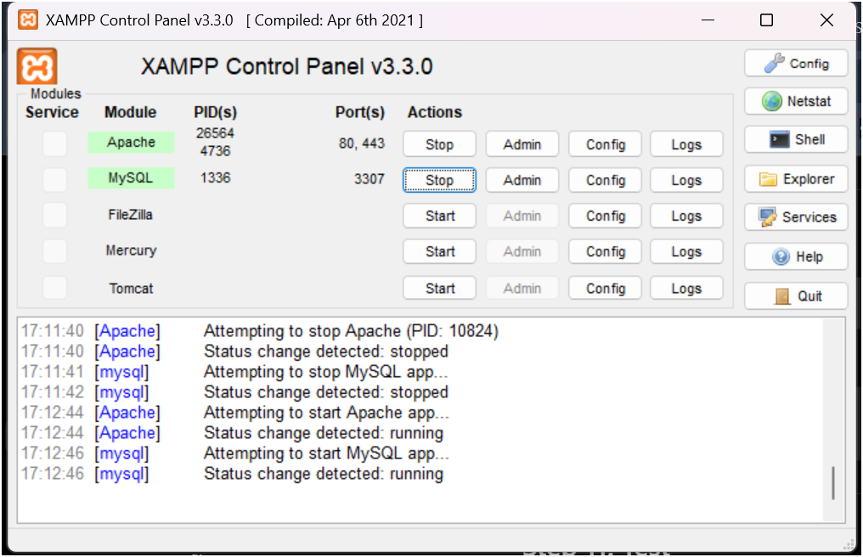
Step 2: Open phpMyAdmin
Open your browser and go to:
http://localhost/phpmyadmin
Step 3: Create Database
Click New → Database Name:
college
Click Create.

Step 4: Create Table
Open the SQL tab and run:

CREATE TABLE students(

id INT PRIMARY KEY,

name VARCHAR(50),

department VARCHAR(30)

);

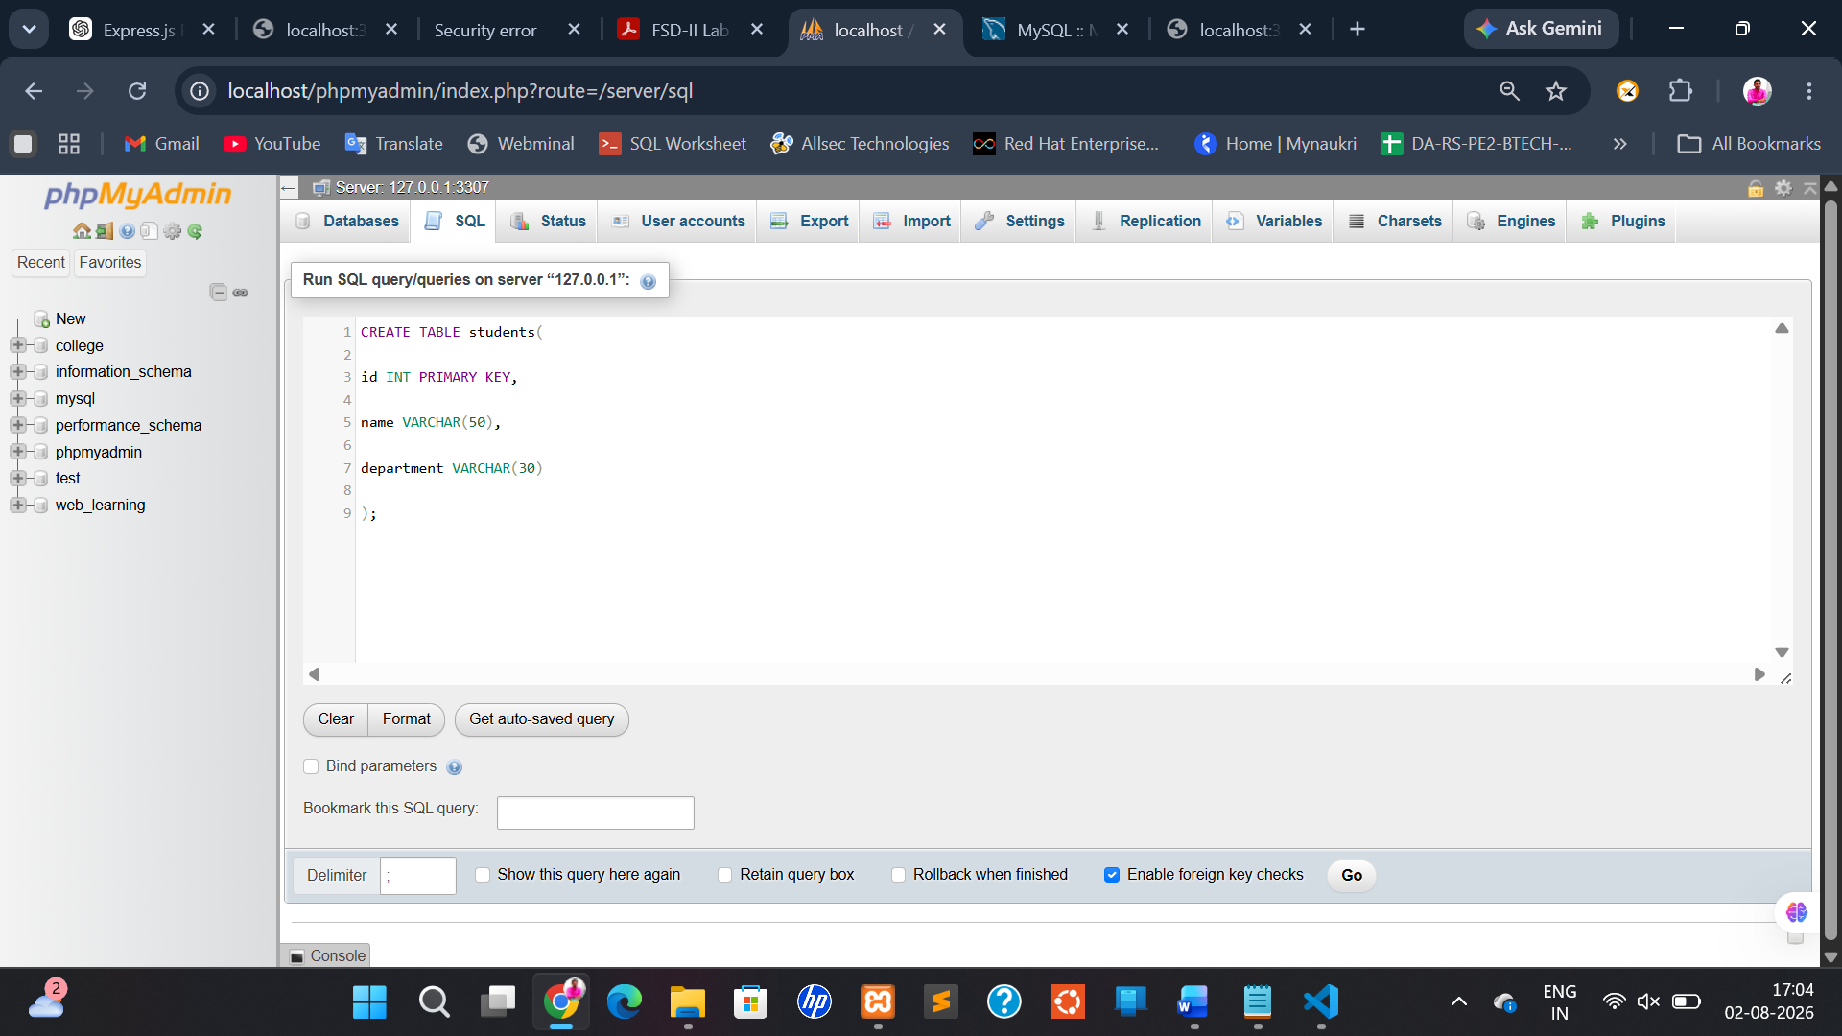

Step 5: Insert Records
Run:
INSERT INTO students VALUES

(1,'Ravi','CSE'),

(2,'Priya','ECE'),

(3,'Rahul','AI');

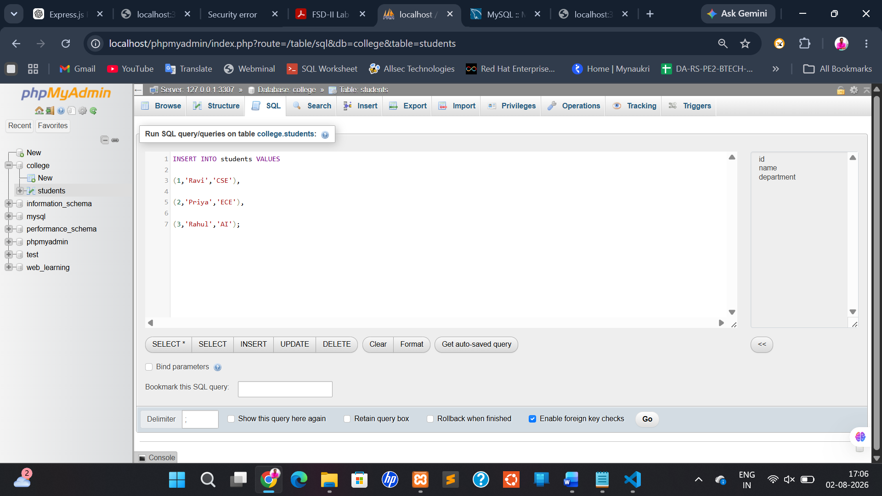
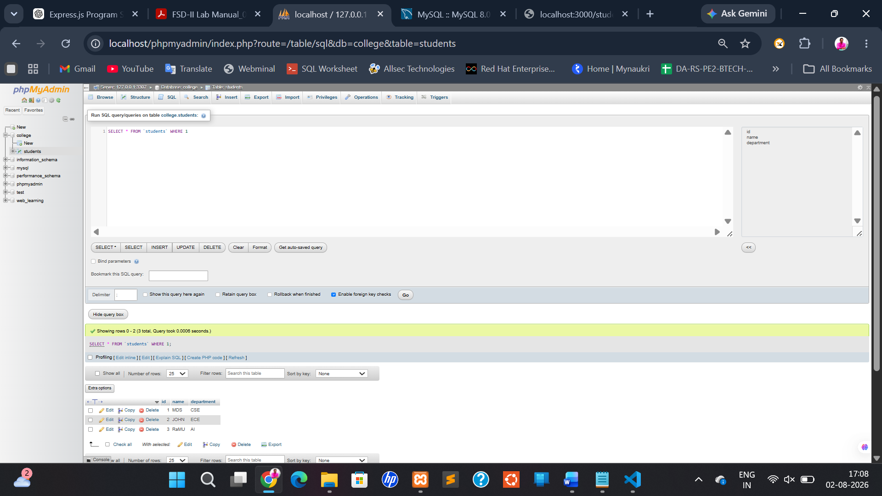

Step 6: Create Project
mkdir directory_name

cd directory_name

Step 7: Initialize
npm init -y

Step 8: Install Packages

npm install express mysql2

Step 9: Create app.js

const express = require("express");
const mysql = require("mysql2");

const app = express();

const connection = mysql.createConnection({
host: "localhost",
user: "root",
password: "",
database: "college"
});

connection.connect((err) => {
if (err) {
console.log(err);
} else {
console.log("MySQL Connected");
}
});

app.get("/students", (req, res) => {
connection.query("SELECT * FROM students", (err, result) => {
if (err) {
res.send(err);
} else {
res.json(result);
}
});
});

app.listen(3000, () => {
console.log("Server Running");
});

Step 10: Run
node app.js
Terminal:
MySQL Connected
Server Running
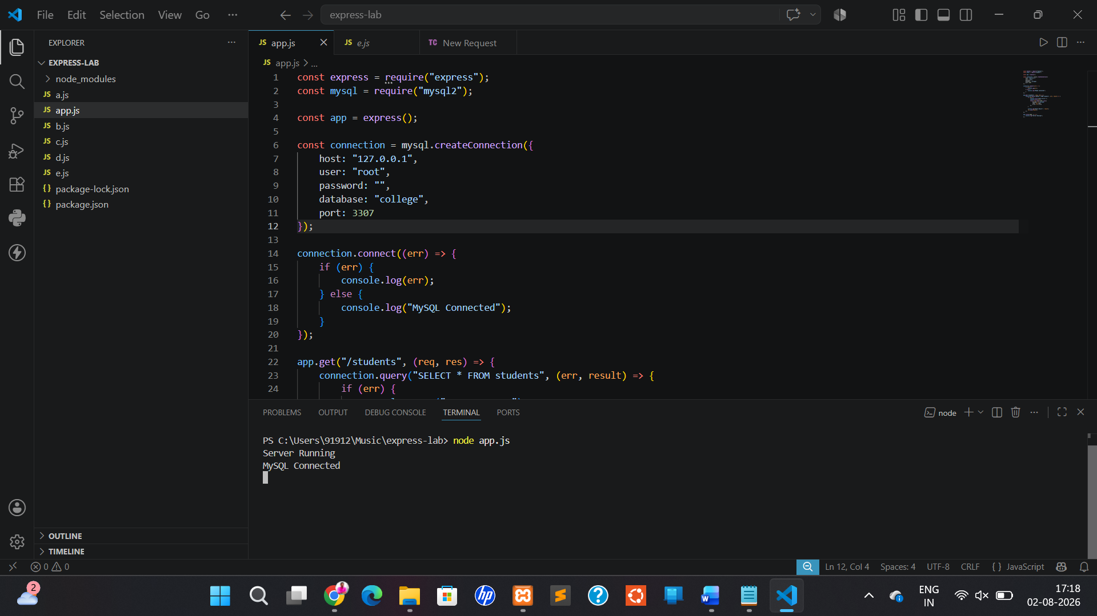
Step 11: Test
Open your browser:
http://localhost:3000/students
Output:

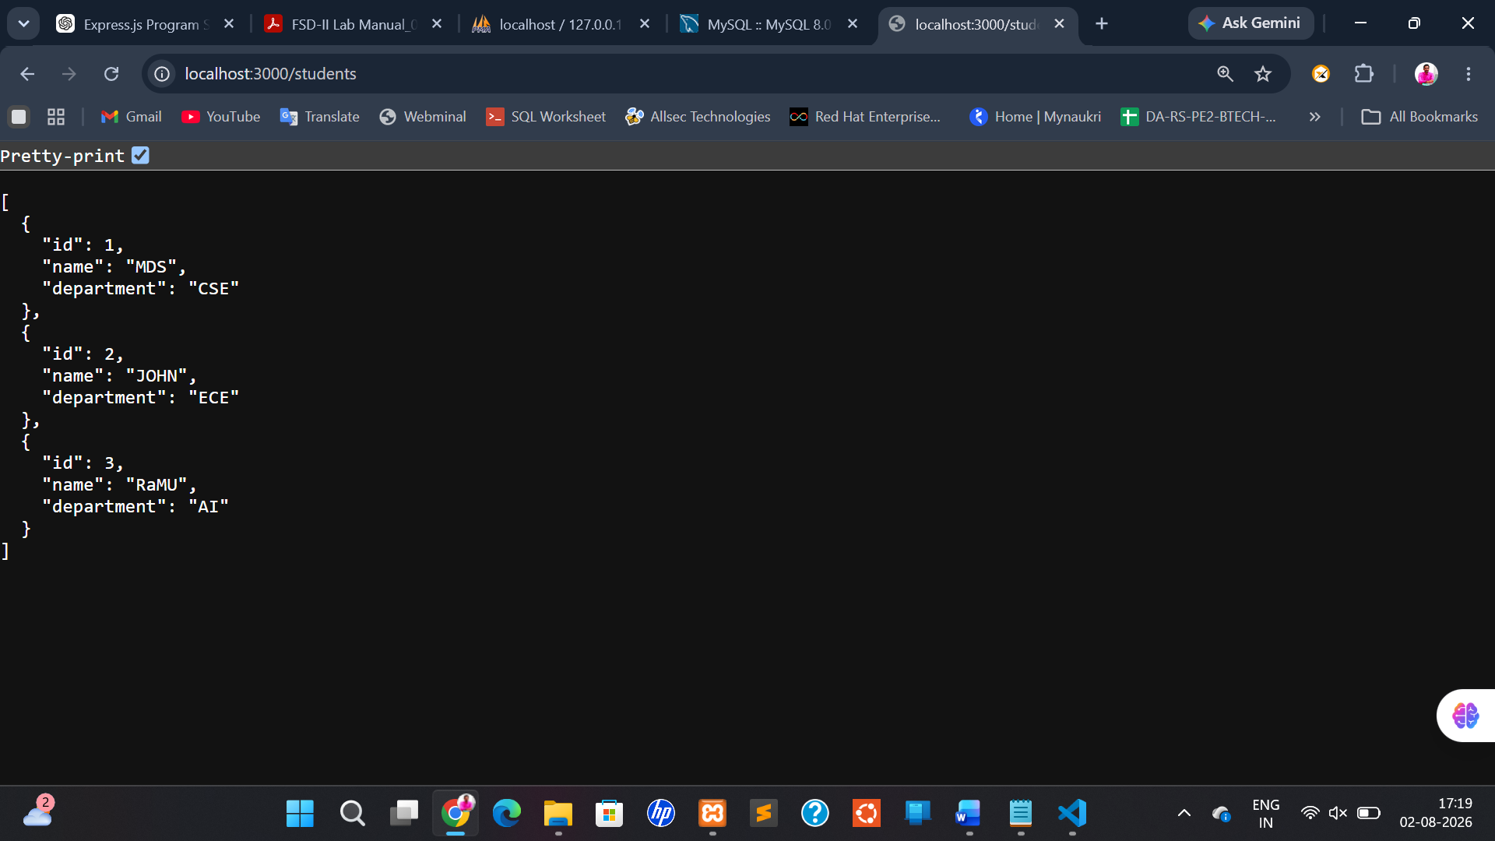

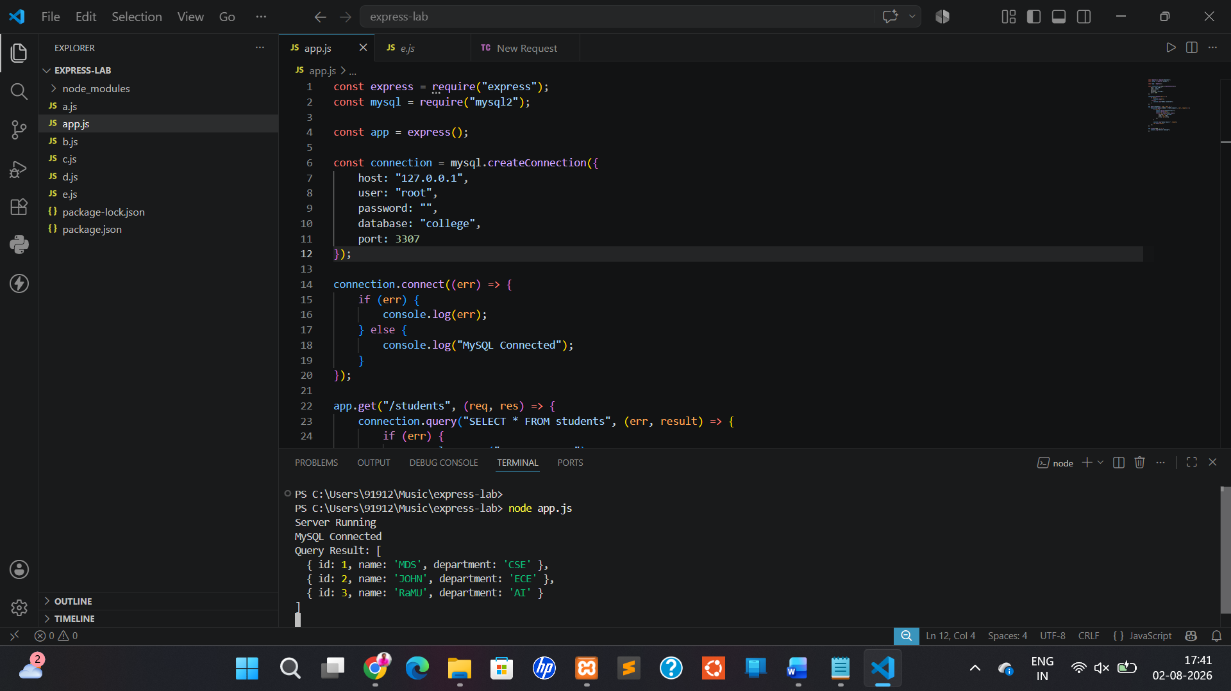

7. Introduction to My SQL
a. Write a program to create a Database and table inside that database using My SQL
Command line client
b. Write a My SQL queries to create table, and insert the data, update the data in the
table
c. Write a My SQL queries to implement the subqueries in the My SQL command line
client
d. Write a My SQL program to create the script files in the My SQL workbench
e. Write a My SQL program to create a database directory in Project and initialize a
database. sql file to integrate the database into API

a. Write a program to create a Database and table inside that database using My SQL
Command line client

Aim
To create a database and a table using the MySQL Command Line Client.

- Open XAMPP Control Panel.
- Start MySQL.
- Click the Shell button in XAMPP.
- In the black window, type:
mysql -u root

Commands

91912@MOHAMMED c:\xampp
# mysql -u root
Welcome to the MariaDB monitor. Commands end with ; or \g.
Your MariaDB connection id is 11
Server version: 10.4.32-MariaDB mariadb.org binary distribution

Copyright (c) 2000, 2018, Oracle, MariaDB Corporation Ab and others.

Type 'help;' or '\h' for help. Type '\c' to clear the current input statement.

Step 1: Create a database
MariaDB [(none)]> CREATE DATABASE university;
Query OK, 1 row affected (0.004 sec)

Step 2: Use the database
MariaDB [(none)]> USE university;
Database changed

Step 3: Create the table
MariaDB [university]> CREATE TABLE students (
-> id INT PRIMARY KEY,
-> name VARCHAR(50),
-> department VARCHAR(30),
-> age INT
-> );
Query OK, 0 rows affected (0.021 sec)

Step 4: Check that the table exists
MariaDB [university]> SHOW TABLES;
+----------------------+
| Tables_in_university |
+----------------------+
| students |
+----------------------+
1 row in set (0.017 sec)

Step 5: View the table structure
MariaDB [university]> DESCRIBE students;
+------------+-------------+------+-----+---------+-------+
| Field | Type | Null | Key | Default | Extra |
+------------+-------------+------+-----+---------+-------+
| id | int(11) | NO | PRI | NULL | |
| name | varchar(50) | YES | | NULL | |
| department | varchar(30) | YES | | NULL | |
| age | int(11) | YES | | NULL | |
+------------+-------------+------+-----+---------+-------+
4 rows in set (0.040 sec)

MariaDB [university]>

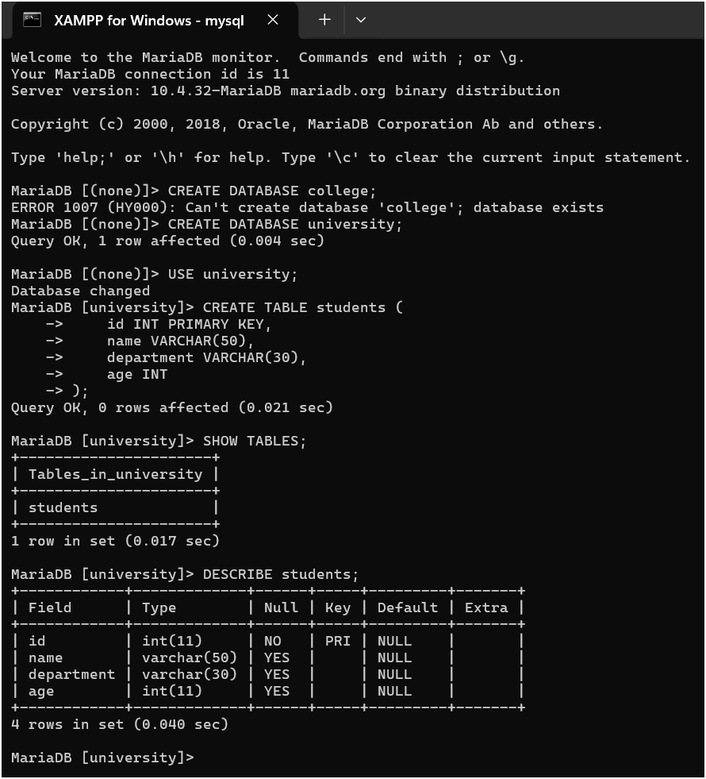

b. Write a My SQL queries to create table, and insert the data, update the data in the
table

Aim
To create a table, insert records, and update existing records.

Step 1: Insert First Record
INSERT INTO students
VALUES(1,'Ram','CSE',20);
Expected Output
Query OK, 1 row affected

Step 2: Insert Second Record
INSERT INTO students
VALUES(2,'Priya','ECE',21);

Step 3: Insert Third Record
INSERT INTO students
VALUES(3,'Arun','AI',22);

Step 4: Display the Table
SELECT * FROM students;
You should see:
+----+-------+------------+------+
| id | name | department | age |
+----+-------+------------+------+
| 1 | Ram | CSE | 20 |
| 2 | Priya | ECE | 21 |
| 3 | Arun | AI | 22 |
+----+-------+------------+------+

Step 5: Update Arun's Age
UPDATE students
SET age=23
WHERE id=3;
Expected Output
Query OK, 1 row affected

Step 6: Display the Updated Table
SELECT * FROM students;
Now you should see:
+----+-------+------------+------+
| id | name | department | age |
+----+-------+------------+------+
| 1 | Ram | CSE | 20 |
| 2 | Priya | ECE | 21 |
| 3 | Arun | AI | 23 |
+----+-------+------------+------+

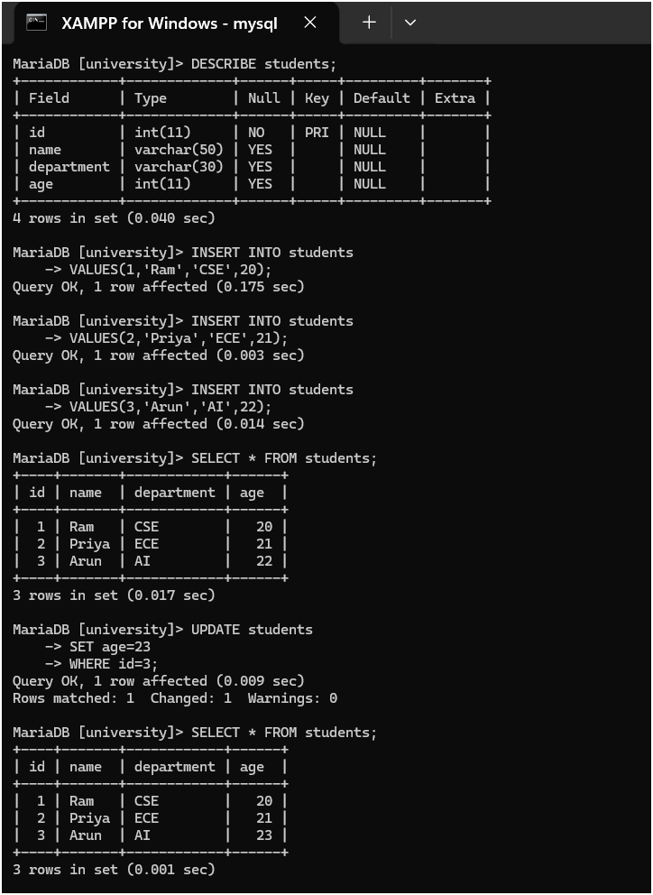

c. Write a My SQL queries to implement the subqueries in the My SQL command line
client

Subqueries
A subquery is a query inside another query.
Step 1: Add a marks Column
ALTER TABLE students
ADD marks INT;
Check the table structure:
DESCRIBE students;
You should now see a new column named marks.

Step 2: Add Marks for Each Student
UPDATE students
SET marks = 80
WHERE id = 1;
UPDATE students
SET marks = 90
WHERE id = 2;
UPDATE students
SET marks = 70
WHERE id = 3;

Step 3: View the Data
SELECT * FROM students;
Expected output:
+----+-------+------------+------+-------+
| id | name | department | age | marks |
+----+-------+------------+------+-------+
| 1 | Ram | CSE | 20 | 80 |
| 2 | Priya | ECE | 21 | 90 |
| 3 | Arun | AI | 23 | 70 |
+----+-------+------------+------+-------+

Step 4: Find the Average Marks
SELECT AVG(marks) FROM students;
Expected output:
+------------+
| AVG(marks) |
+------------+
| 80.0000 |
+------------+

Step 5: Subquery - Students Scoring Above Average
SELECT *
FROM students
WHERE marks >
(
SELECT AVG(marks)
FROM students
);
Expected output:
+----+-------+------------+------+-------+
| id | name | department | age | marks |
+----+-------+------------+------+-------+
| 2 | Priya | ECE | 21 | 90 |
+----+-------+------------+------+-------+

Step 6: Subquery - Student with Highest Marks
SELECT *
FROM students
WHERE marks =
(
SELECT MAX(marks)
FROM students
);
Expected output:
+----+-------+------------+------+-------+
| id | name | department | age | marks |
+----+-------+------------+------+-------+
| 2 | Priya | ECE | 21 | 90 |
+----+-------+------------+------+-------+

Step 7: Subquery - Student with Lowest Marks
SELECT *
FROM students
WHERE marks =
(
SELECT MIN(marks)
FROM students
);
Expected output:
+----+-------+------------+------+-------+
| id | name | department | age | marks |
+----+-------+------------+------+-------+
| 3 | Arun | AI | 23 | 70 |
+----+-------+------------+------+-------+

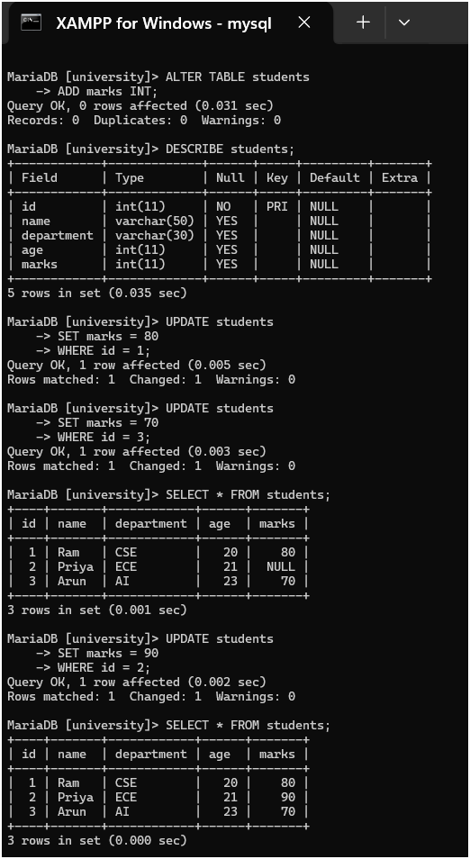
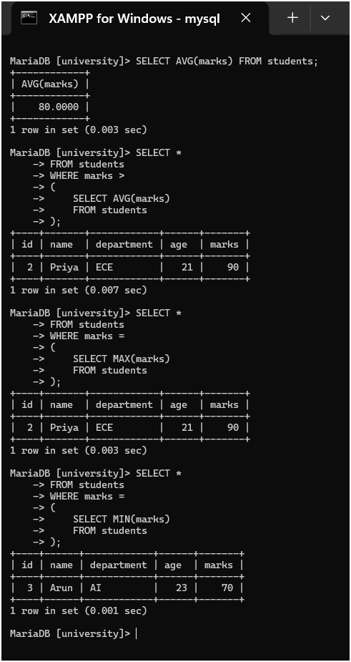

d. Write a My SQL program to create the script files in the My SQL workbench

Create a SQL Script File in MySQL Workbench
Aim
Create a SQL script (database.sql) using MySQL Workbench and execute it.

Step 1: Open MySQL Workbench
- Press the Windows key.
- Search for MySQL Workbench.
- Open it.
Step 2: Connect to the Database

You will see a connection like:

Local instance MySQL80

Double-click it.

A new SQL Editor window will open.

Step 3: Create a New SQL Script
Click:
File
↓
New Query Tab
or click the + icon to open a new SQL tab.
Step 4: Type the SQL Commands
Paste the following:
CREATE DATABASE studentdb;

USE studentdb;

CREATE TABLE students (
id INT AUTO_INCREMENT PRIMARY KEY,
name VARCHAR(50),
department VARCHAR(30),
age INT
);

INSERT INTO students(name, department, age)
VALUES
('Ram','CSE',20),
('Priya','ECE',21),
('Arun','AI',22);

SELECT * FROM students;

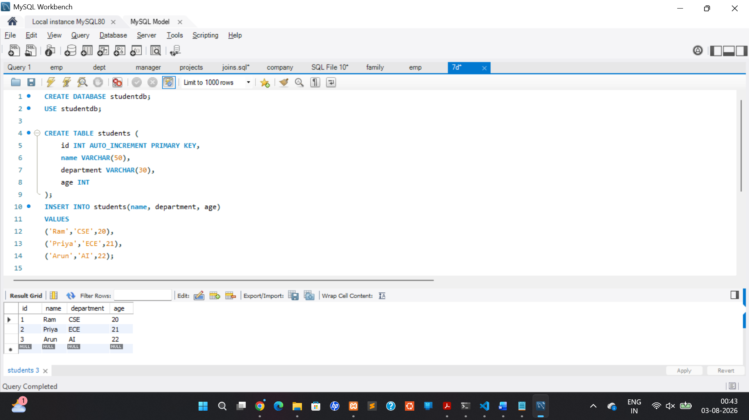

Step 5: Save the Script
Click:
File
↓
Save Script As...
Choose a location such as:
Documents
↓
student-api
↓
database
Save the file as:
database.sql

Step 6: Execute the Script
Click the ⚡ Execute button.
If everything is correct, the database, table, and records will be created.

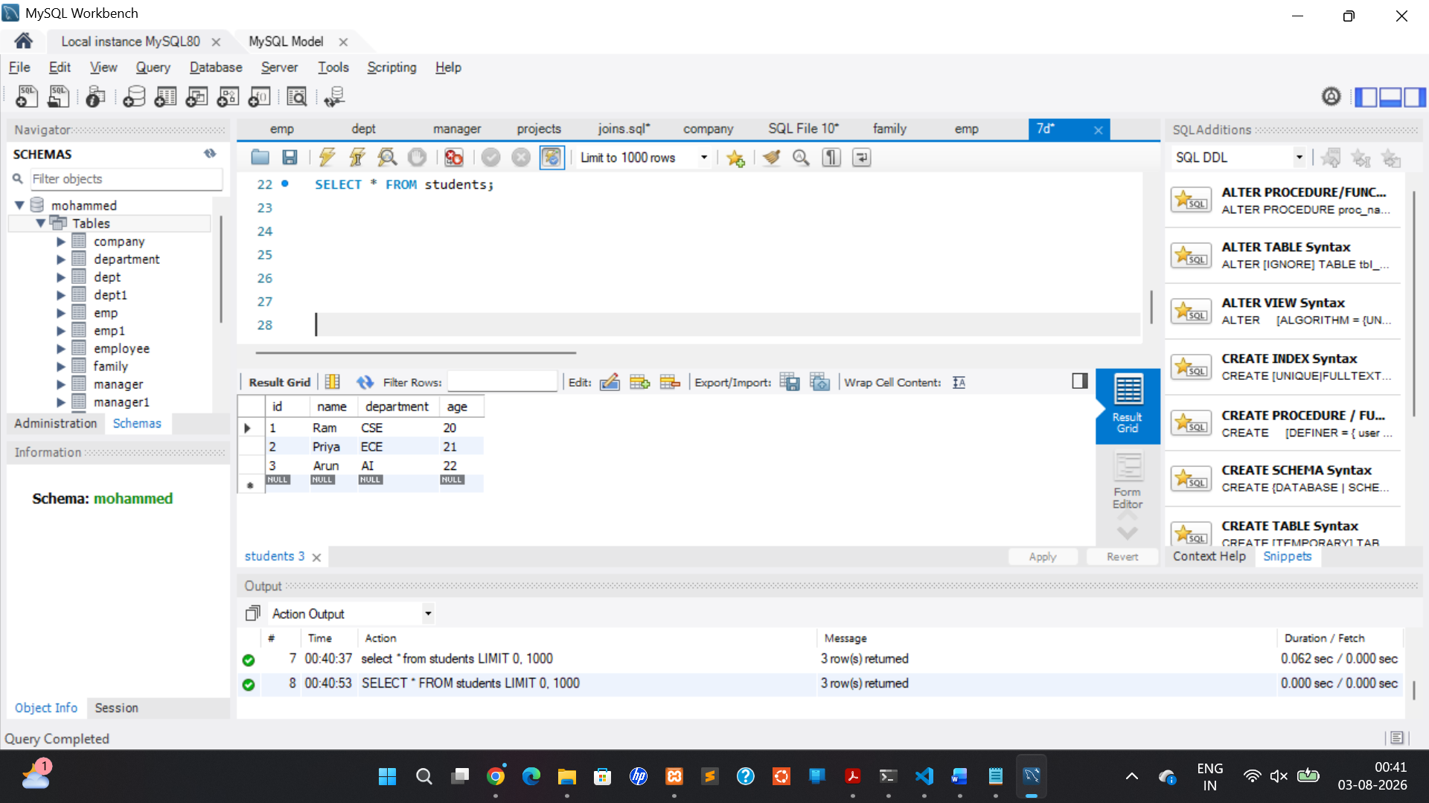

e. Write a My SQL program to create a database directory in Project and initialize a
database. sql file to integrate the database into API.

Create a Database Directory in the Project and Integrate It with Express API
This experiment is done in VS Code.

Step 1: Open Your Express Project
For example:
student-api

Step 2: Create a Database Folder
Right-click the project name.
Select:
New Folder
Name it:
database
Your project will look like:
student-api
│
├── database
├── node_modules
├── package.json
├── app.js
└── ...

Step 3: Create database.sql
Right-click the database folder.
Choose:
New File
Name it:
database.sql

Step 4: Add SQL Commands
Paste:
CREATE DATABASE IF NOT EXISTS munnadb;

USE munnadb;

CREATE TABLE IF NOT EXISTS students (
id INT AUTO_INCREMENT PRIMARY KEY,
name VARCHAR(50),
department VARCHAR(30),
age INT
);

INSERT INTO students(name, department, age)
VALUES
('Munna','CSE',20),
('Mohammed','ECE',21),
('Sohel','AI',22);

SELECT * FROM students;

Press Ctrl + S to save.

Step 5: Install the MySQL Package
Open the VS Code terminal.
Run:
npm install mysql2

Step 6: Create db.js
In the project root, create a new file named:
db.js
Add this code:

const mysql = require("mysql2");

const connection = mysql.createConnection({
host: "127.0.0.1",
port: 3307,
user: "root",
password: "",
database: "munnadb"
});

connection.connect((err) => {
if (err) {
console.log("Connection Error:", err);
} else {
console.log("Connected to MySQL");
}
});

module.exports = connection;

Step 7: Modify app.js
Example:
const express = require("express");
const db = require("./db");

const app = express();

// Home Route
app.get("/", (req, res) => {
res.send("Welcome to Student API");
});

// Students Route
app.get("/students", (req, res) => {
db.query("SELECT * FROM students", (err, result) => {
if (err) {
console.log(err);
return res.status(500).send(err.message);
}

res.json(result);
});
});

app.listen(3000, () => {
console.log("Server running on port 3000");
});

Step 8: Import the SQL File
Option 1: MySQL Command Line
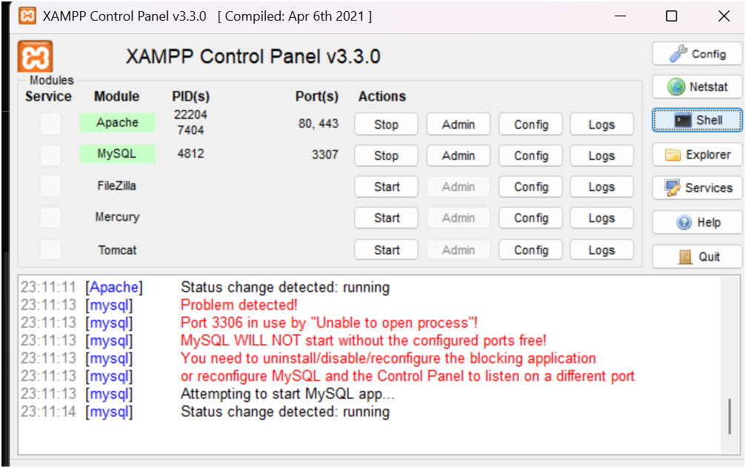
Open the MySQL client:
mysql -u root
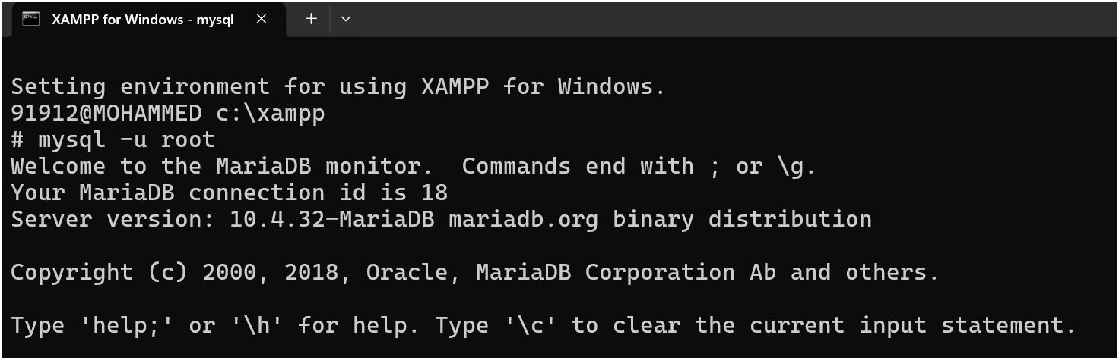
Run:
SOURCE C:/path/to/your/project/database/database.sql;
Replace the path with the actual location of your database.sql file.

Or
Correct example
If your SQL file is named database.sql and is inside the database folder, use:

SOURCE C:/Users/91912/Music/express-lab/database/database.sql;

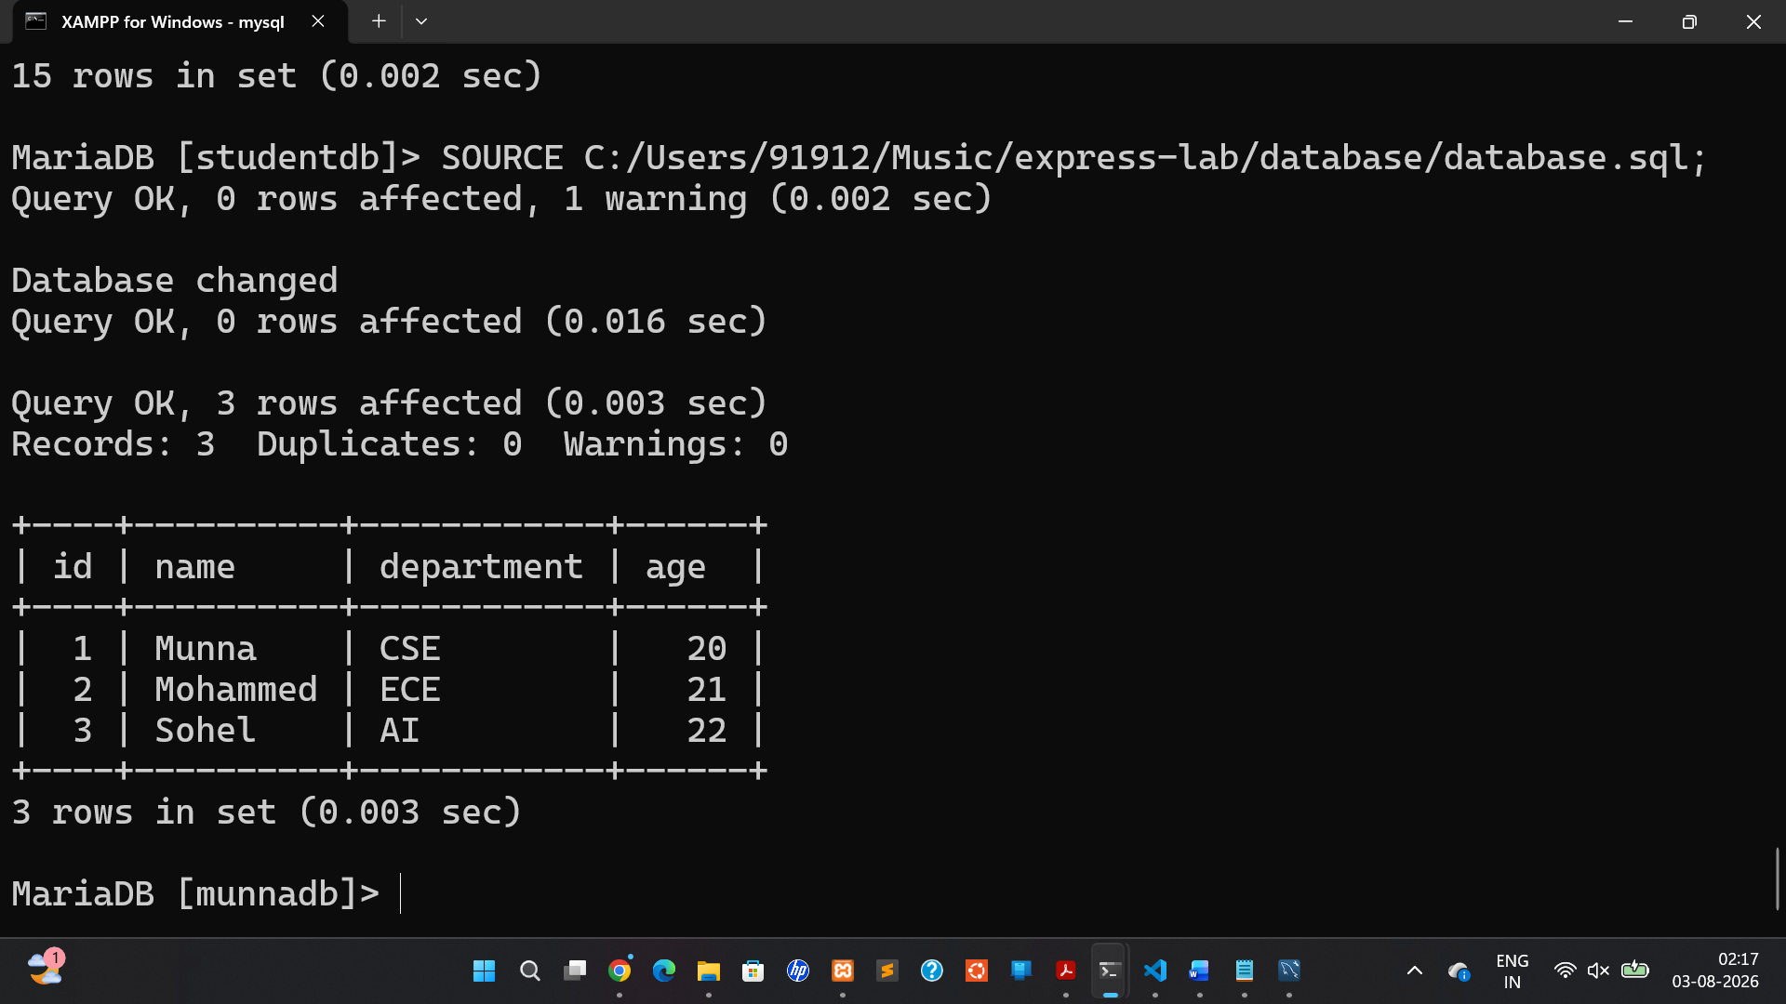

Option 2: MySQL Workbench
- Open MySQL Workbench.
- Click File → Open SQL Script.
- Select database.sql.
- Click ⚡ Execute.

Step 9: Run the Express Application
In the VS Code terminal:
node app.js
You should see:
Connected to MySQL
Server running on port 3000

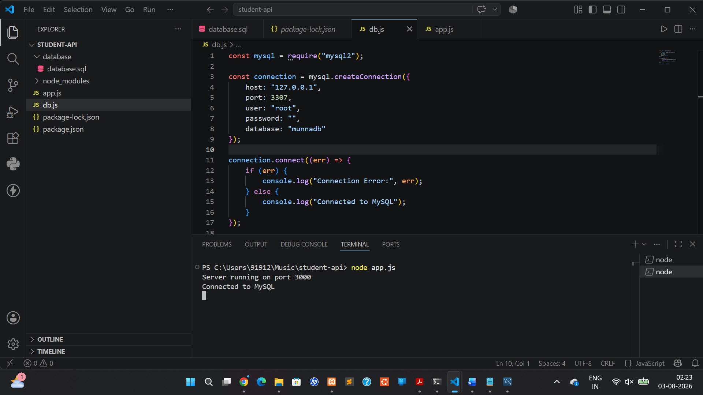

Step 10: Test the API
Open your browser or Postman and visit:
http://localhost:3000/students
Expected response:
Restart the server
Stop the server by pressing:
Ctrl + C
Then run:
node app.js

4. Open the correct URL
Visit:
Home page:
http://localhost:3000/
You should see:
Welcome to Student API
Then visit:
http://localhost:3000/students
You should see JSON data from your database.

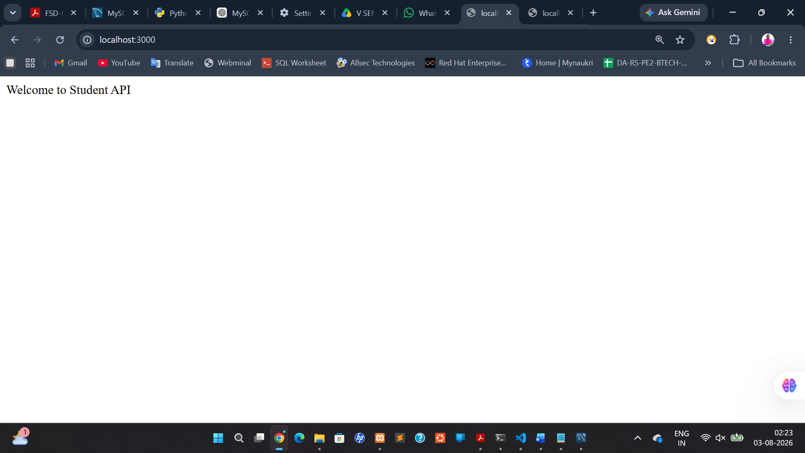

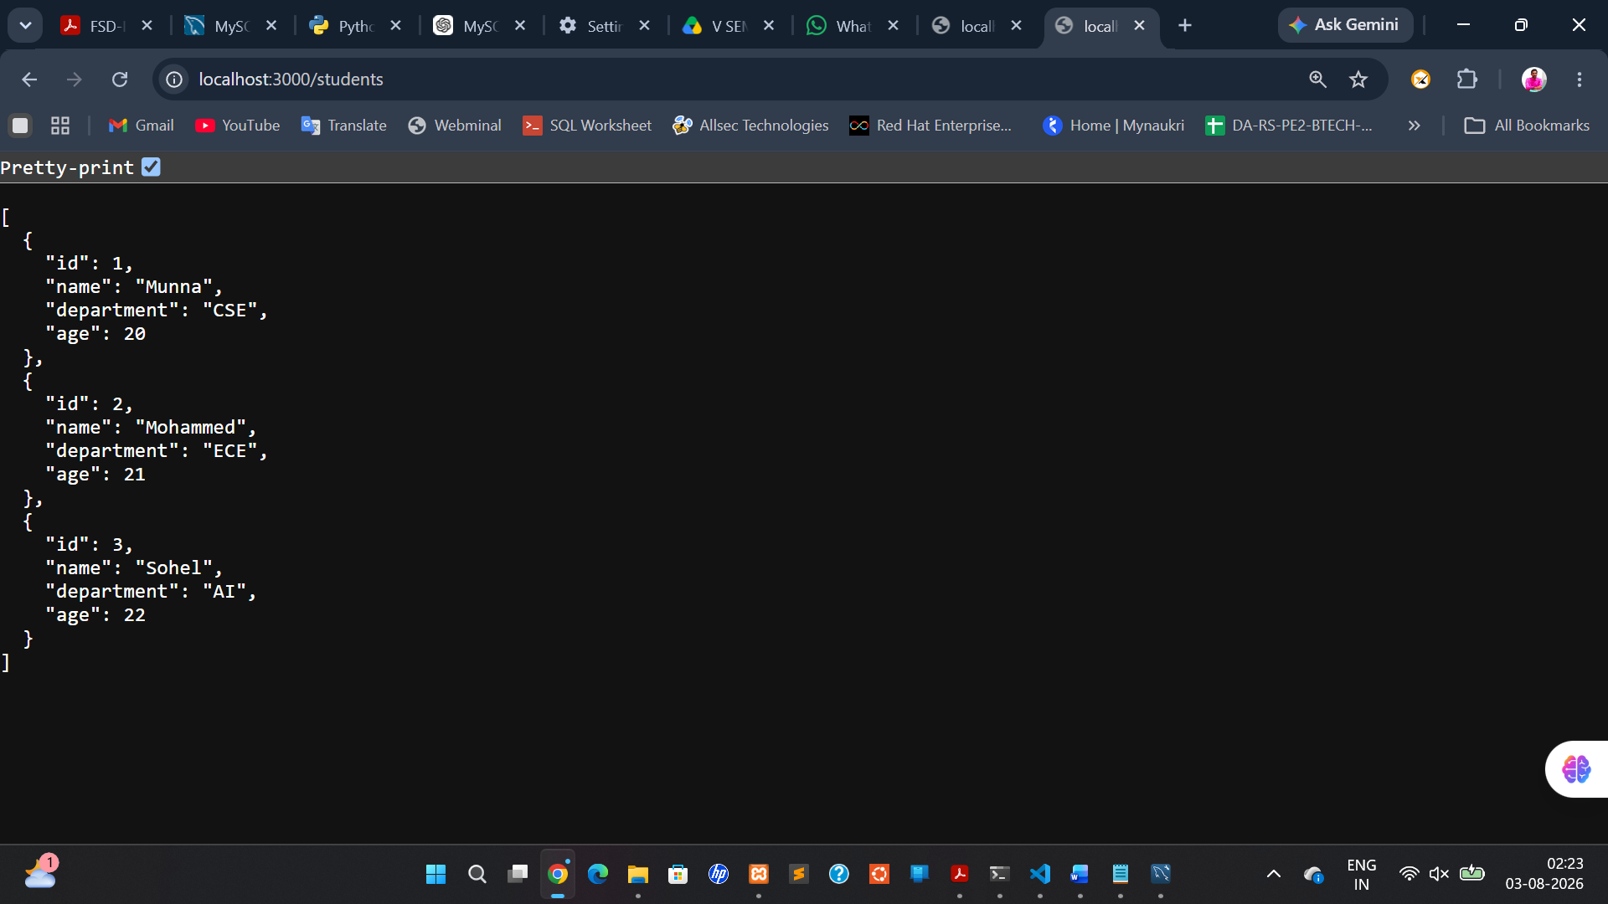

8. Team Collaboration Using GitHub
o Form groups of 2 3 students
o Create a shared GitHub repo
o Assign tasks and work in branches
o Use Issues, Pull Requests, and Code Reviews
o Document code with README.md

Textbooks:
1. Web Design with HTML, CSS, JavaScript and JQuery Set Book by Jon
Duckett Professional JavaScript for Web Developers Book by Nicholas C.
Zakas
2. John Dean, Web Programming with HTML5, CSS and JavaScript, Jones & Bartlett
Learning, 2019.
3. Pro MERN Stack: Full Stack Web App Development with Mongo, Express, React, and
Node, Vasan Subramanian, 2nd
4. Learning PHP, MySQL, JavaScript, CSS & HTML5: A Step-by-Step Guide
to Creating Dynamic Websites by Robin Nixon
5. AZAT MARDAN, Full Stack Java Script: Learn Back bone. js, Node.jsand
Mongo DB.2015
Reference Books:
1. Full-Stack JavaScript Development by Eric Bush.
2. Programming the World Wide Web, 7th Edition, Robet W Sebesta, Pearson, 2013.
3. Tomasz Dyl ,KamilPrzeorski , MaciejCzarnecki, Mastering Full Stack React Web
Development 2017
Online Learning Resources:
1. https://ict.iitk.ac.in/product/full-stack-developer-html5-css3-js-bootstrap-php-4/
2. https://www.w3schools.com/html
3. https://www.w3schools.com/css
4. https://www.w3schools.com/js/
5. https://www.w3schools.com/nodejs
6. https://www.w3schools.com/typescript
7. https://docs.github.com/
8. https://education.github.com/git-cheat-sheet-education.pdf

